**CAPSTONE PROJECT -1**

**DEVOPS**

**DONE BY  
RANJITH KUMAR**

**Overview:**

You have been hired as a Sr. DevOps Engineer in Abode Software. They want to implement DevOps Lifecycle in their company. You have been asked to implement this lifecycle as fast as possible. Abode Software is a product-based company and their product is available on this GitHub link.

https://github.com/hshar/website.git

**Following are the specifications of the lifecycle:**

1. Install the necessary software on the machines using a configuration management tool

2. Git workflow has to be implemented

3. CodeBuild should automatically be triggered once a commit is made to master branch or develop branch.

a. If a commit is made to master branch, test and push to prod

b. If a commit is made to develop branch, just test the product, do not push to prod

4. The code should be containerized with the help of a Dockerfile. The Dockerfile should be built every time there is a push to GitHub. Use the following pre-built container for your application: hshar/webapp

The code should reside in '/var/www/html'

5. The above tasks should be defined in a Jenkins Pipeline with the following

jobs:

a. Job1 : build

b. Job2 : test

c. Job3 : prod

**STEPS:**

1.Create an EC2 instance and install ansible on it

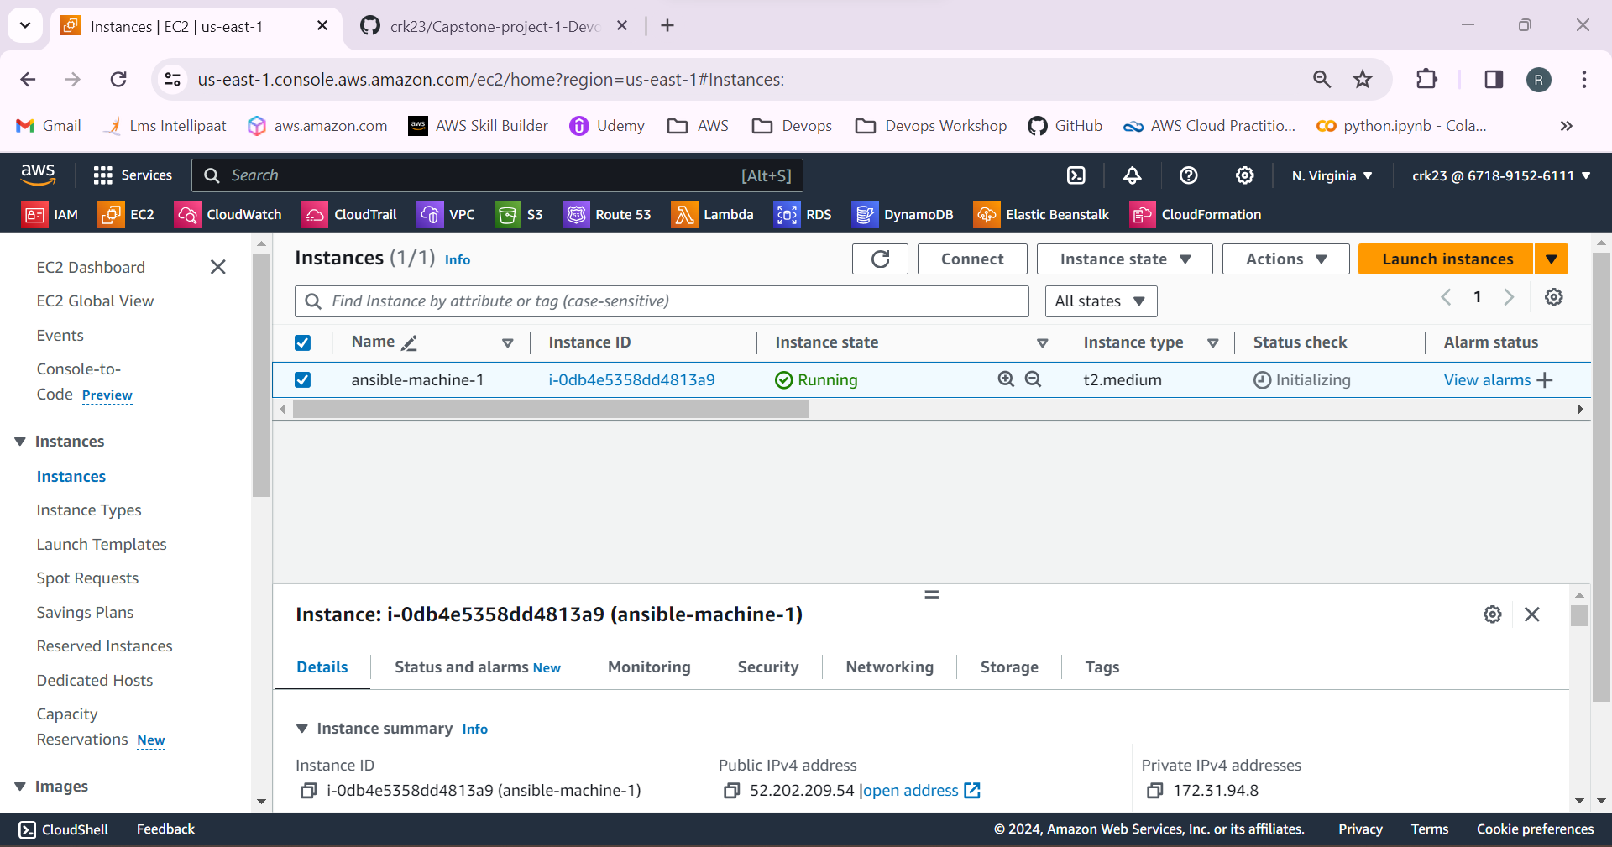

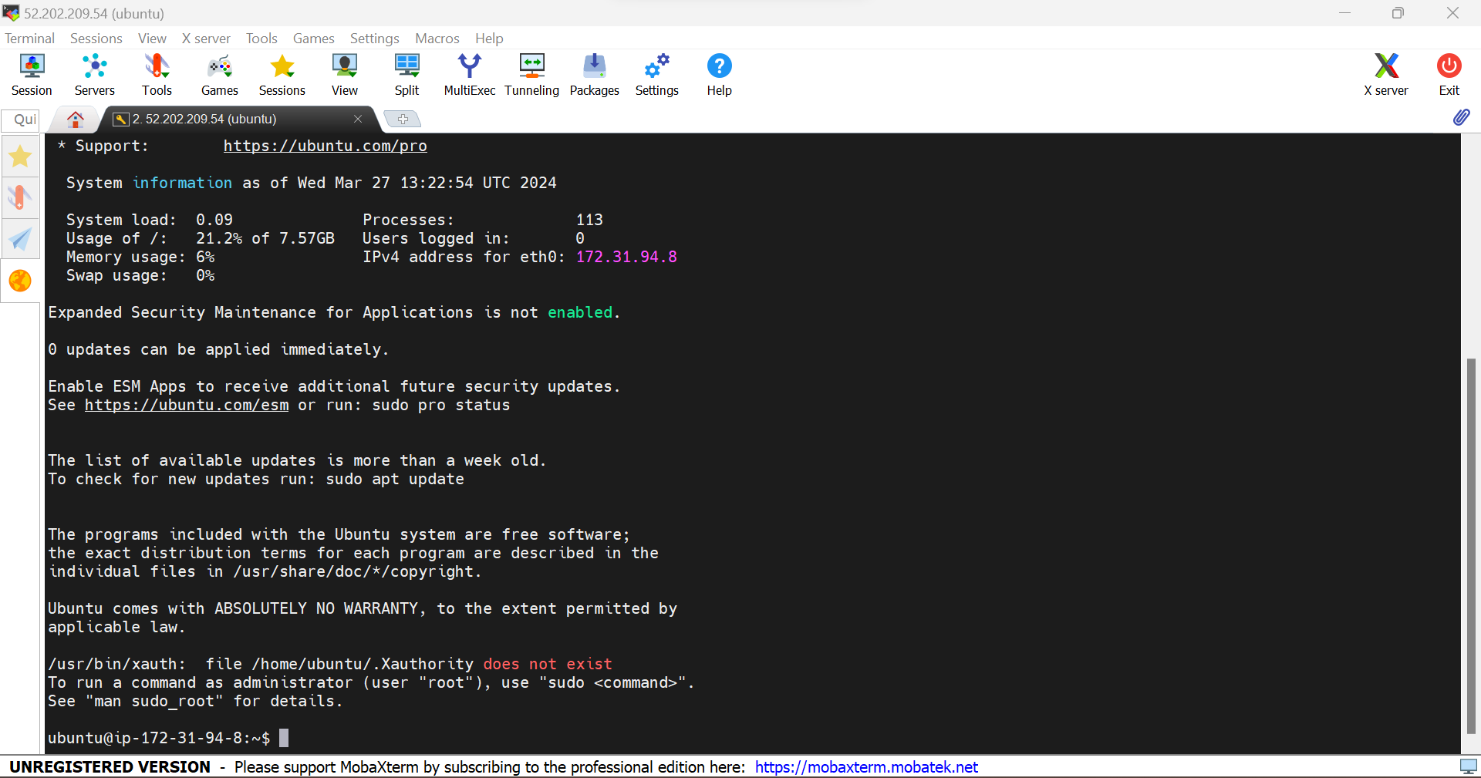

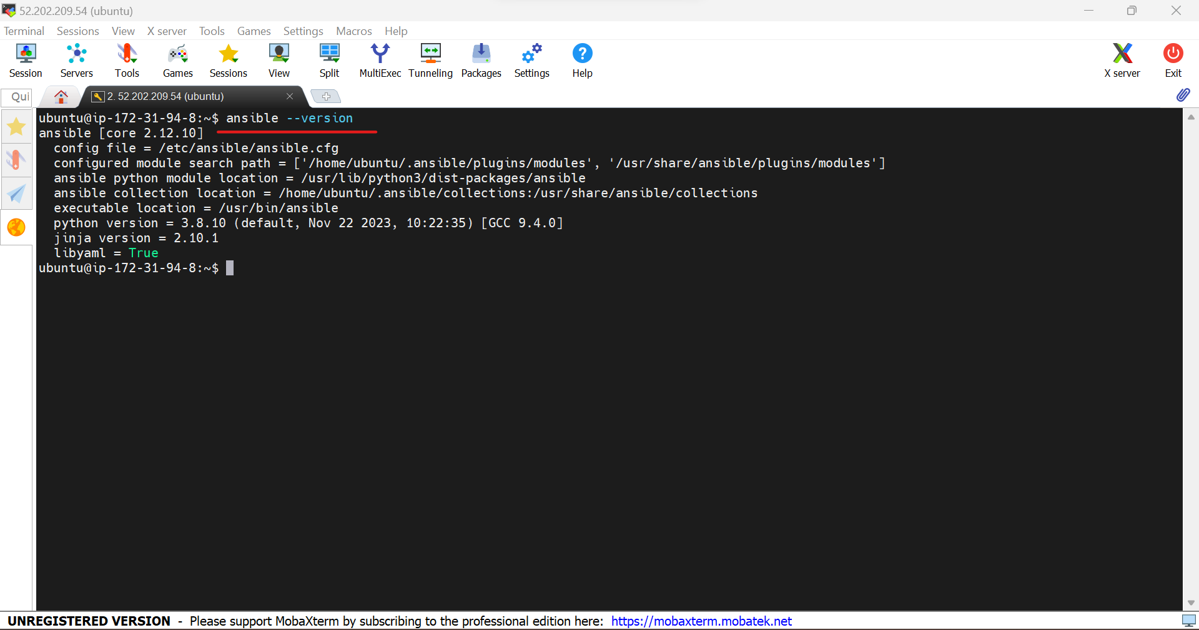

2.Create 2 EC2 instances for production and test environment

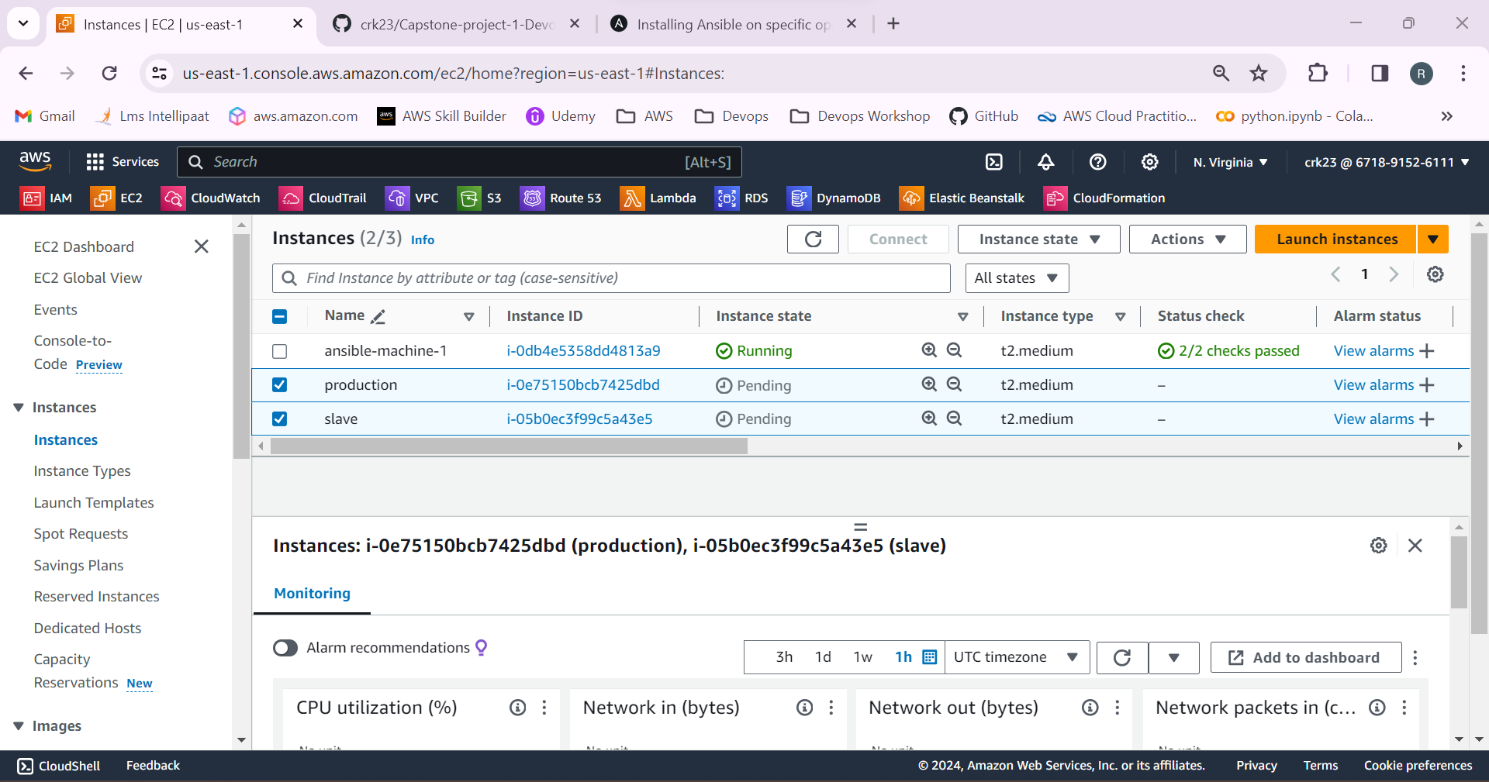

3. In the master server generate the public key by using the command **ssh-keygen.** Go to **.ssh** and copy the key from the **id_rsa.pub.**

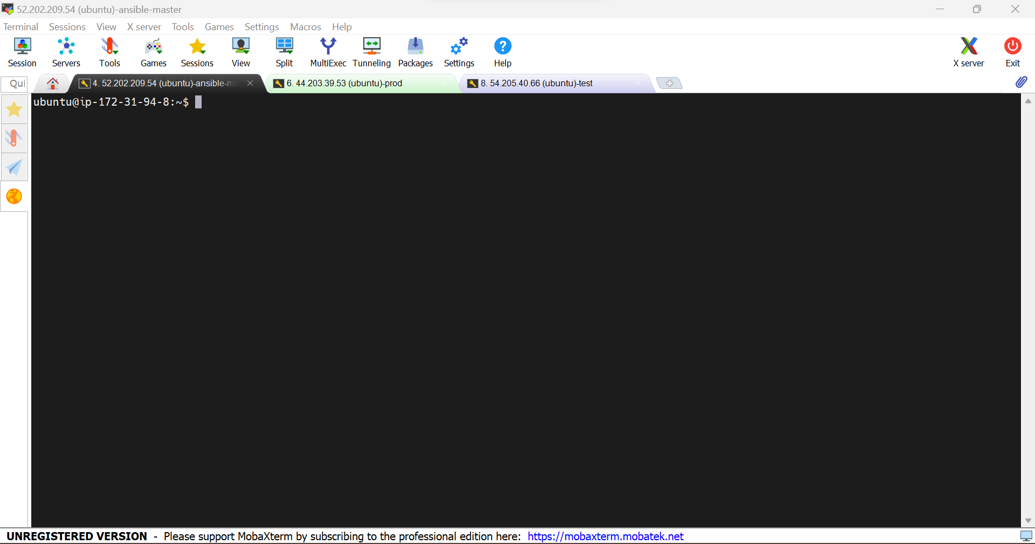

4.Go to the test and production server, go to the **.ssh** path and paste it in the authorized_keys.

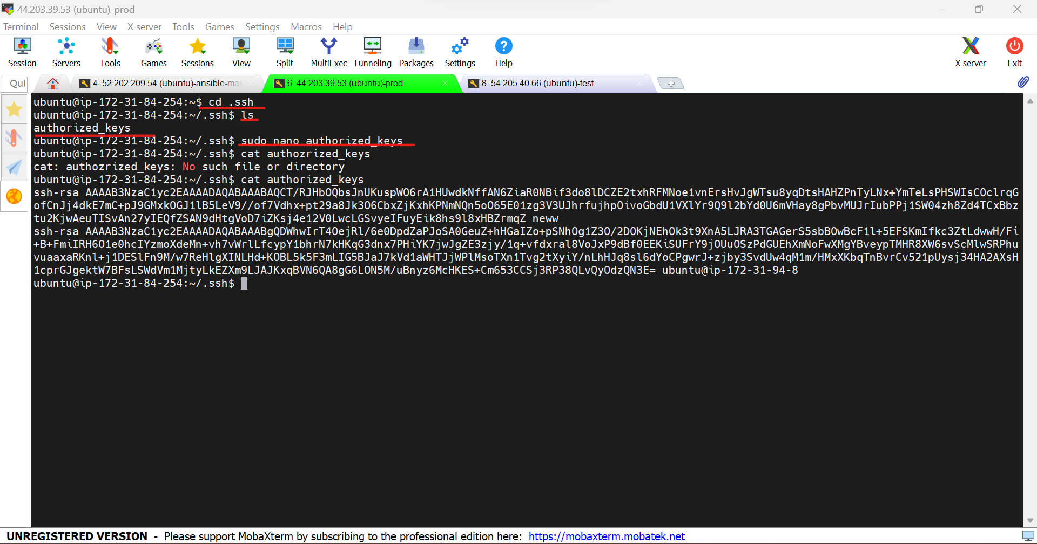

5.In master machine, Go to the path **/etc/ansible/hosts**

And add the production and test ip address as slave.

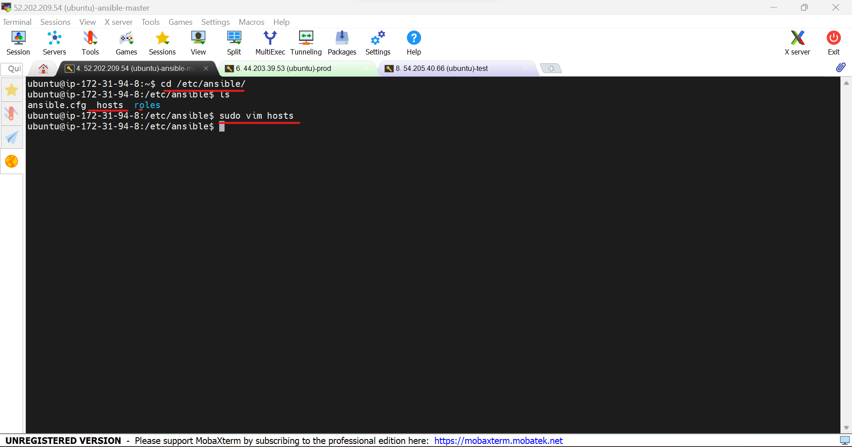

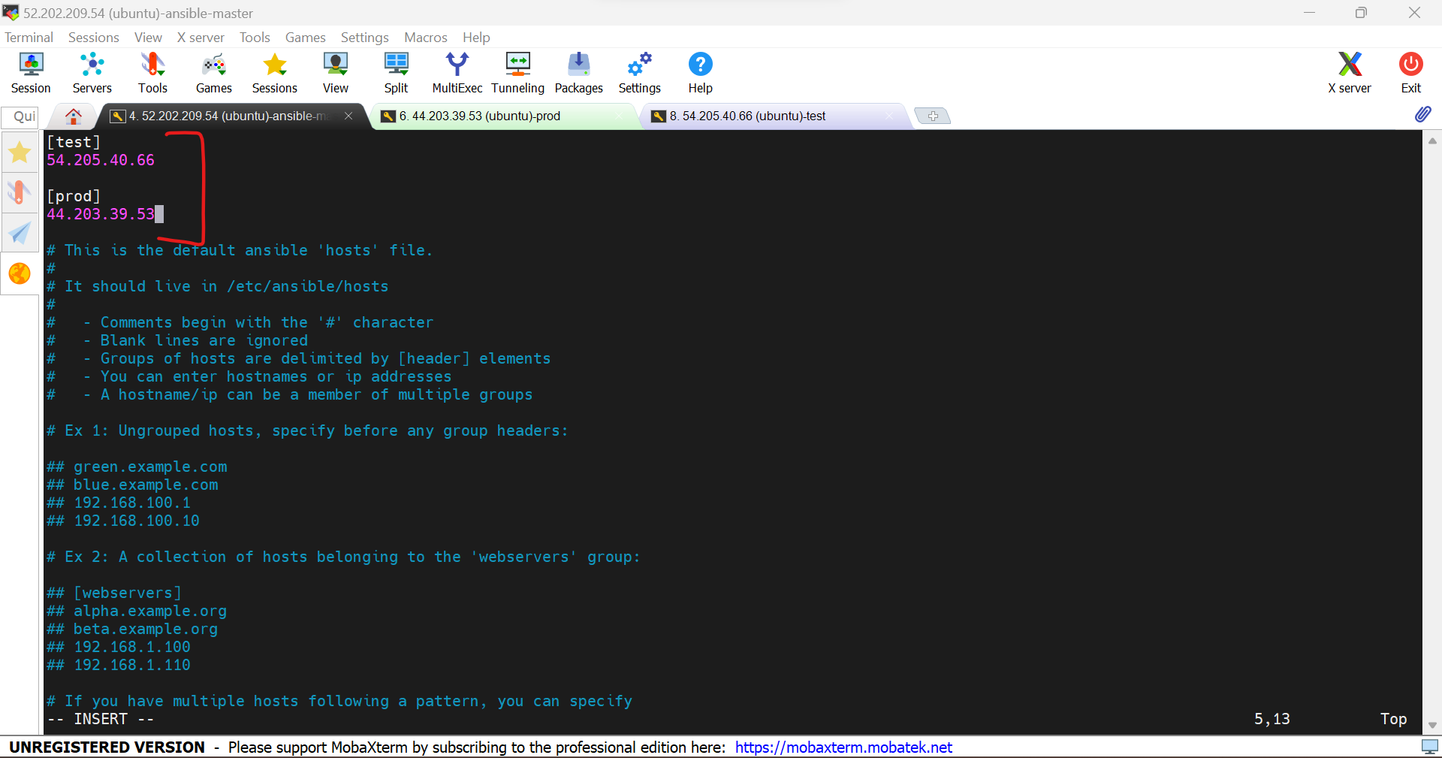

6.Use the command **ansible -m ping all/slave** to check the connection working from the master to test and production.

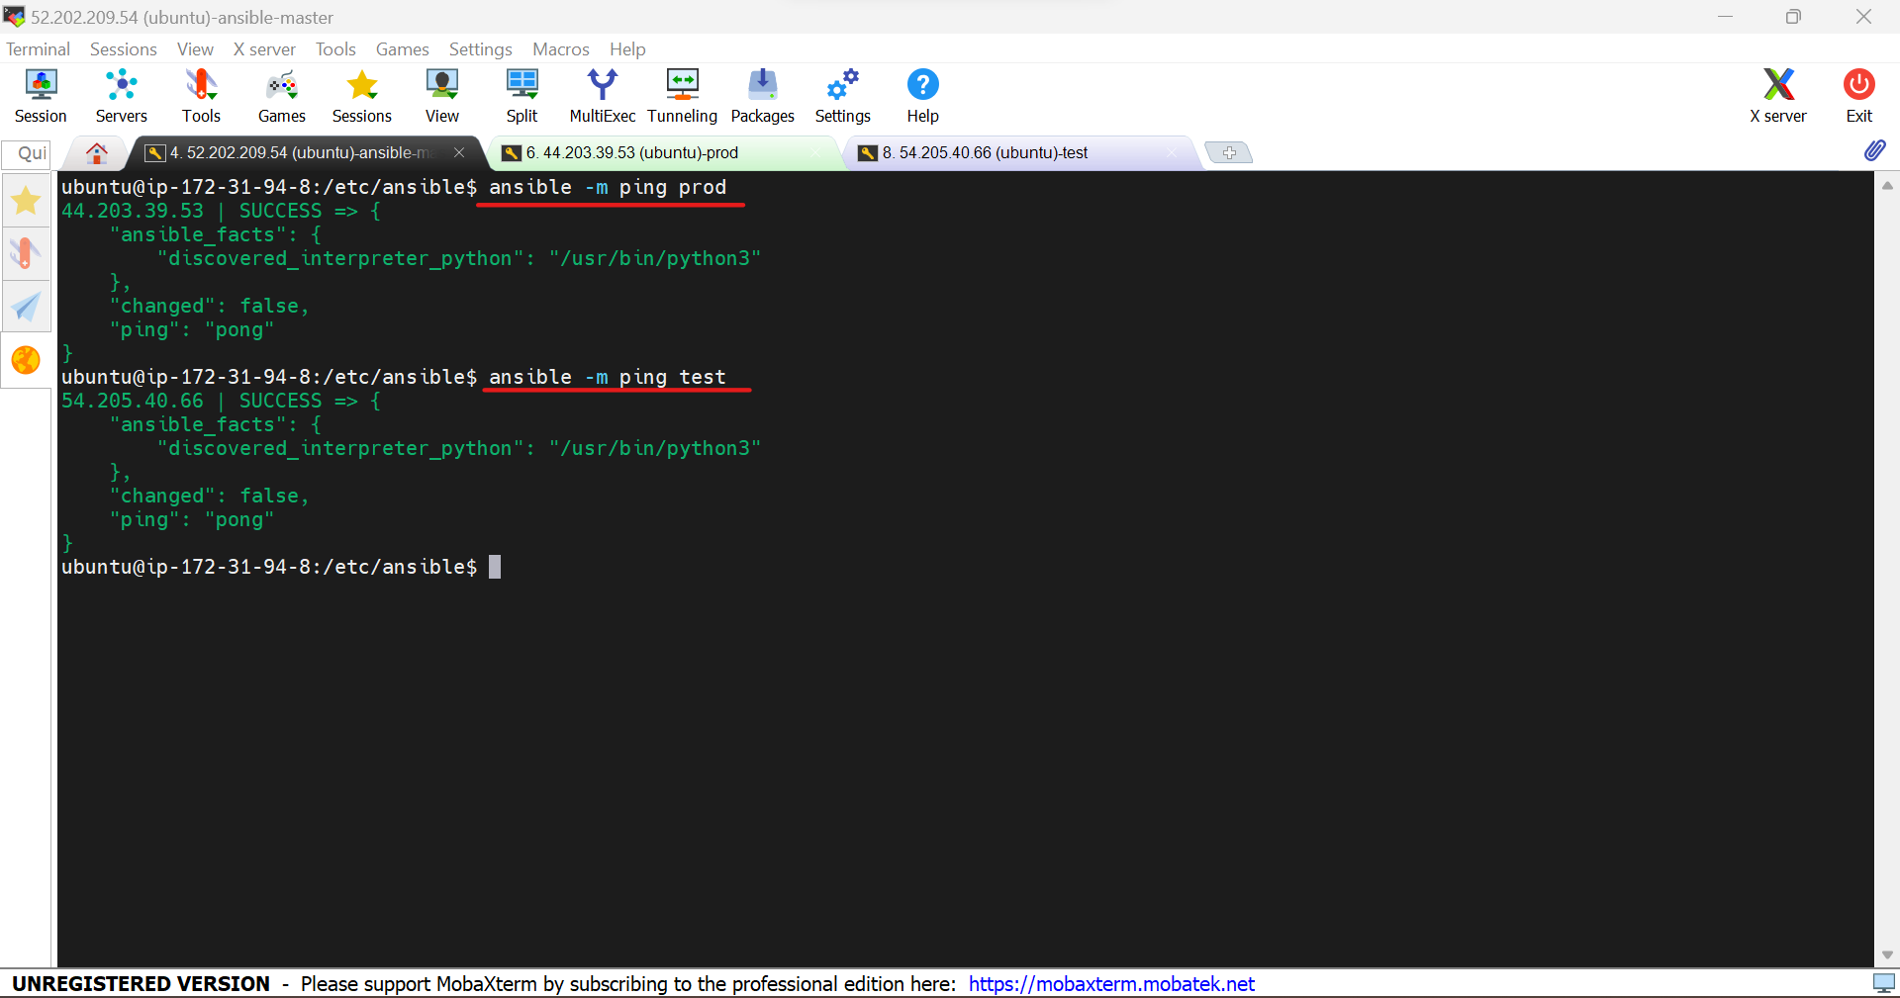

7.Create a yaml file to install Jenkins,java and docker in the test and production machines. It has script file to install java, Jenkins and docker in test machine and script file to install docker and java in production machine

---

- name: Installations on Machine1

hosts: localhost

become: true

tasks:

- name: Installing Jenkins, Java, and Docker

script: master.sh

- name: Installations on Slave2

hosts: slave

become: true

tasks:

- name: Installing Java, and Docker

script: slave.sh

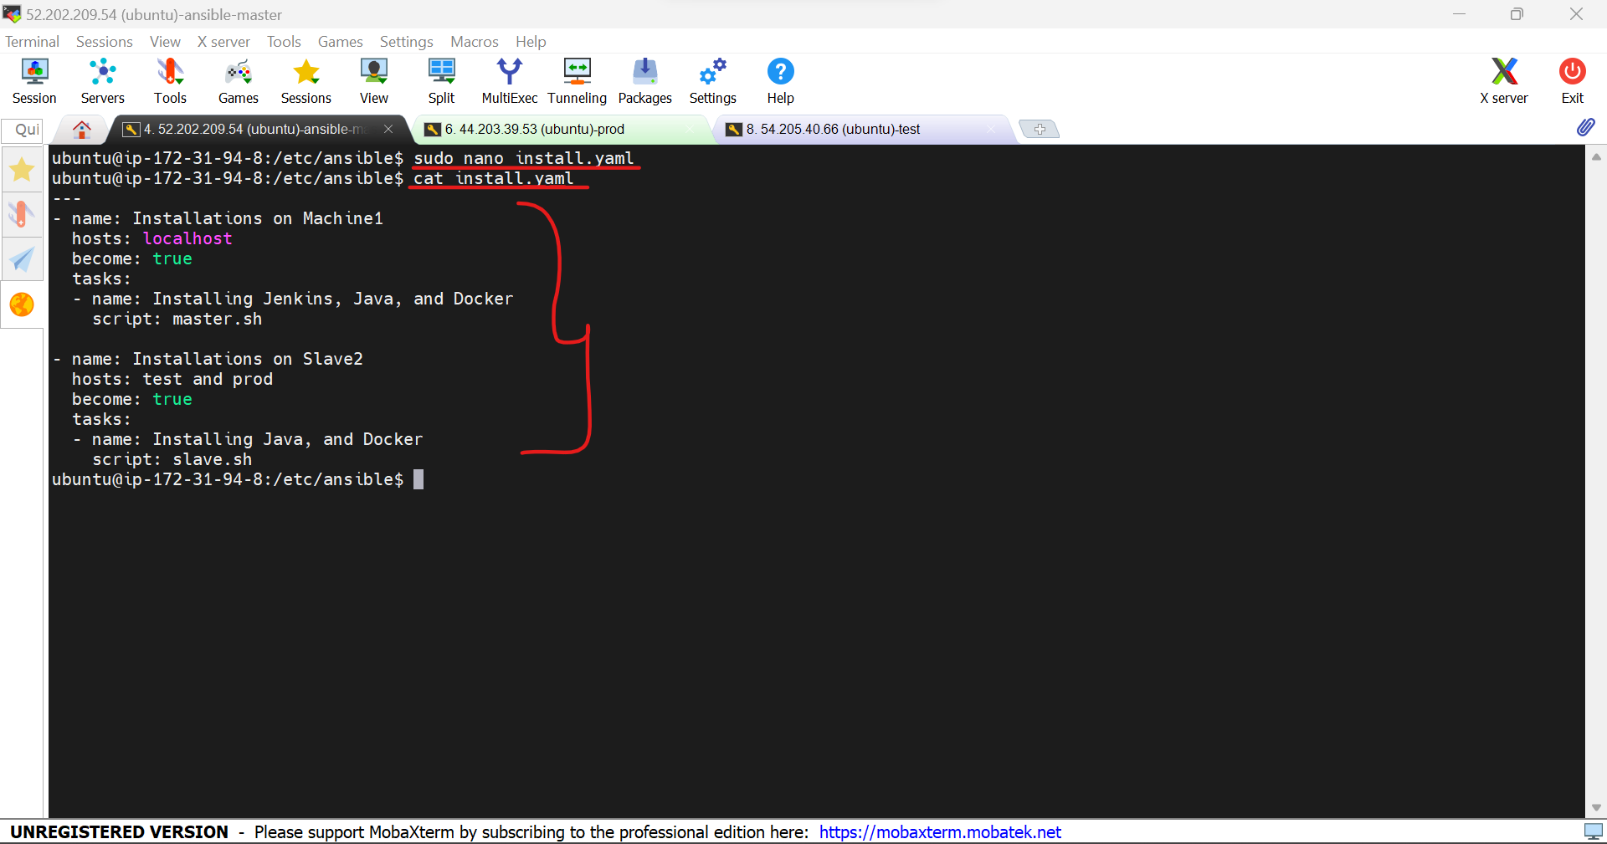

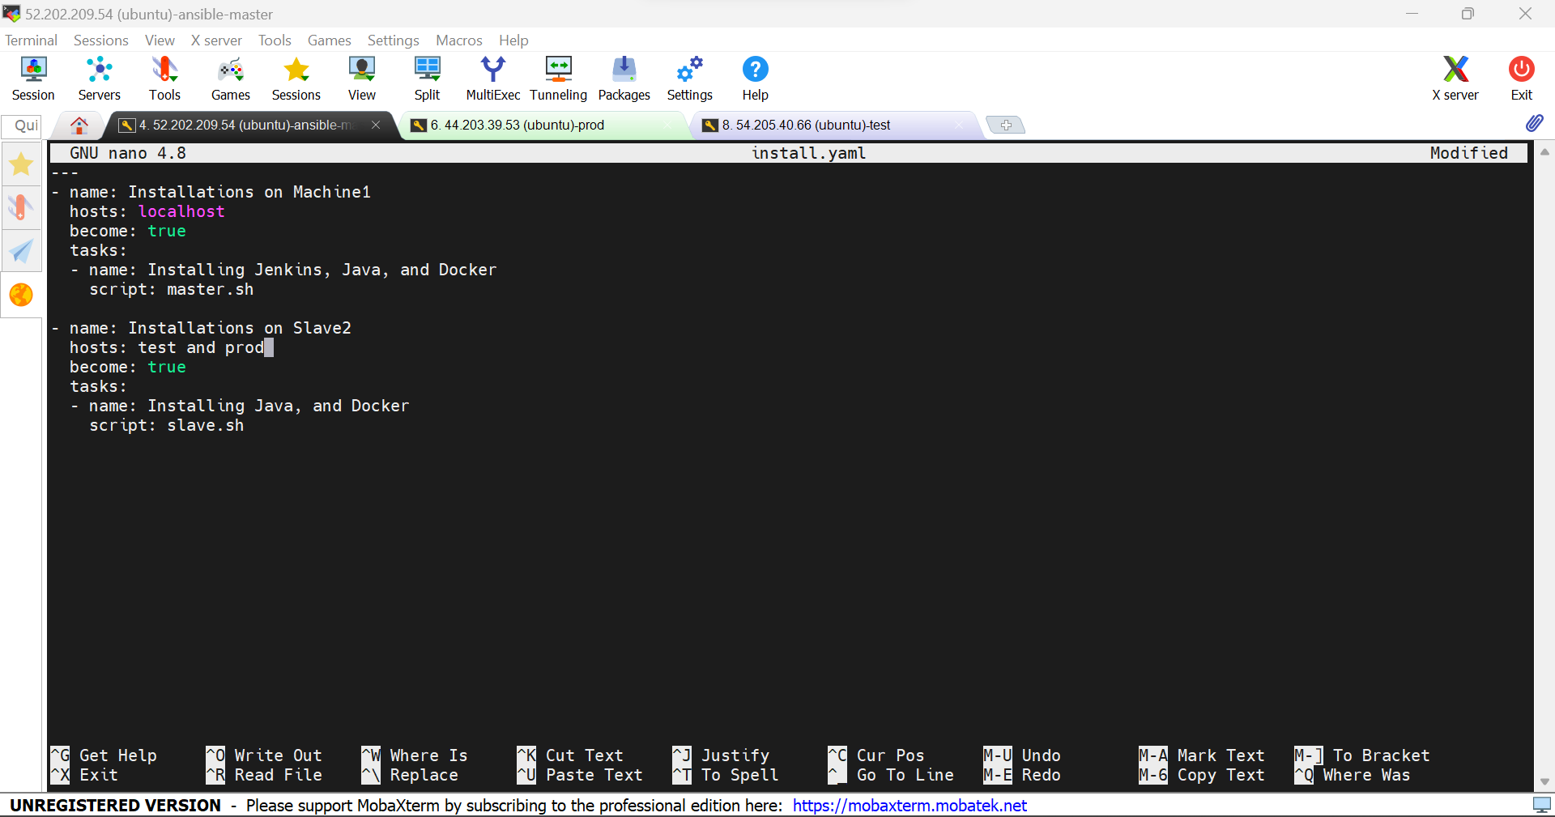

Changed the hosts name from test & prod to slave

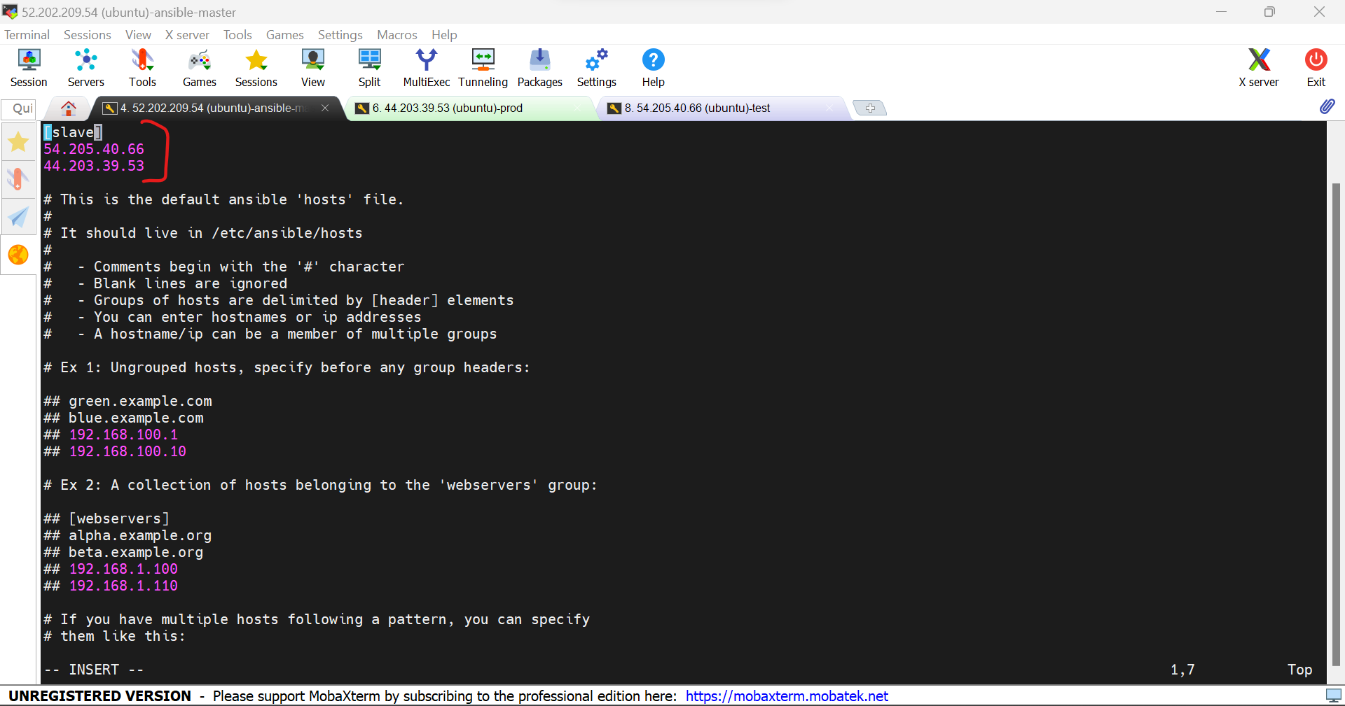

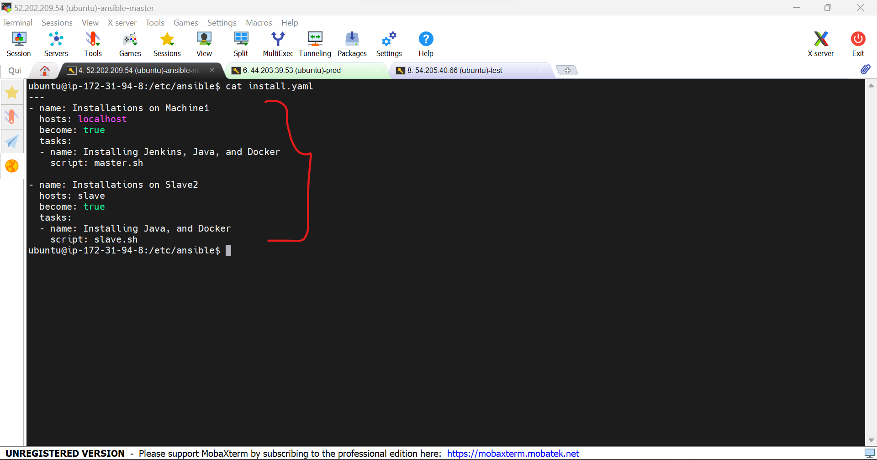

8.create a master.sh file to be included in the yaml file.

sudo apt install docker.io -y

sudo apt install openjdk-11-jdk -y

sudo wget -O /usr/share/keyrings/jenkins-keyring.asc \

https://pkg.jenkins.io/debian-stable/jenkins.io-2023.key

echo deb [signed-by=/usr/share/keyrings/jenkins-keyring.asc] \

https://pkg.jenkins.io/debian-stable binary/ | sudo tee \

/etc/apt/sources.list.d/jenkins.list > /dev/null

sudo apt-get update

sudo apt-get install jenkins -y

9.Create slave.sh file to include in the yaml file

sudo apt install docker.io -y

sudo apt install openjdk-11-jdk -y

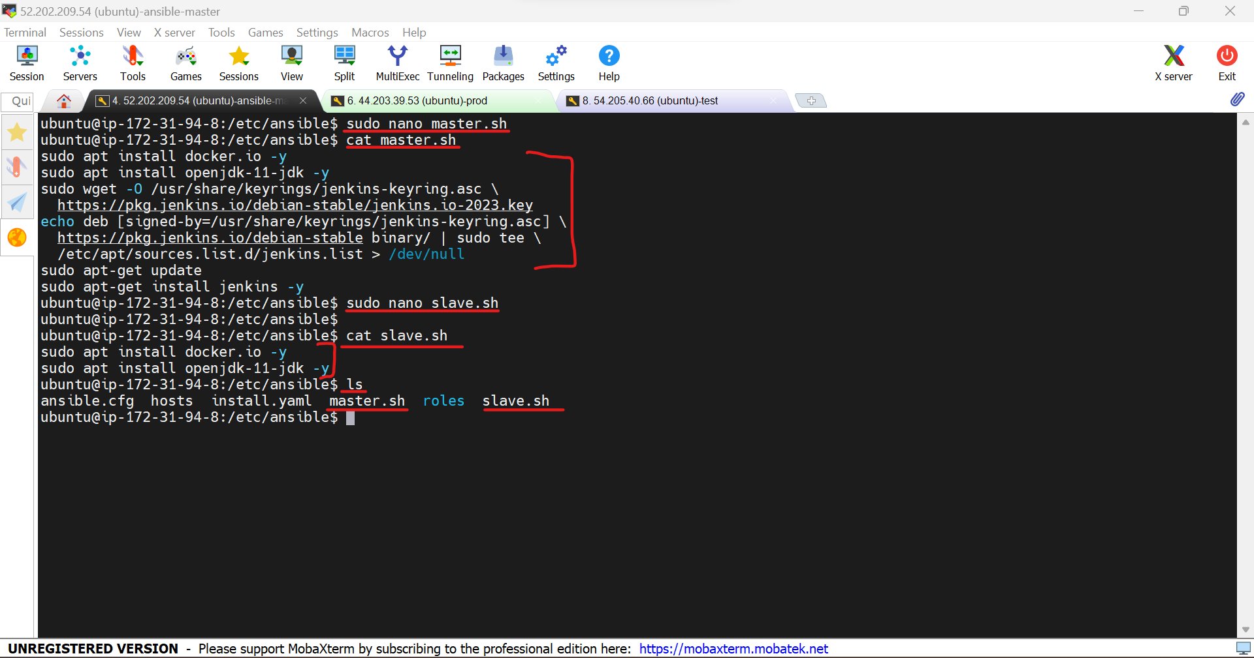

10.Use the command **ansible-playbook “yaml file name”** to execute it in the master, test and production machines.

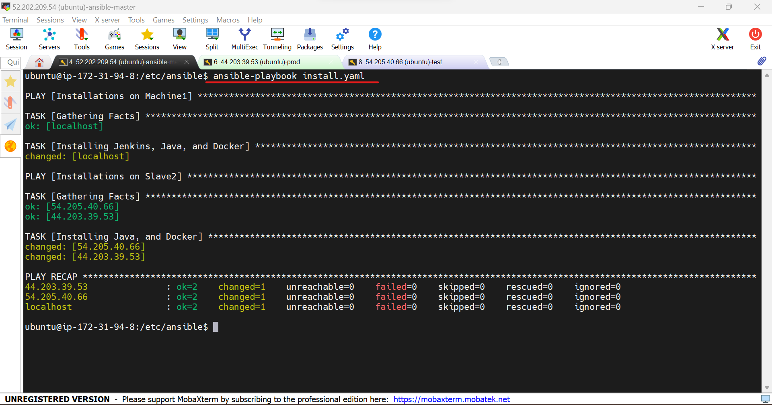

11.Java, docker and Jenkins installed in master.

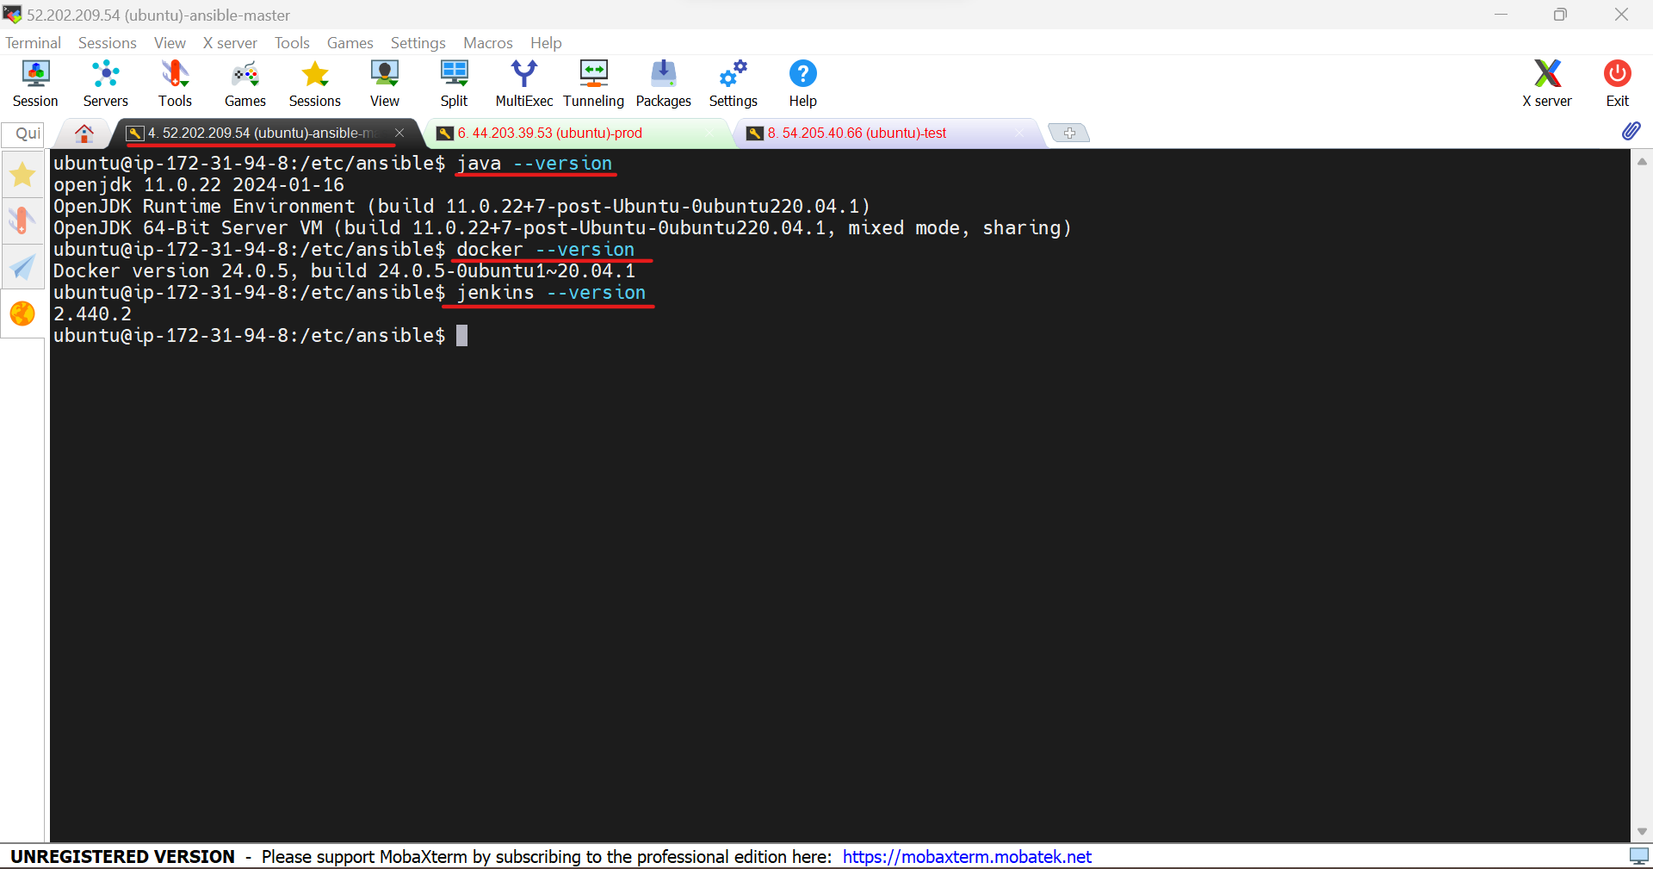

12.Docker and java installed in production machine.

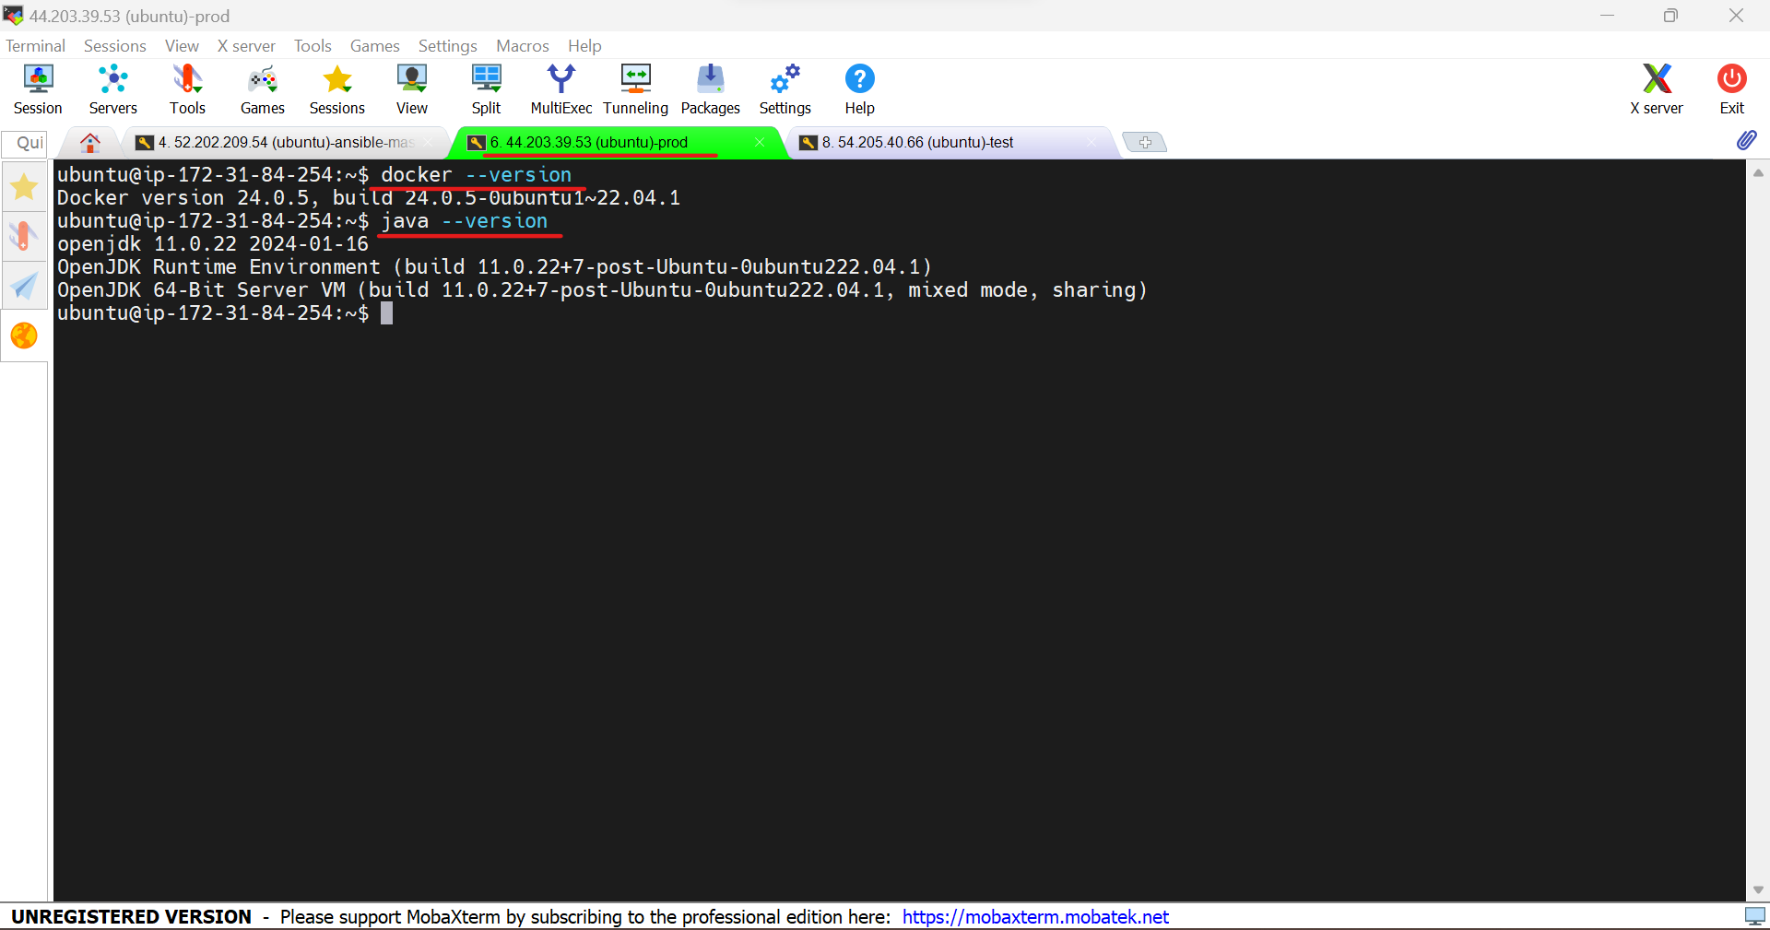

13.Docker and java installed in test machine.

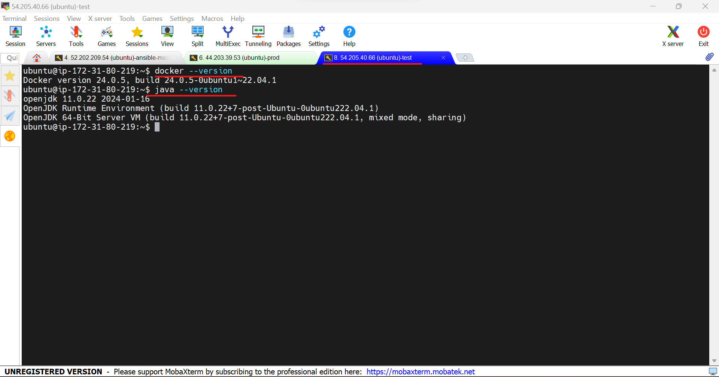

14.Copy the public ip of the master machine and paste in the browser with the port 8080

**52.202.209.54:8080**

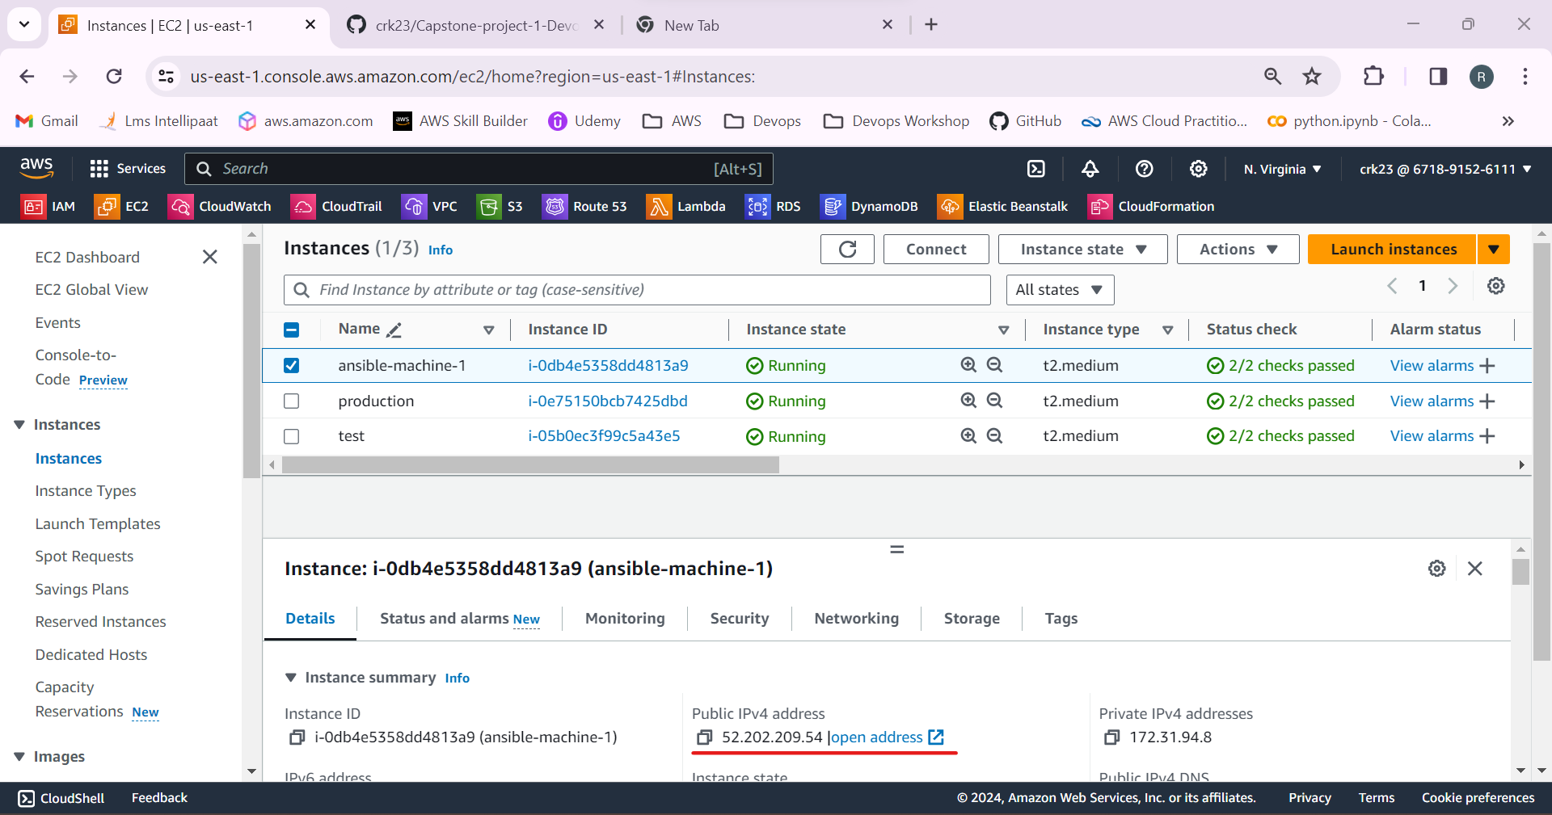

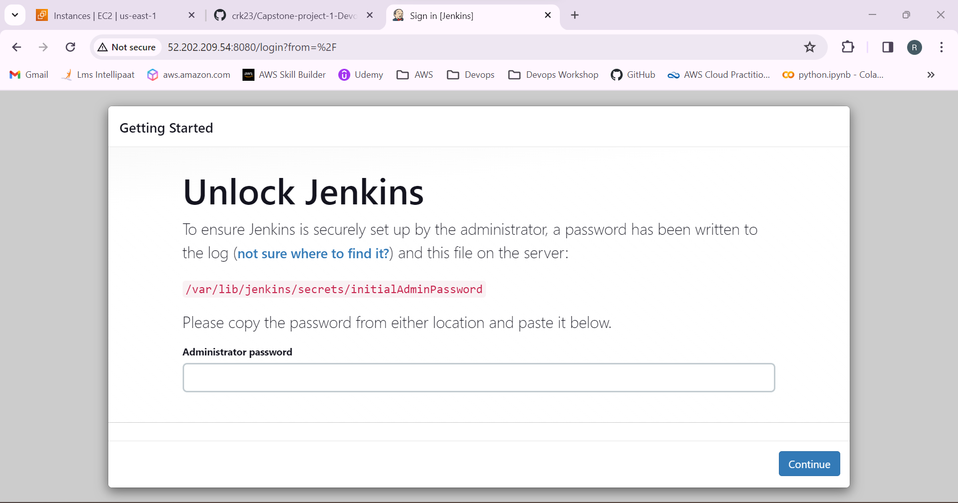

15.Cat to the location mentioned to get the password

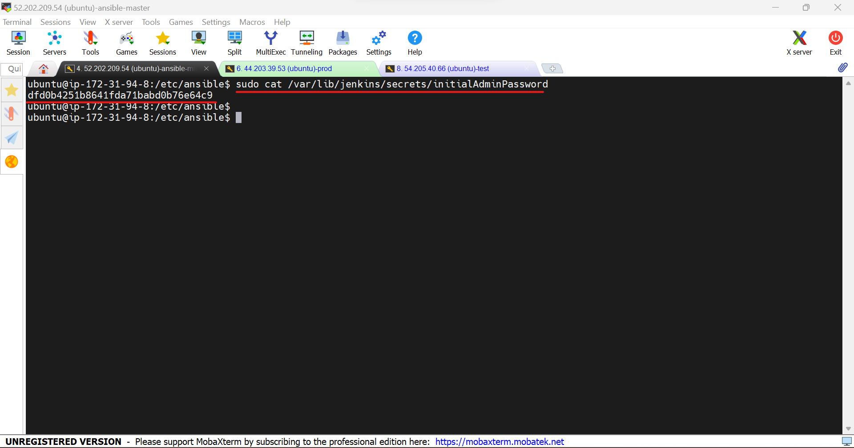

16.Create an Jenkins admin user.

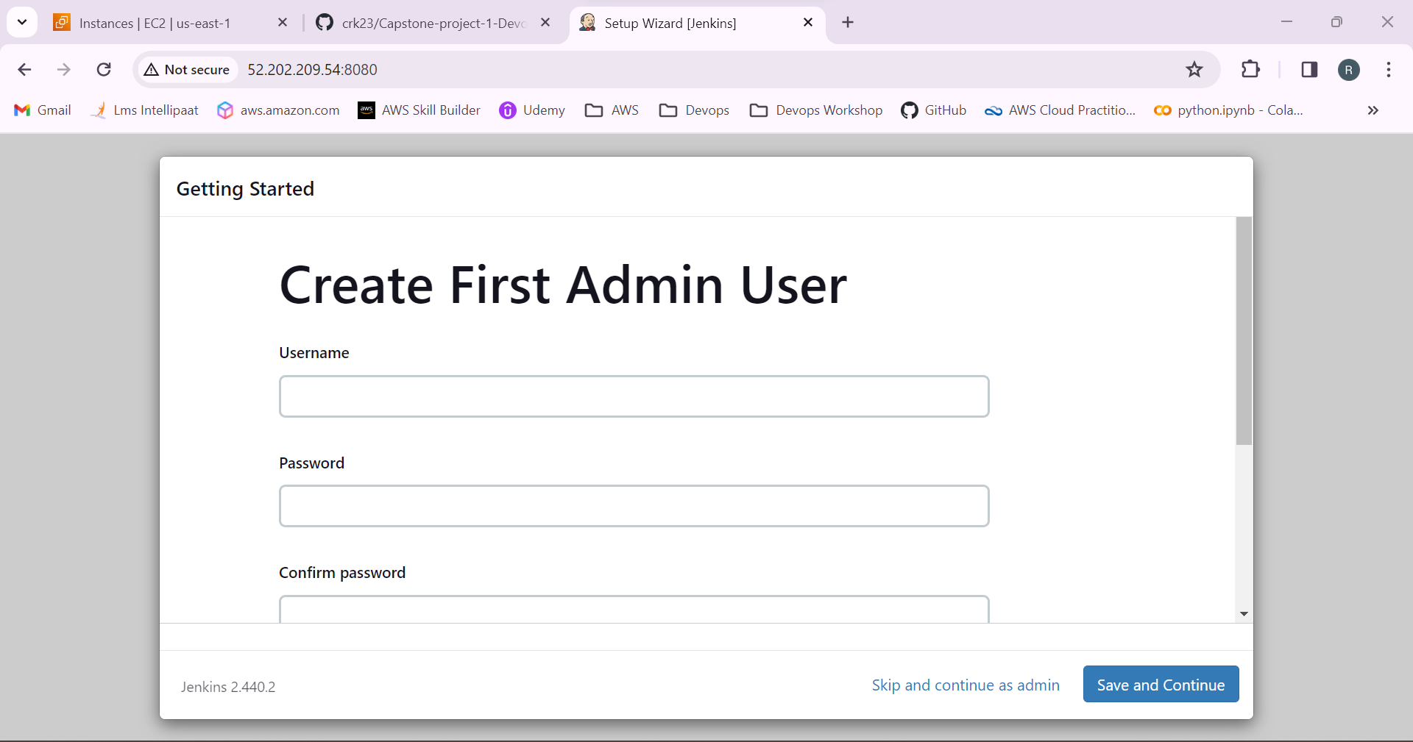

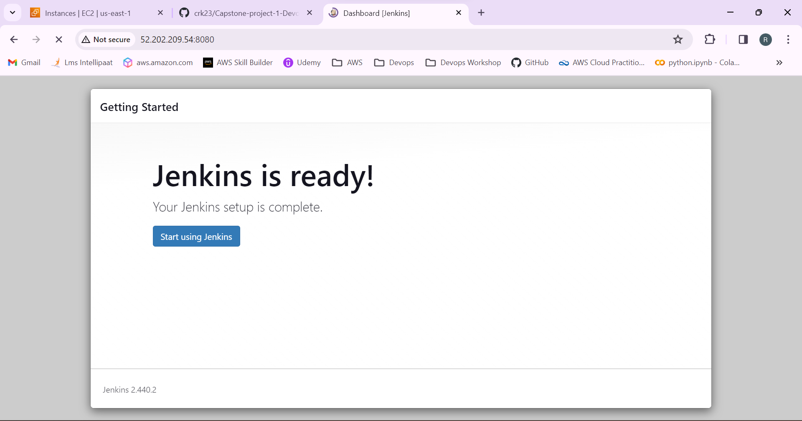

17.Jenkins login successful.

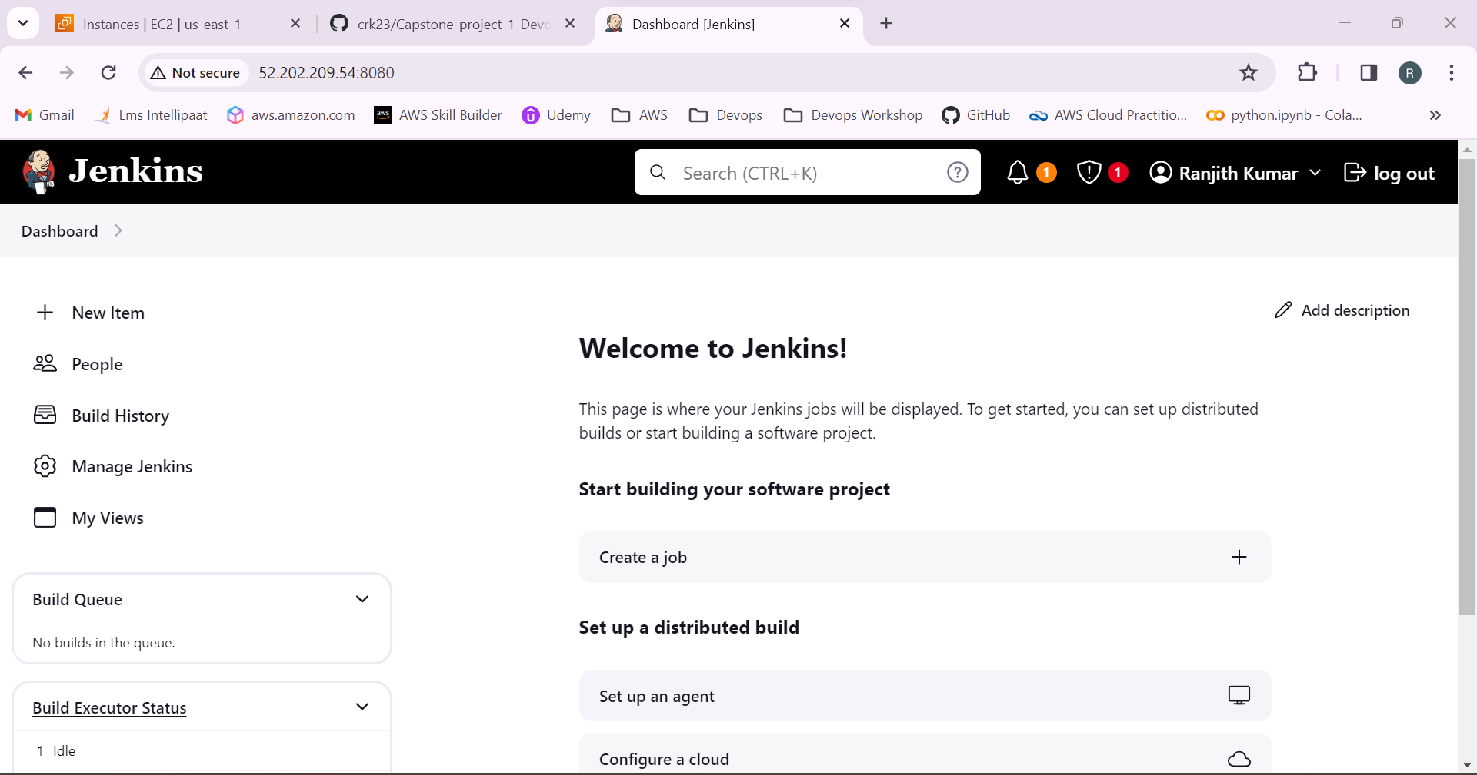

18.Select manage Jenkins to add the test and production nodes.

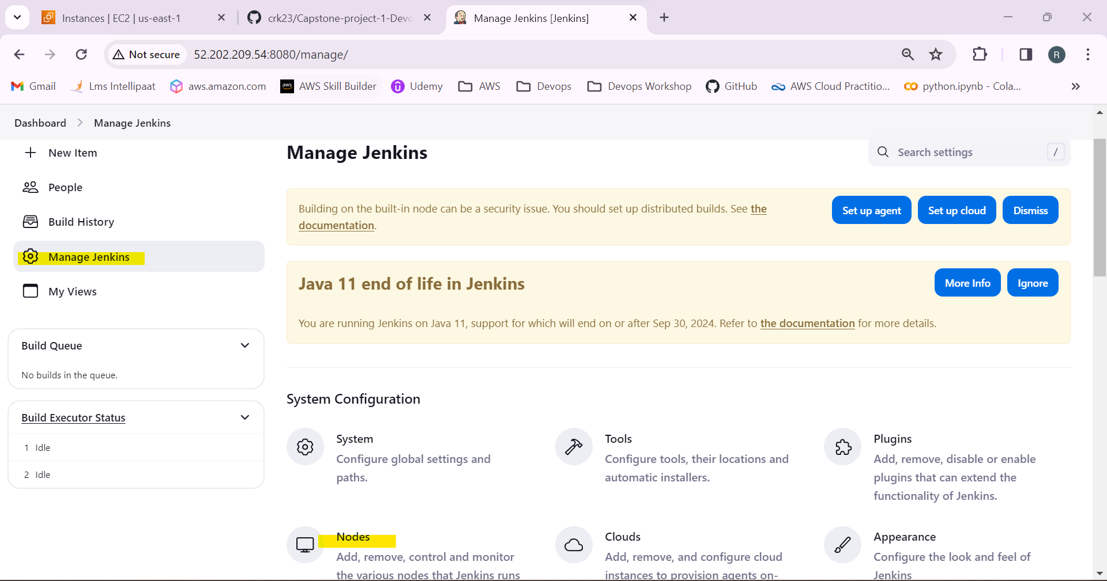

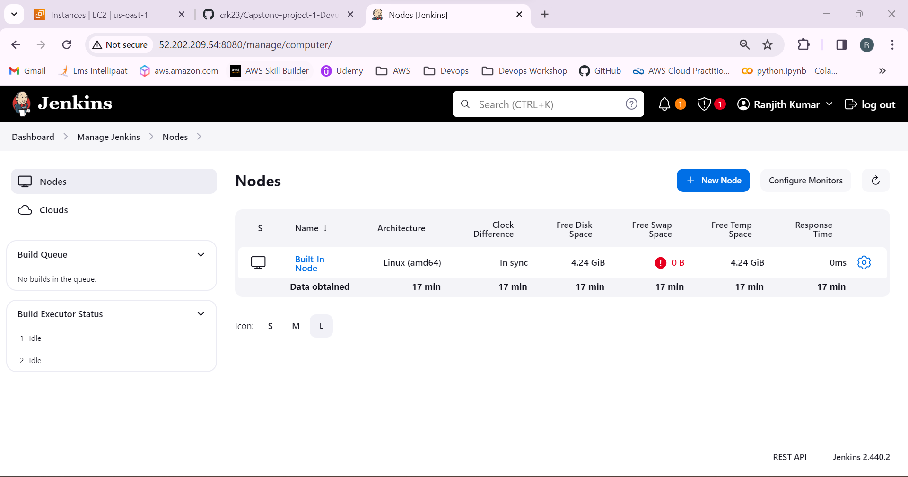

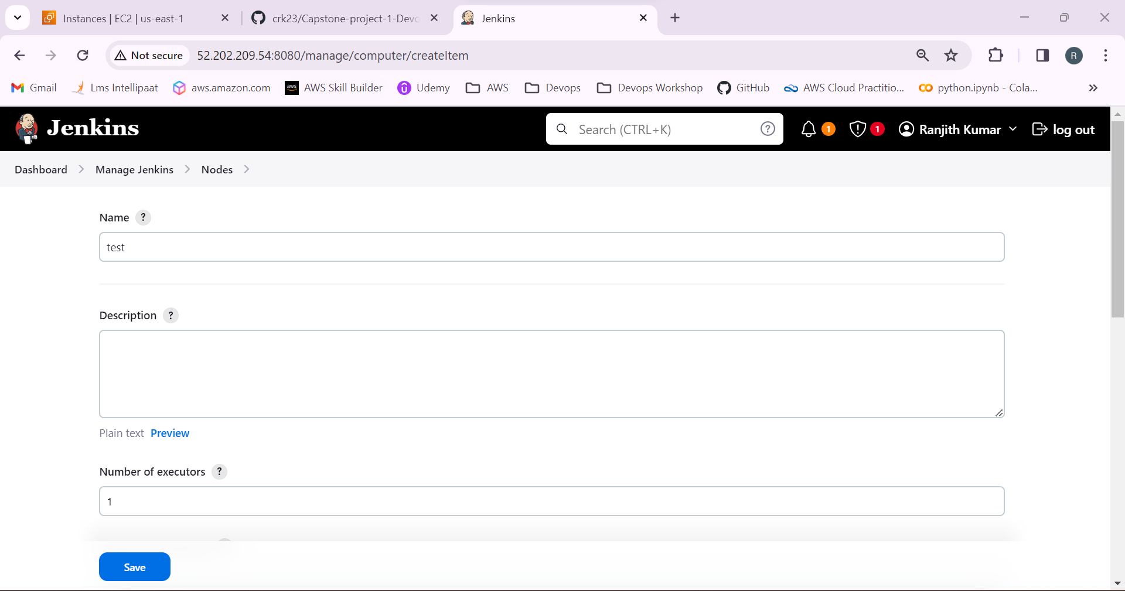

19.Launch method as via SSH

Remote root directory has /home/ubuntu/jenkins

Copy the DNS name of the prod and test machines and paste it in the host

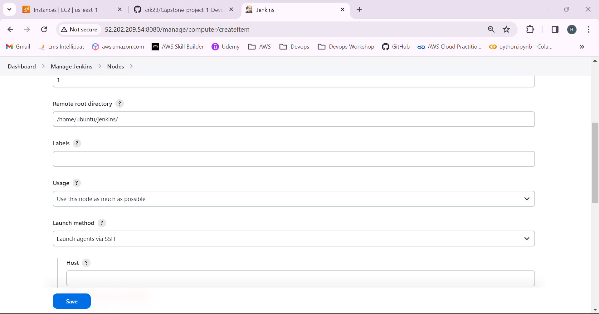

20.Generate the credentials using the pem key

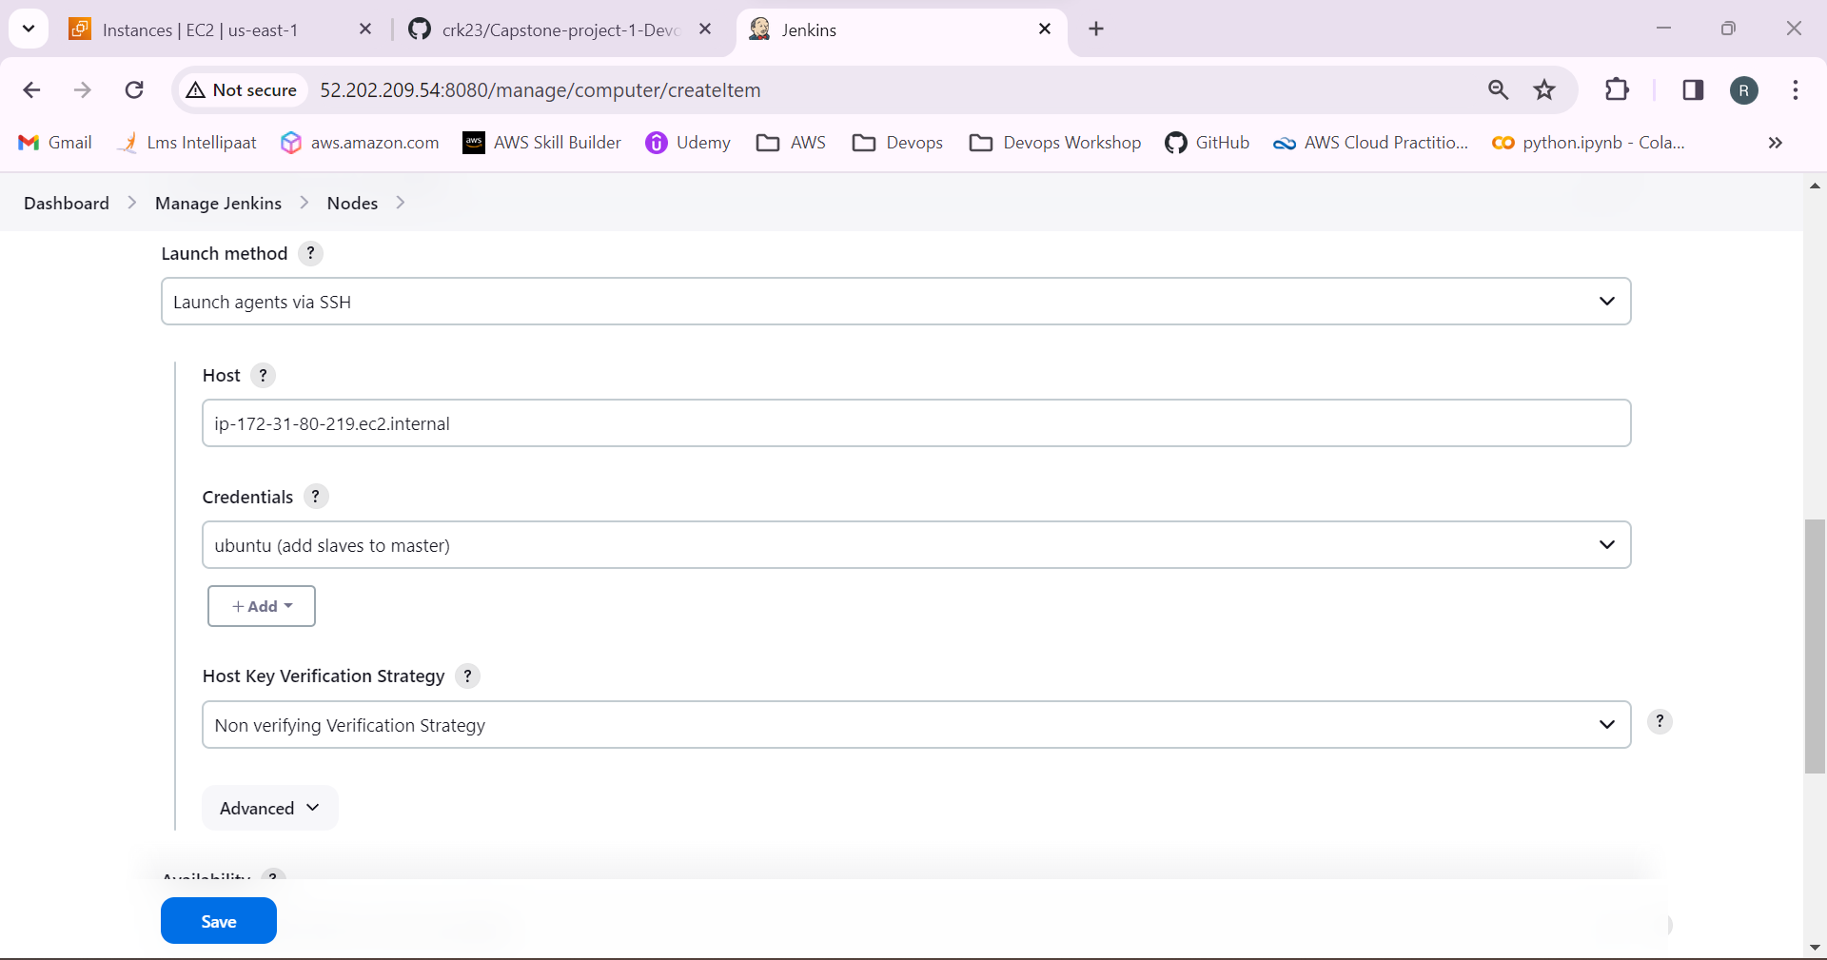

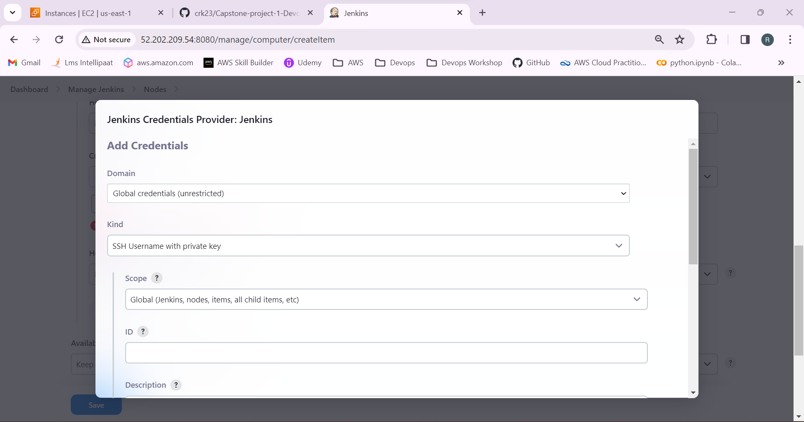

21.Test and production machines added successfully.

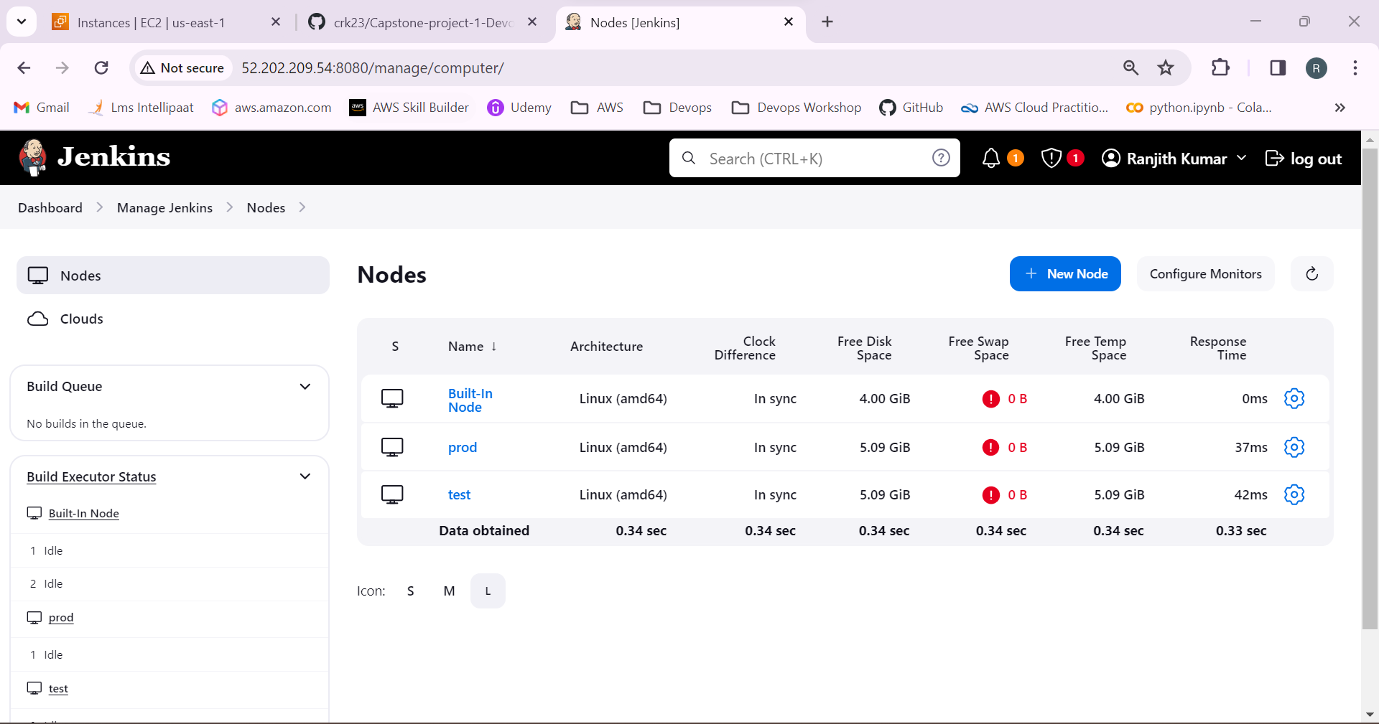

22.Go to the github and copy the repository link.

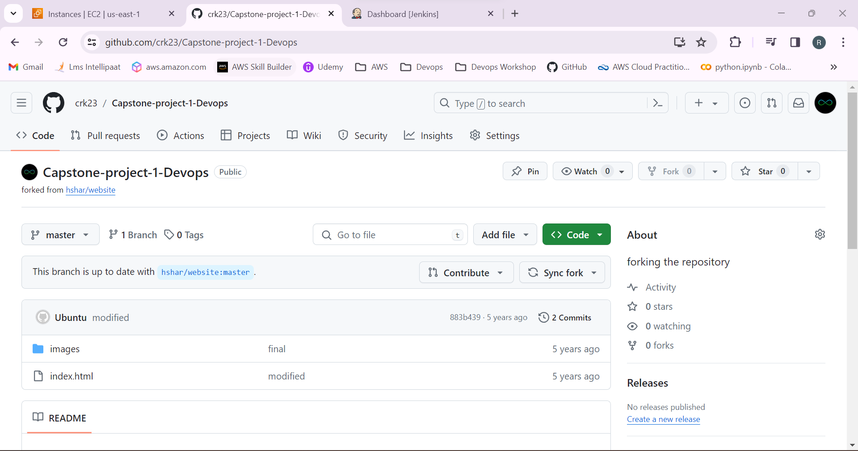

23.Clone the repository to the master by using the command

**Git clone “repository link”**

Now we can see the repository details in the master.

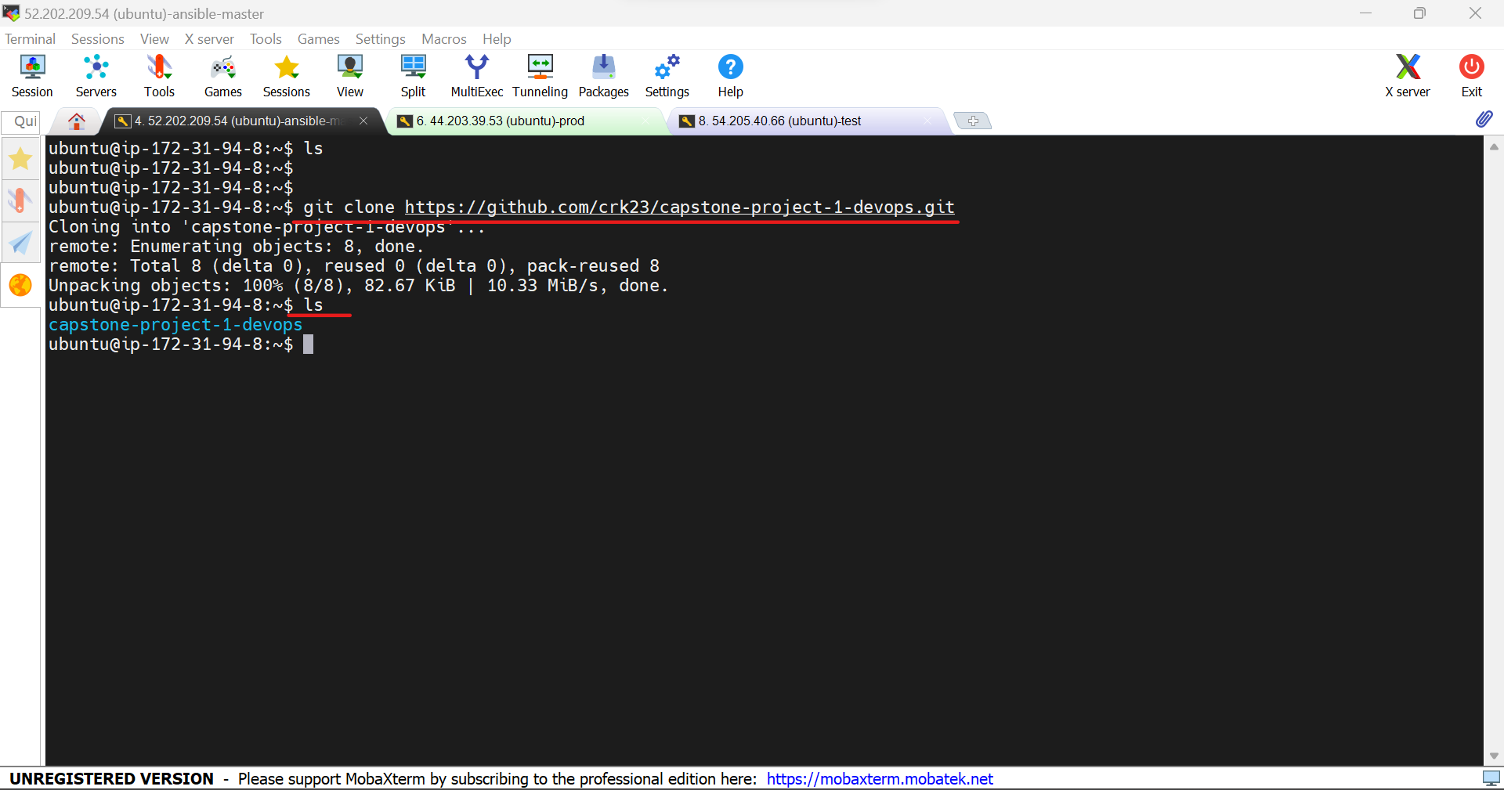

24.Go to the respository and check the branch.

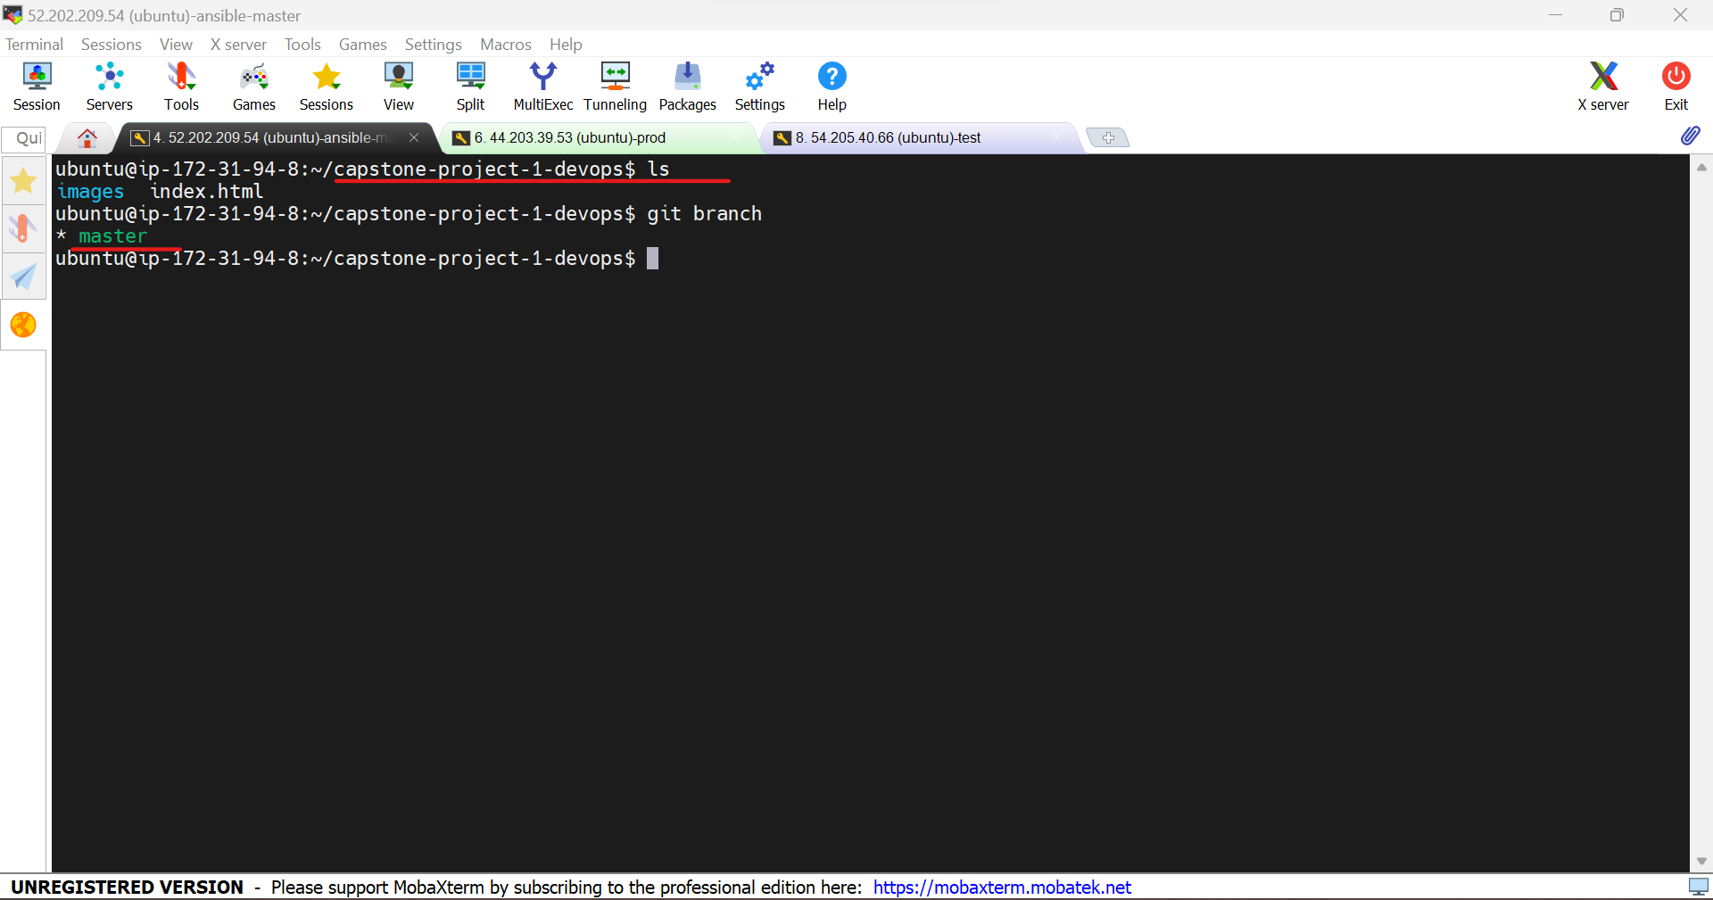

25.Create a Docker file.

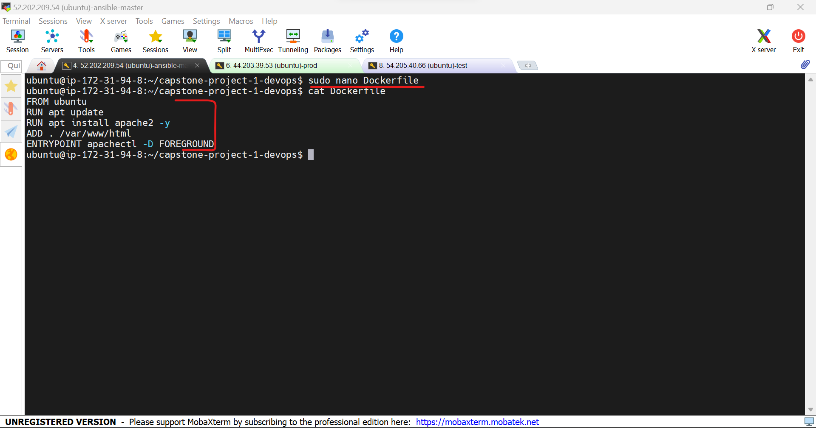

26.Now check the status of git. We need to save the changes.

Use the commands

**Git add .**

**Git commit -m “any message”**

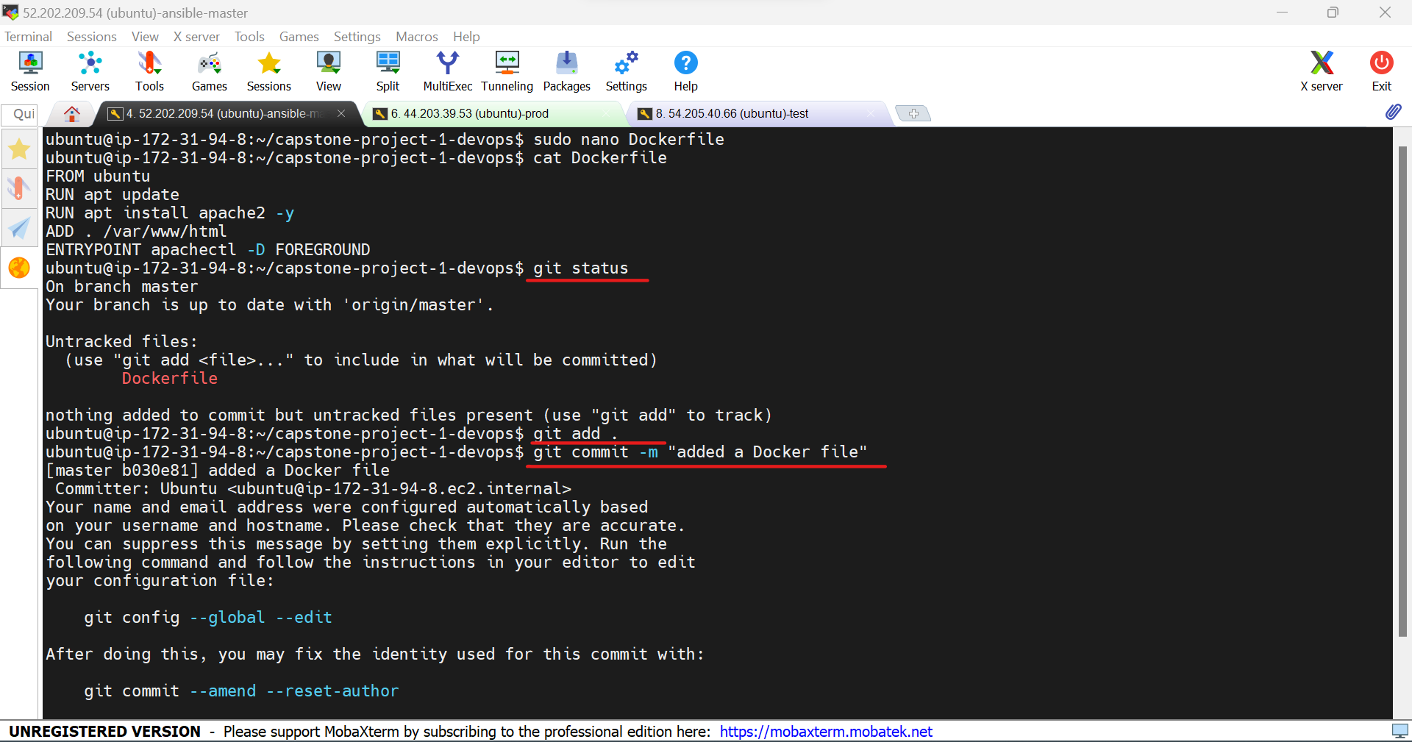

27.Create a develop branch and go to the develop branch by using the commands

**Git branch develop**

**Git checkout develop**

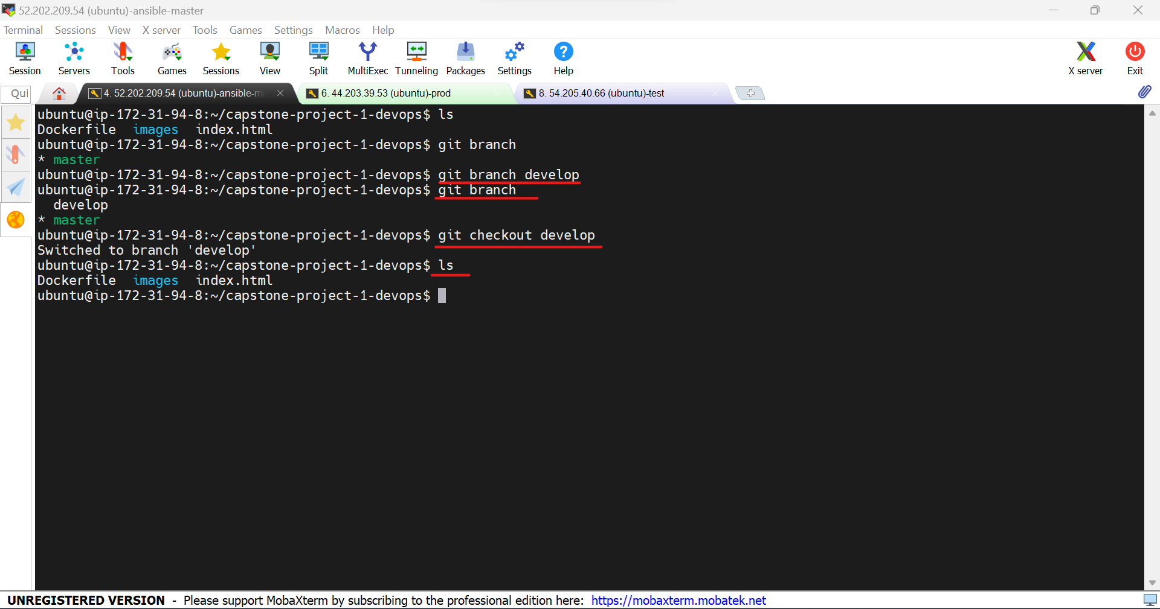

28.Create job1 in Jenkins.

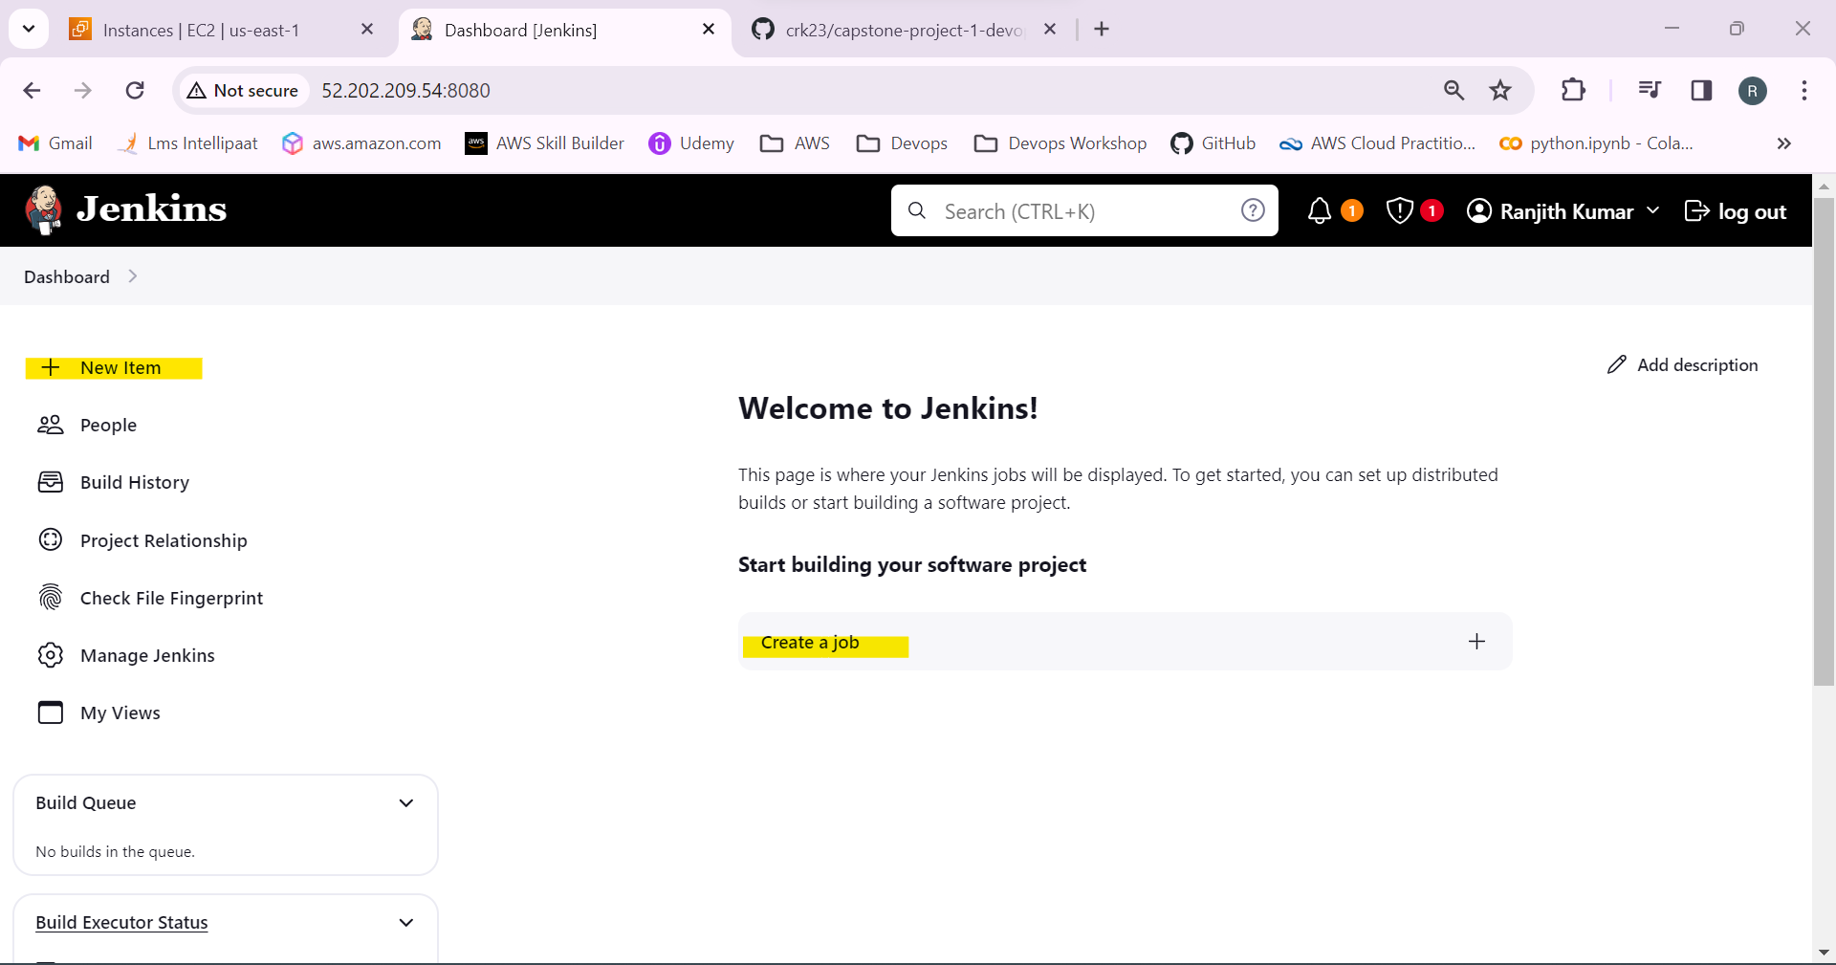

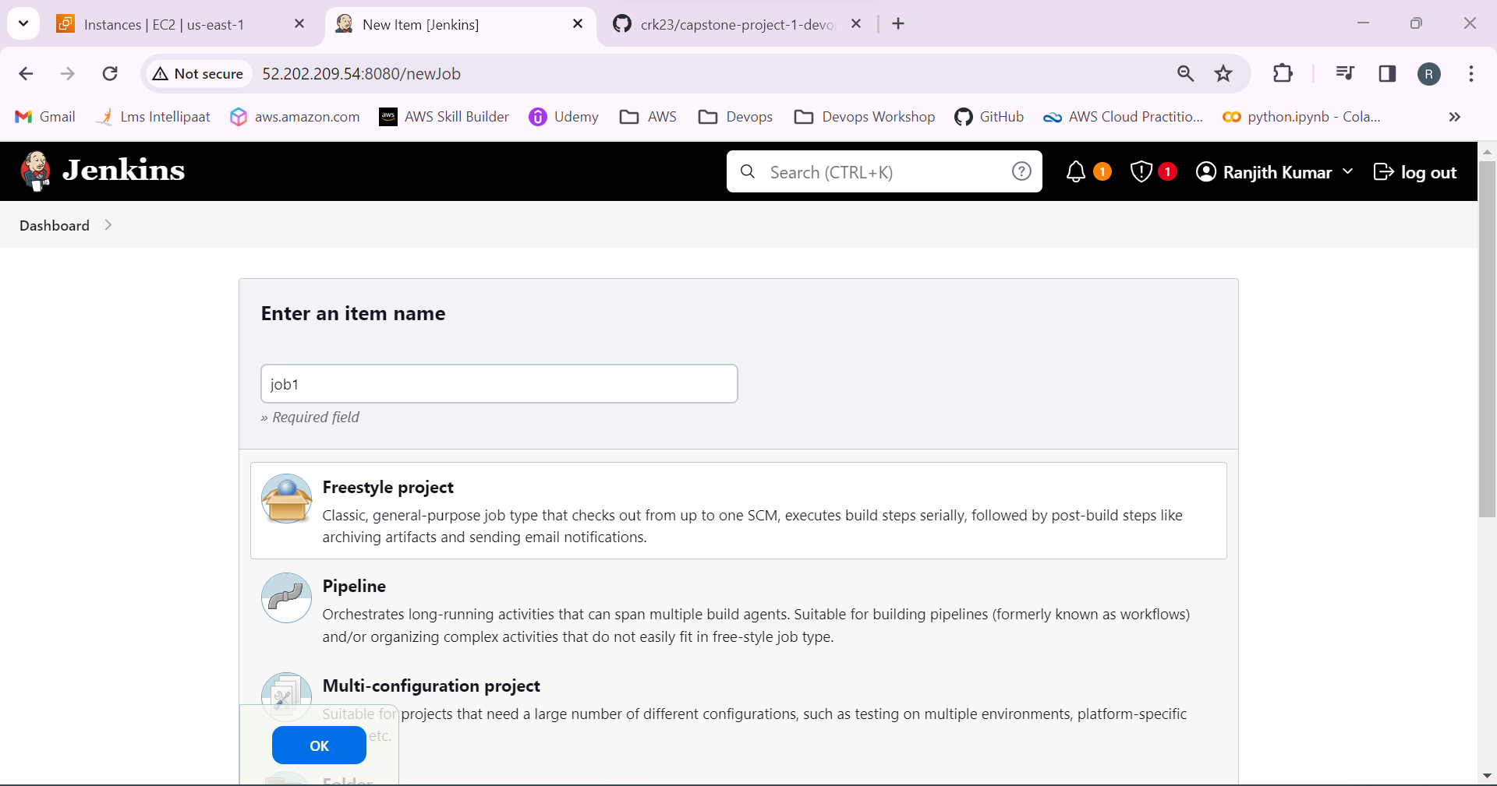

29.Copy the link of the github repository and paste in github project and source code management.

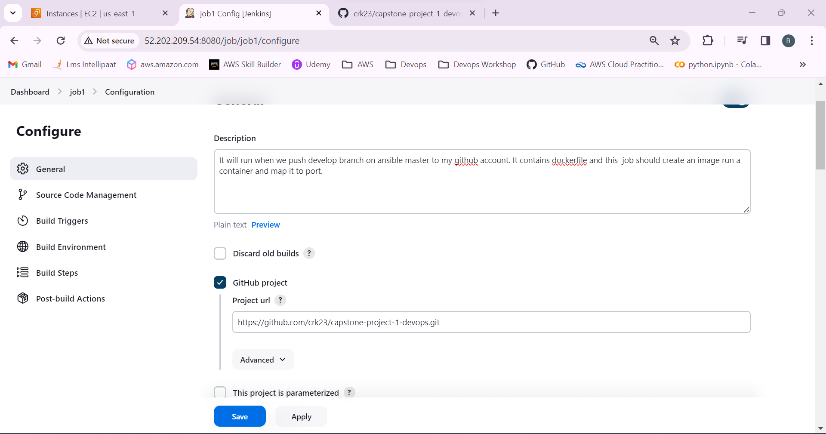

30.Select test in restrict where the project can be run to run the project in the test node.

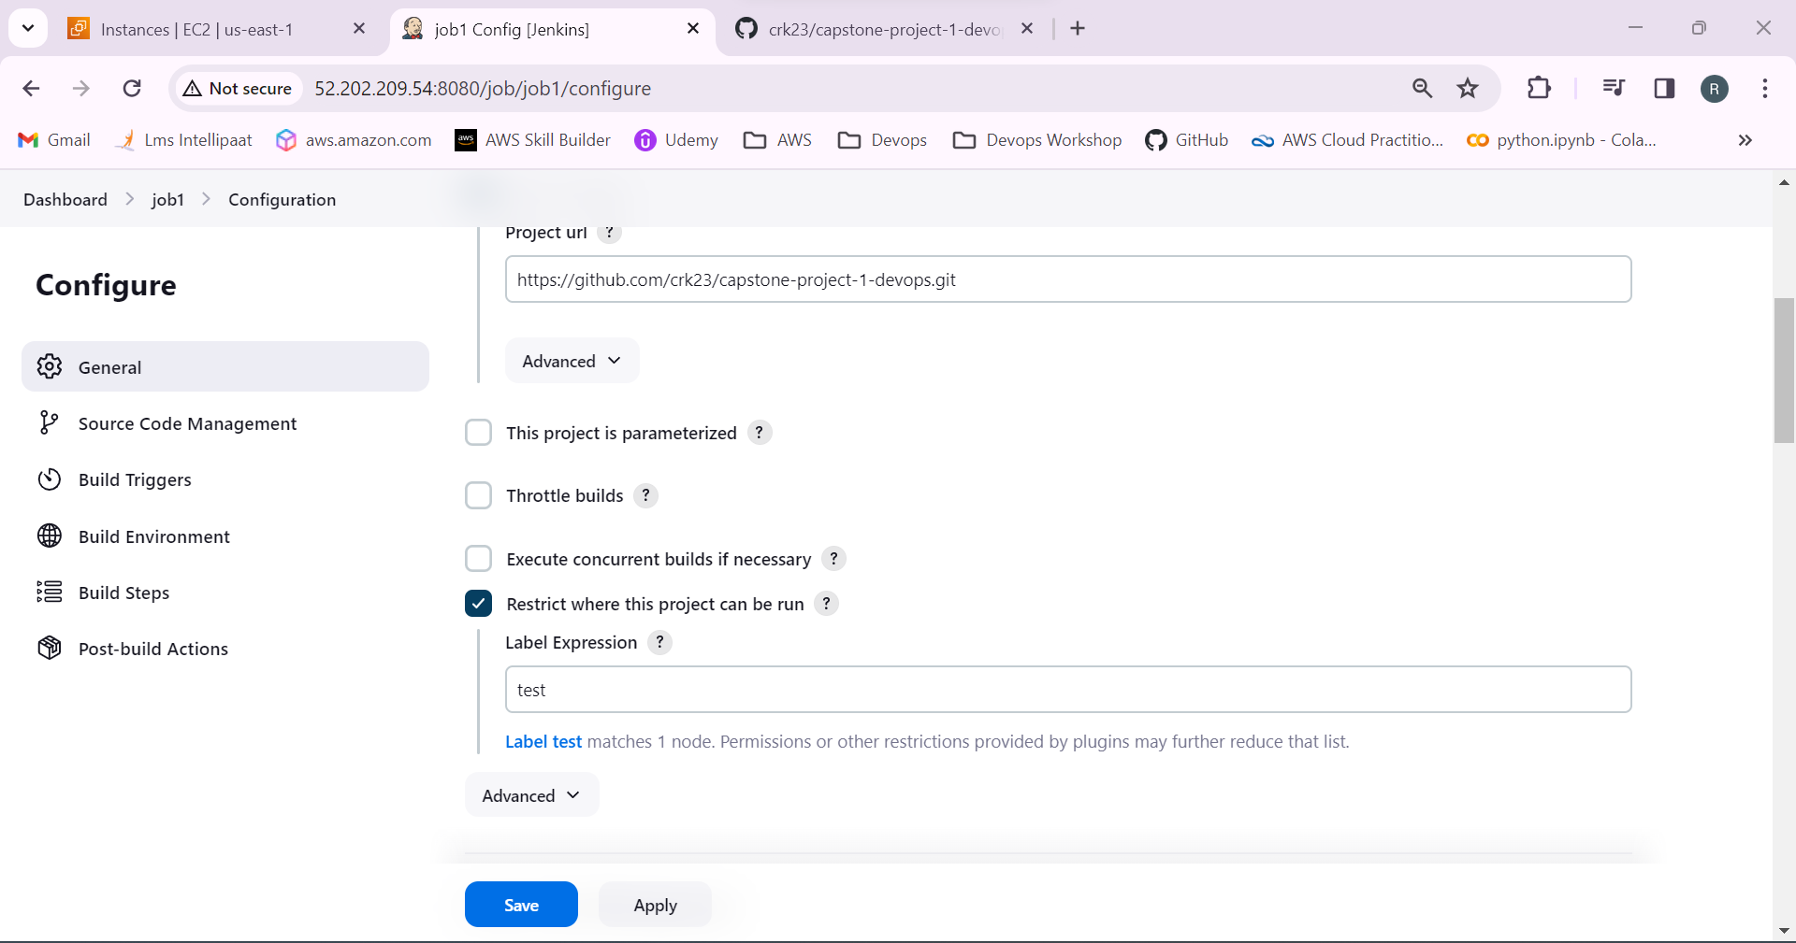

32.Select the branches to build as develop.

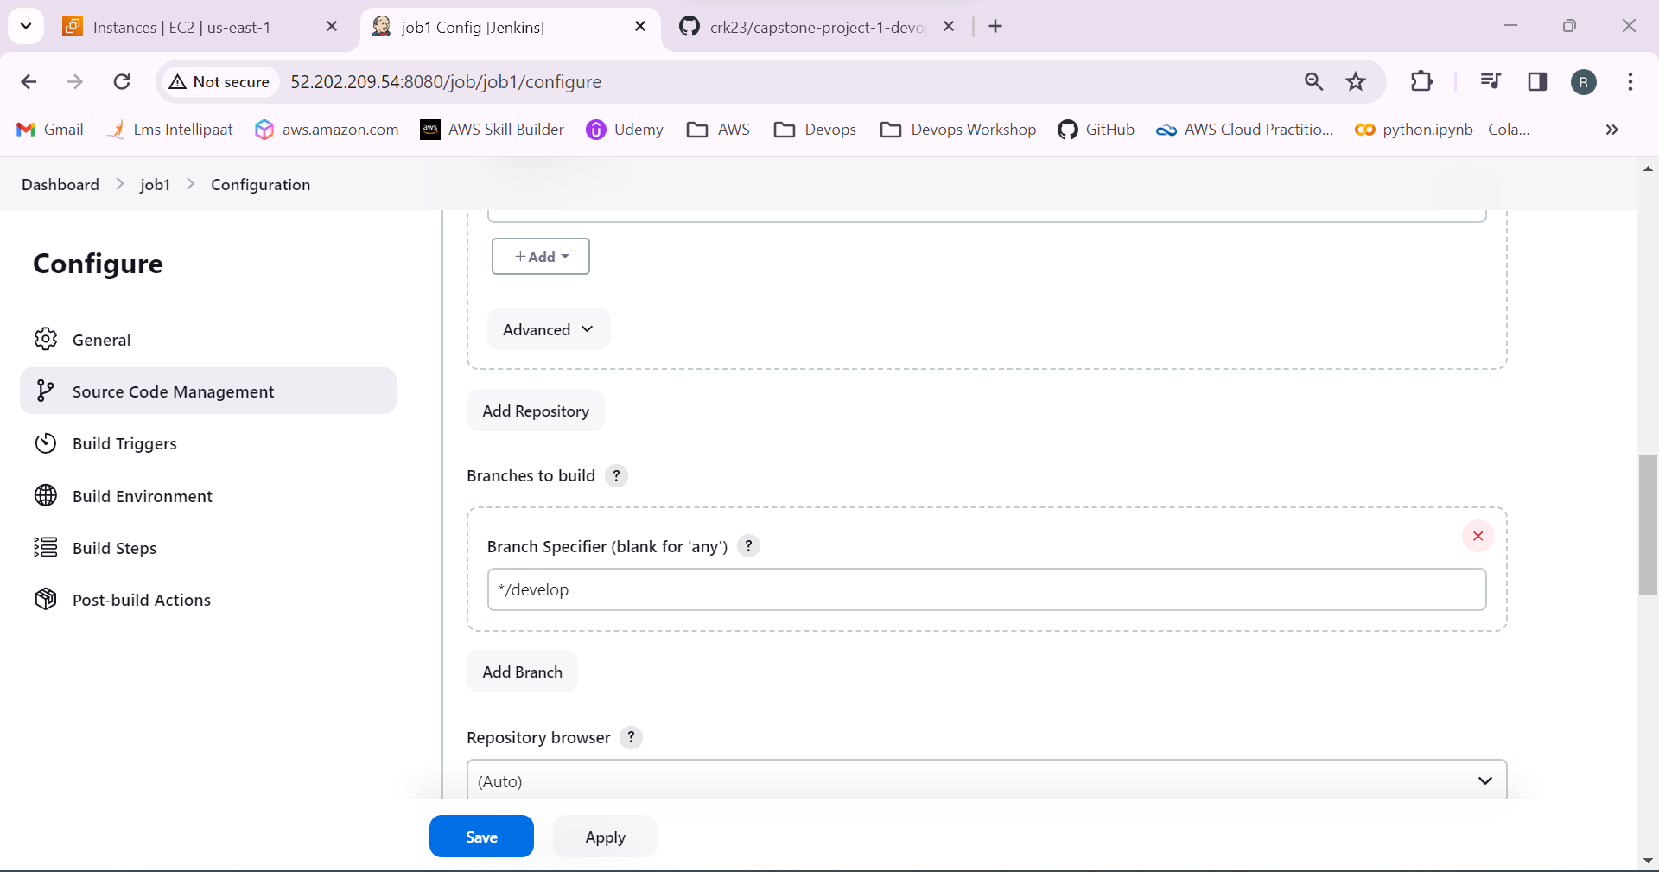

33.Go to the github settings and select webhook to generate a webhook by giving the Jenkins ip address.

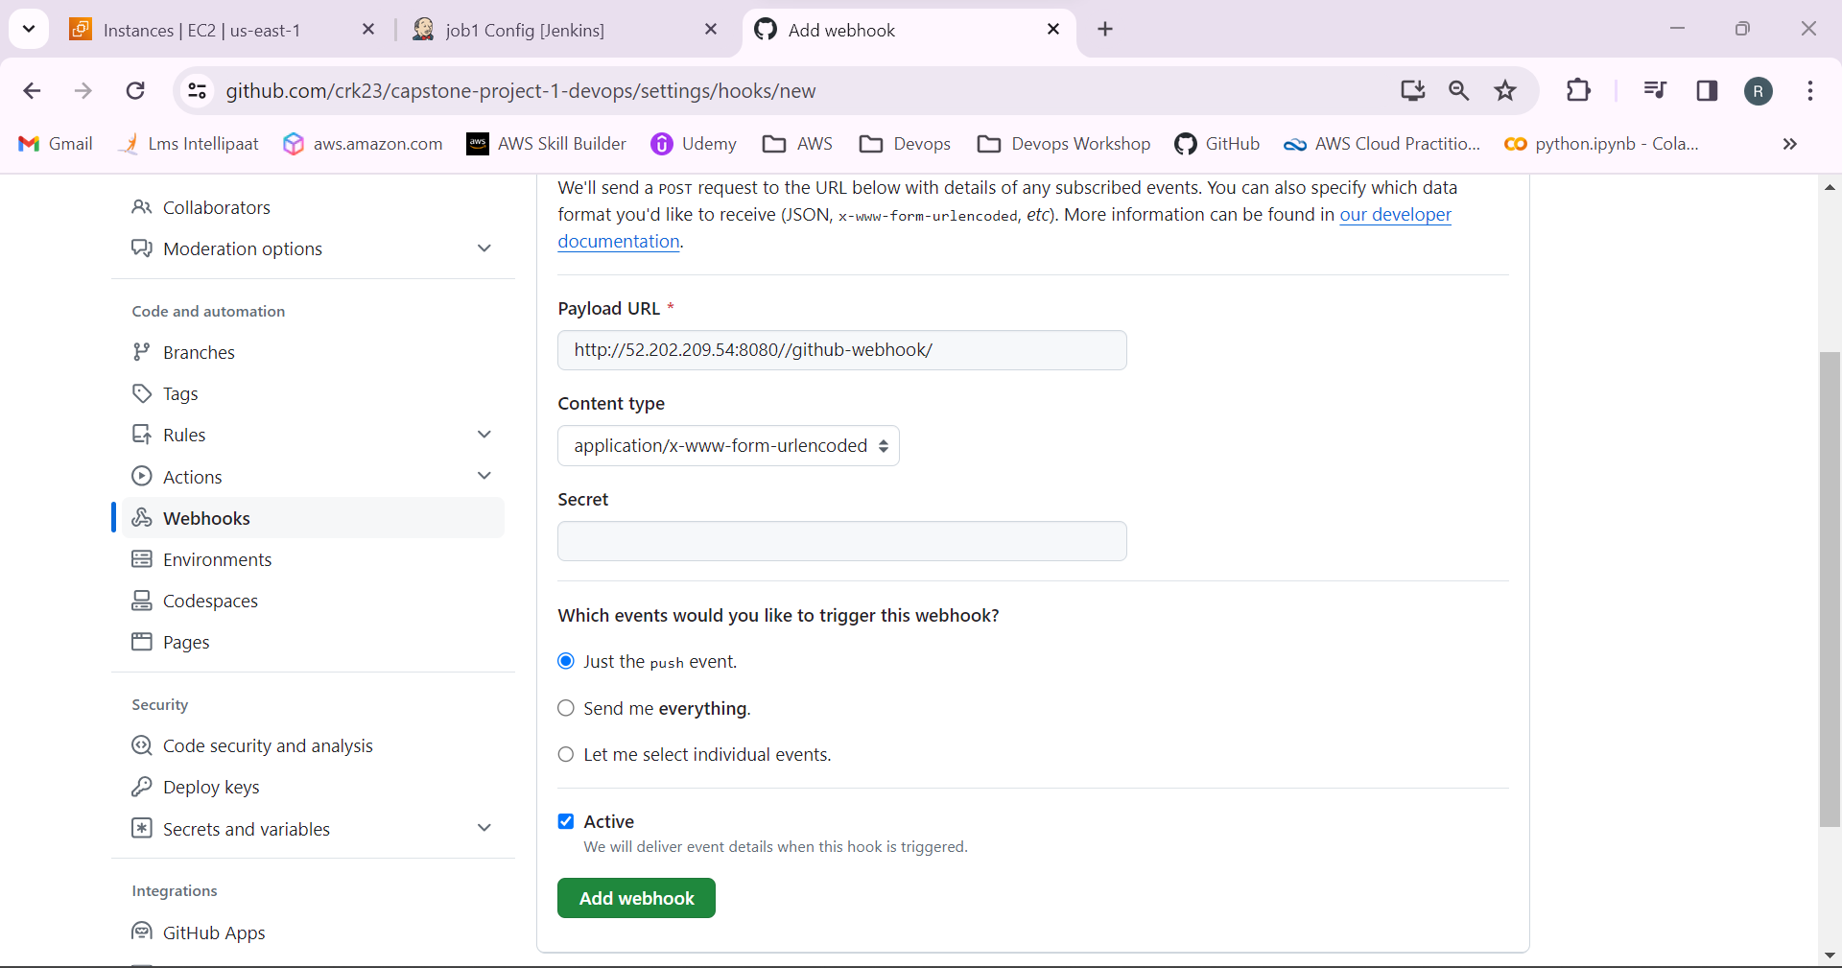

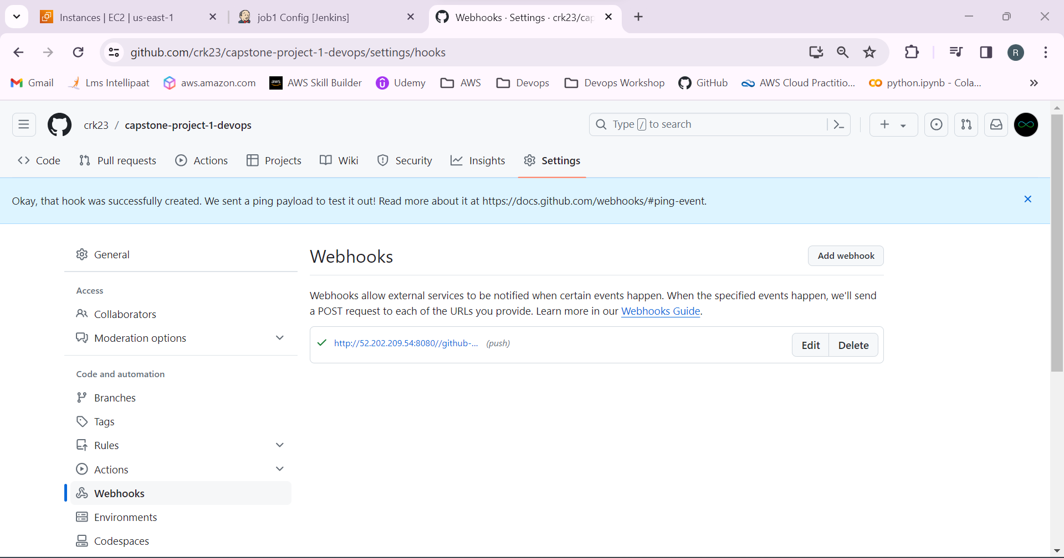

34.In build steps select the execute shell and add the commands build an docker image and run a container when there is a push to github.

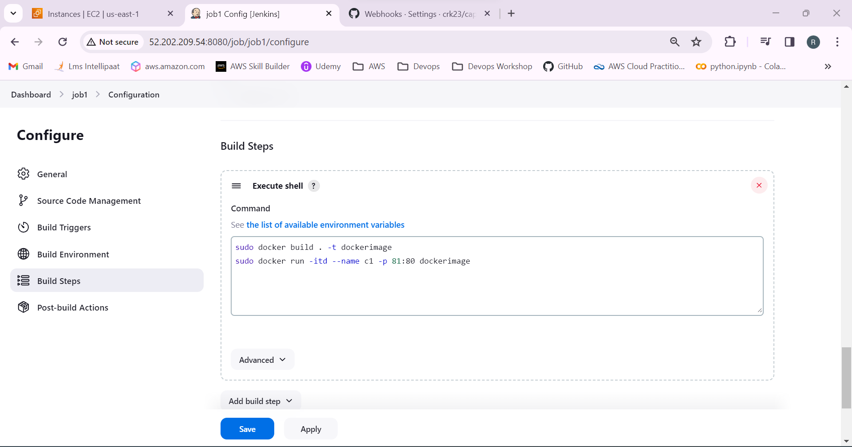

35.Job1 is created.

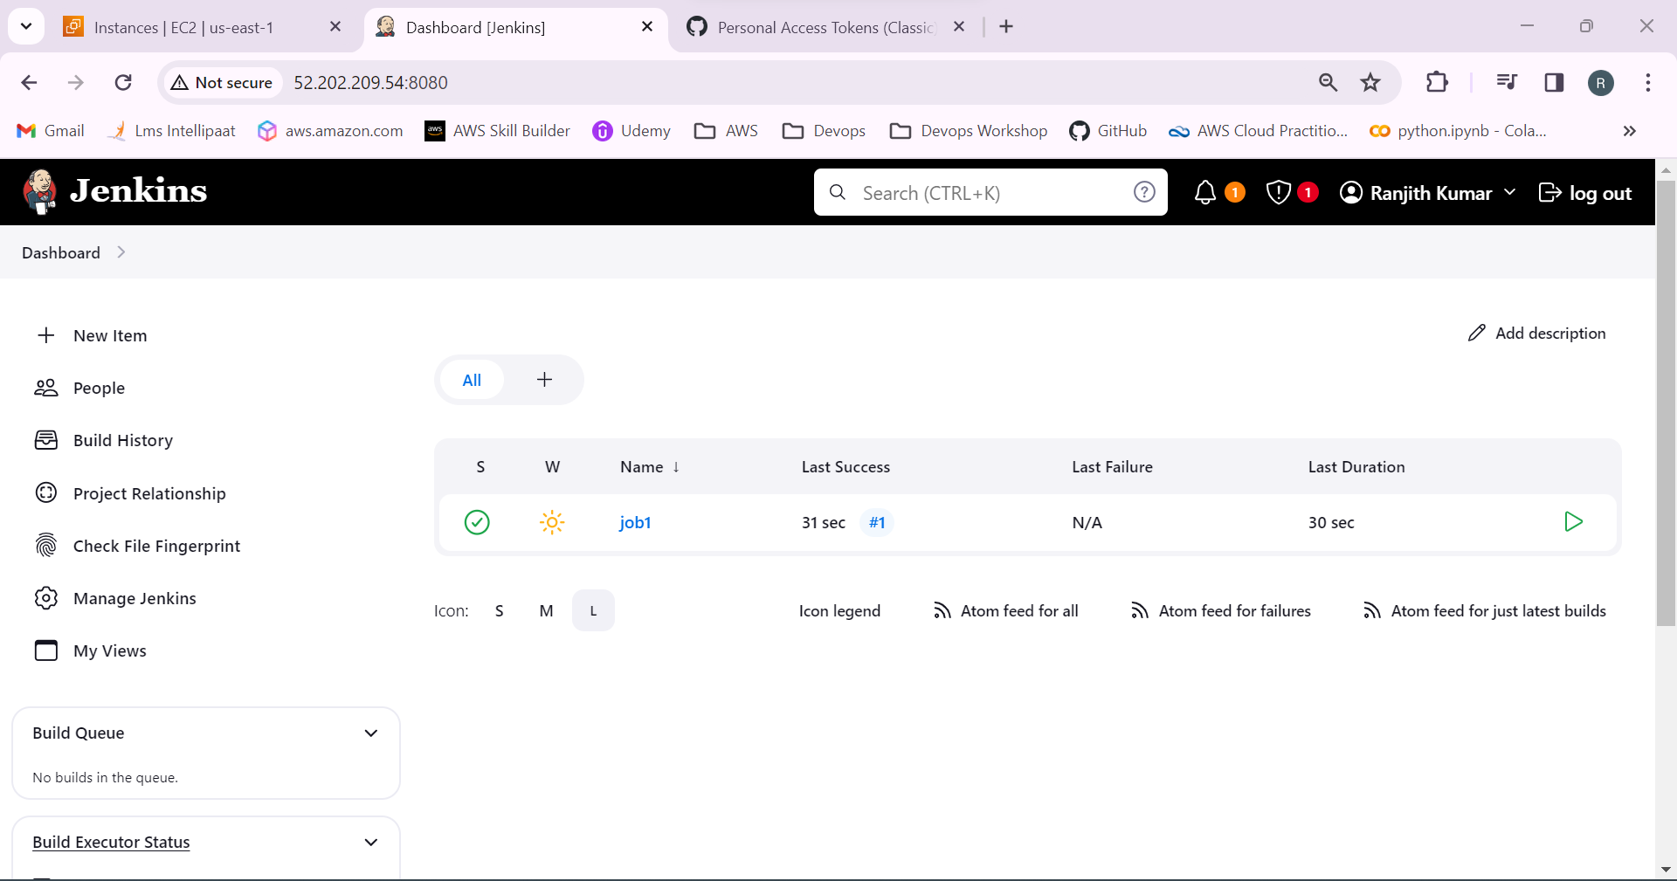

36.Check the repository is added to the master.

Push the develop branch to the github by using the command

**Git push origin develop**

Successfully pushed the develop branch to github.

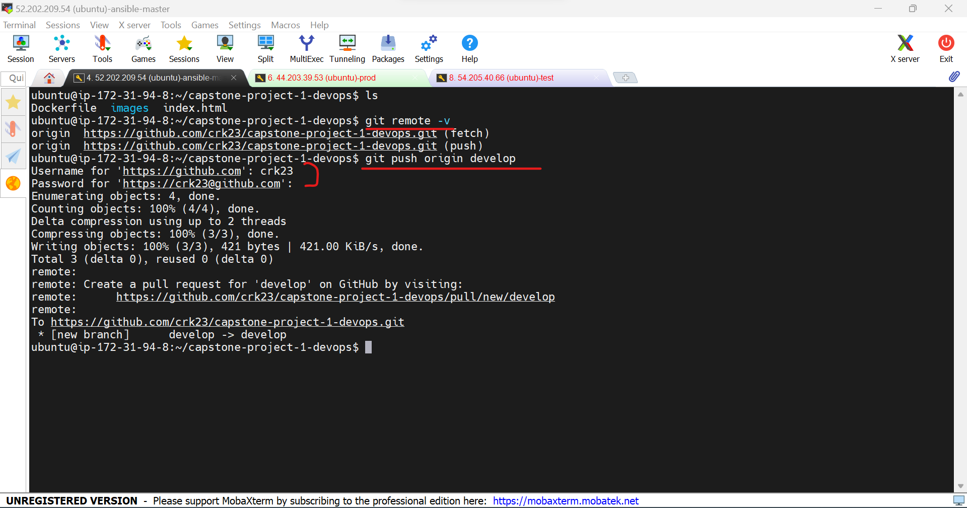

Now we can see the develop branch in github

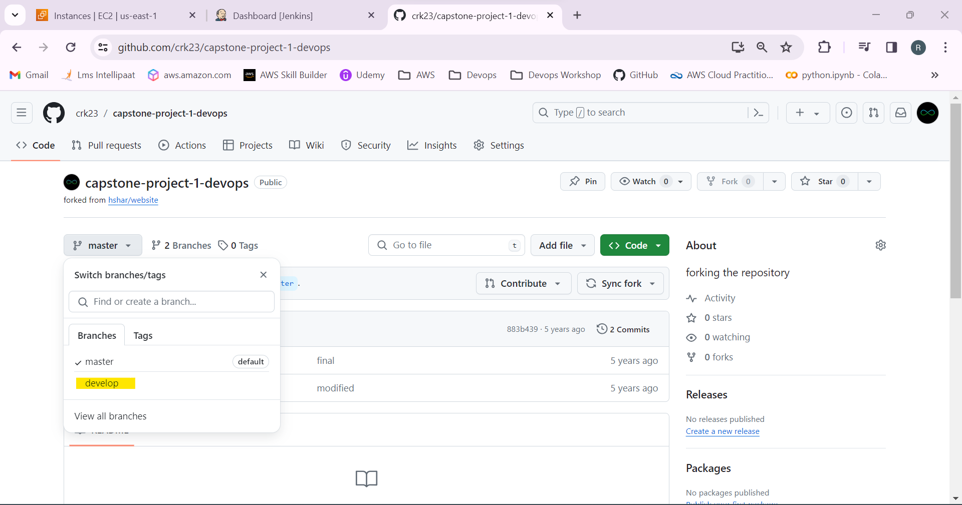

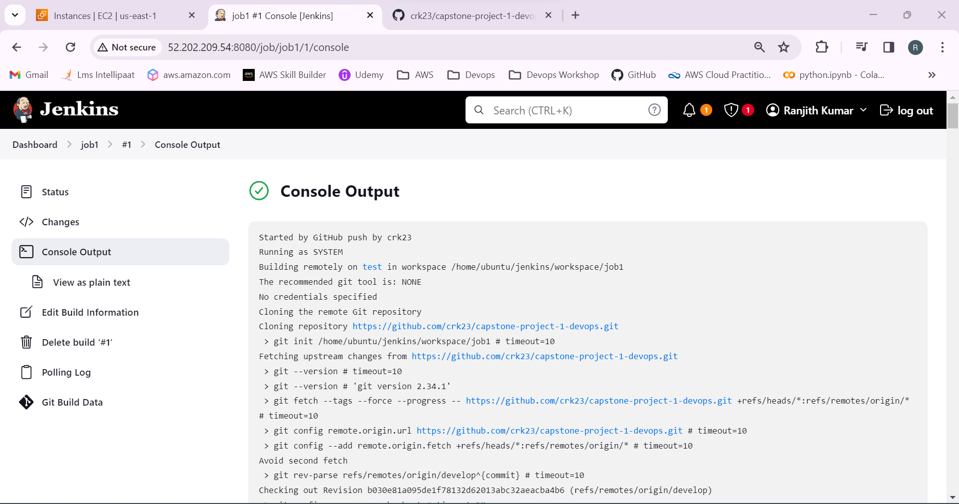

37.Go to the path of the Jenkins job. Docker file and docker images an conntainers has been created.

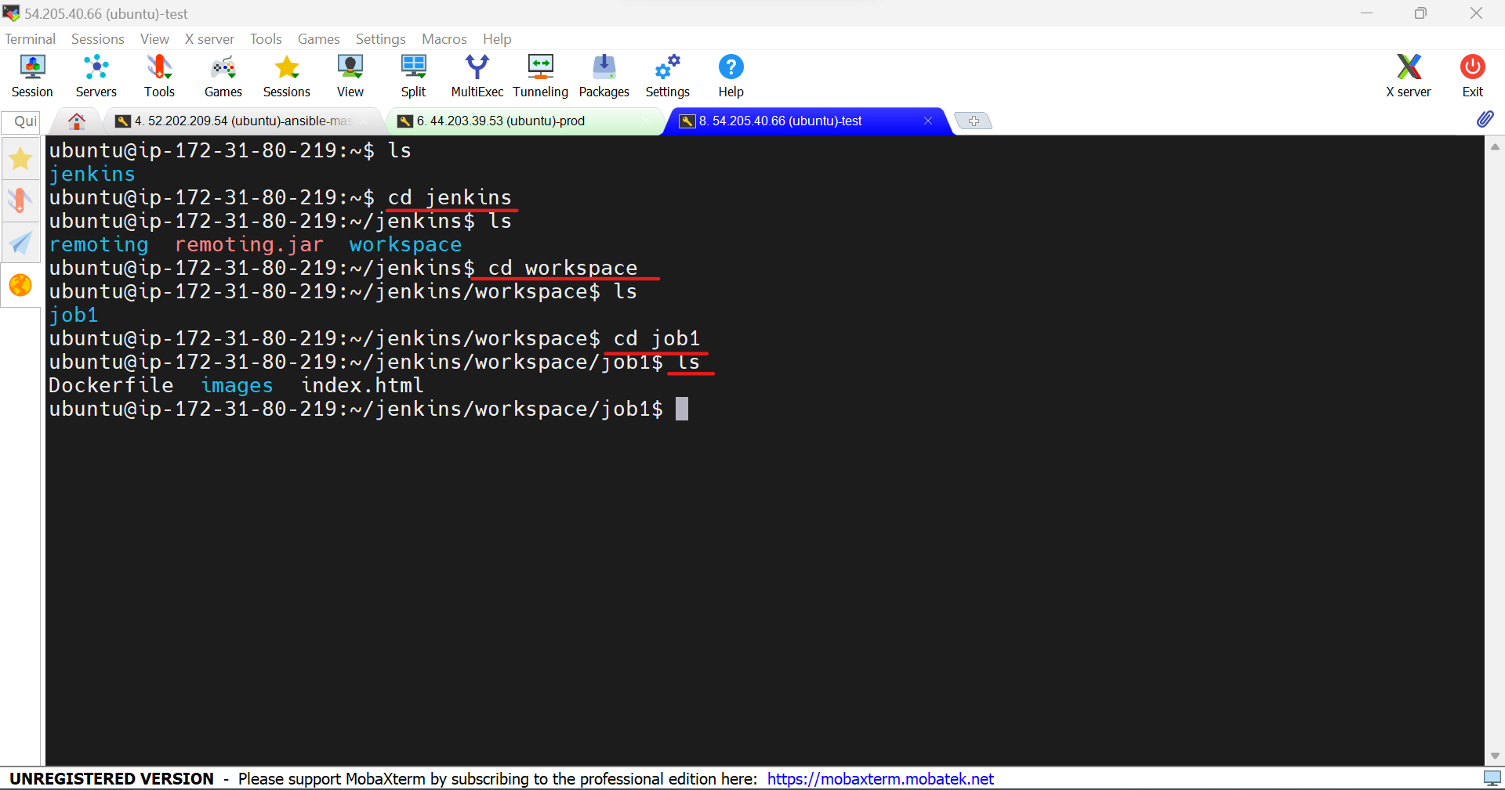

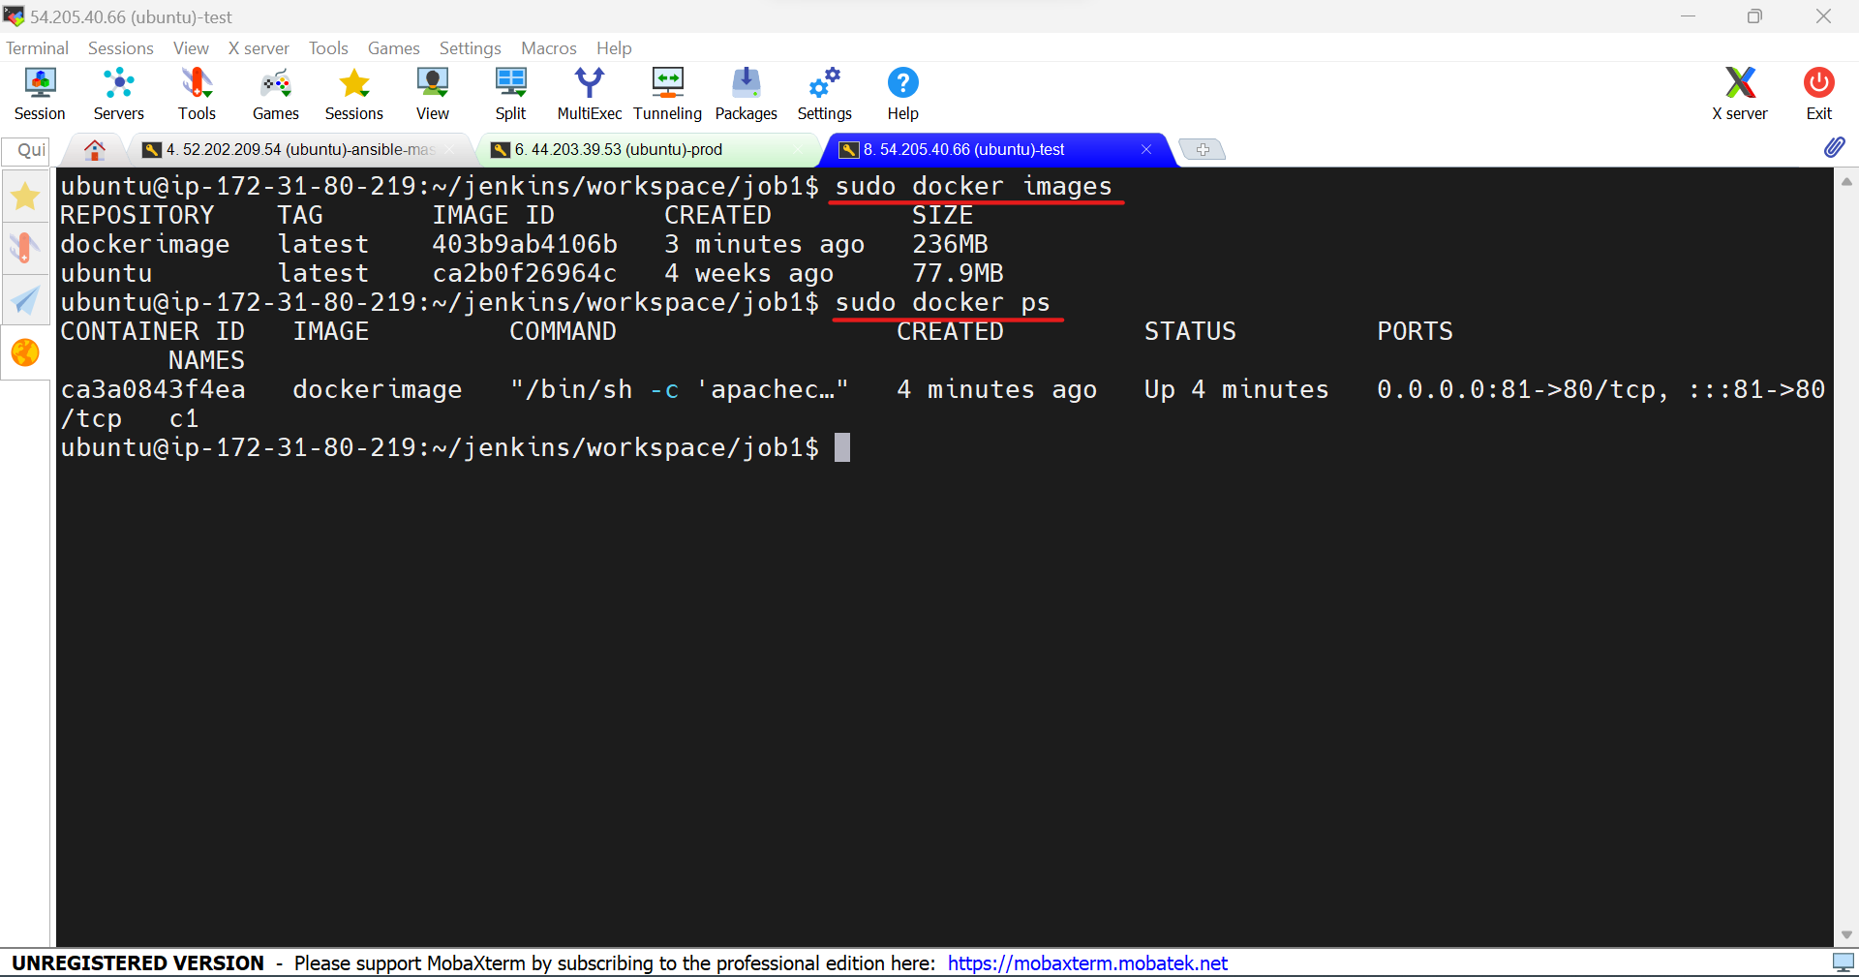

38.Copy the public ip of the test machined and paste it in the browser with port 81.

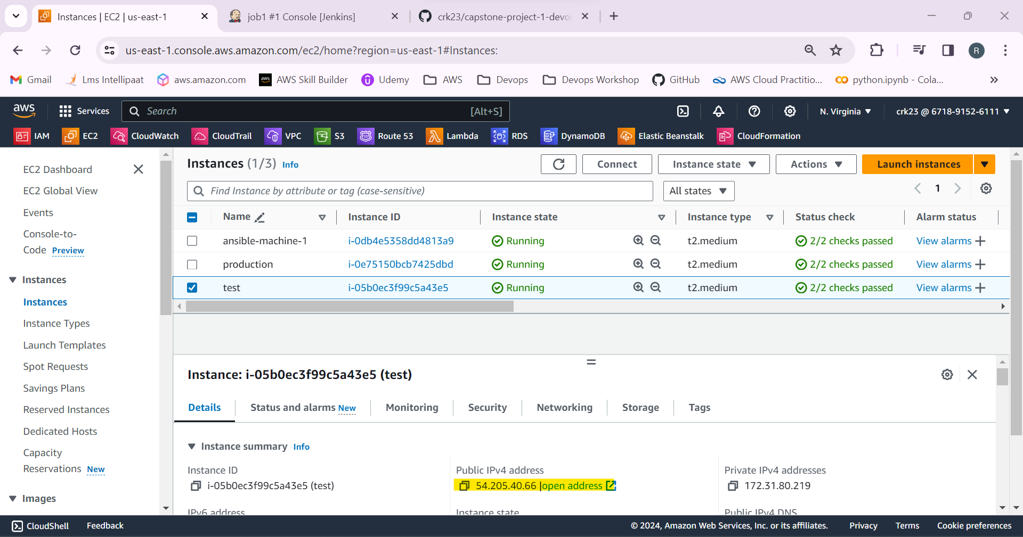

It’s working!

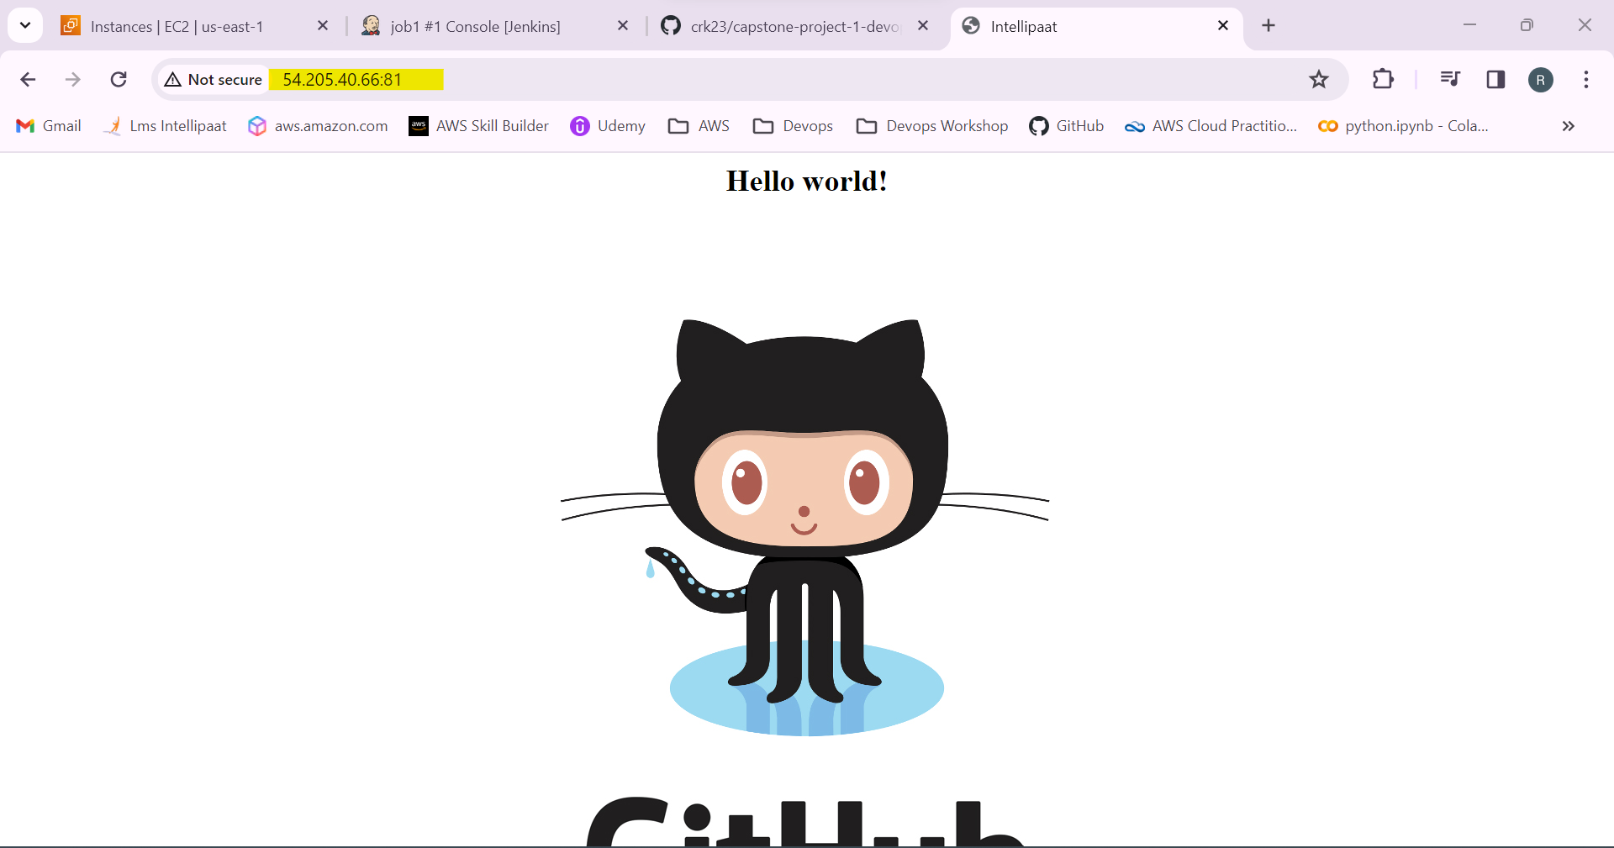

39.Create Job2 in Jenkins.

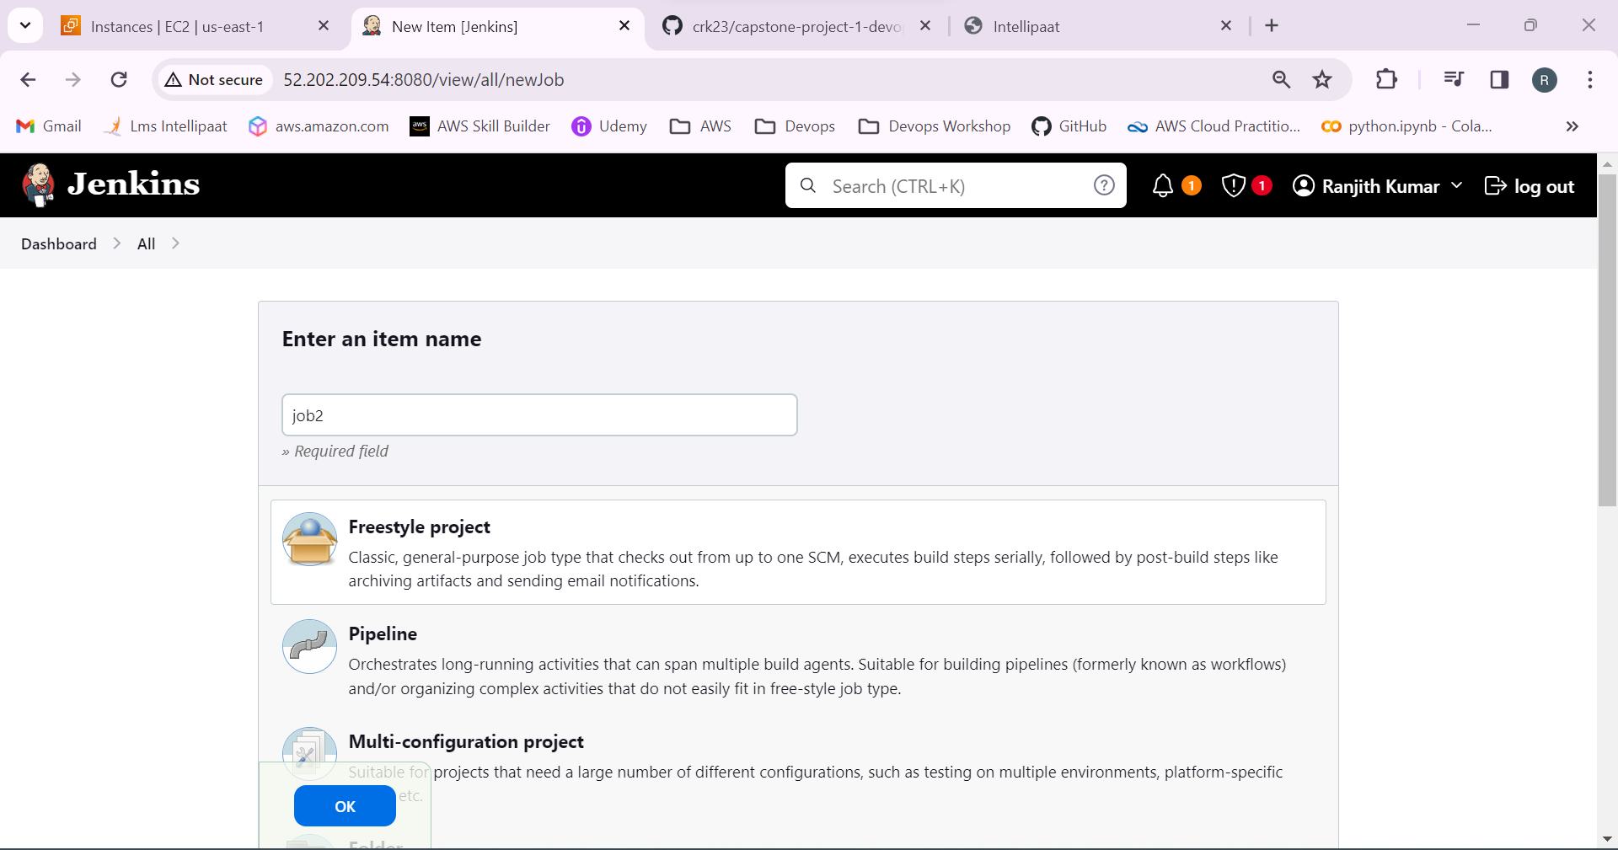

40.Add the github repo link in github project and source code management.

Restrict the project to run in test node.

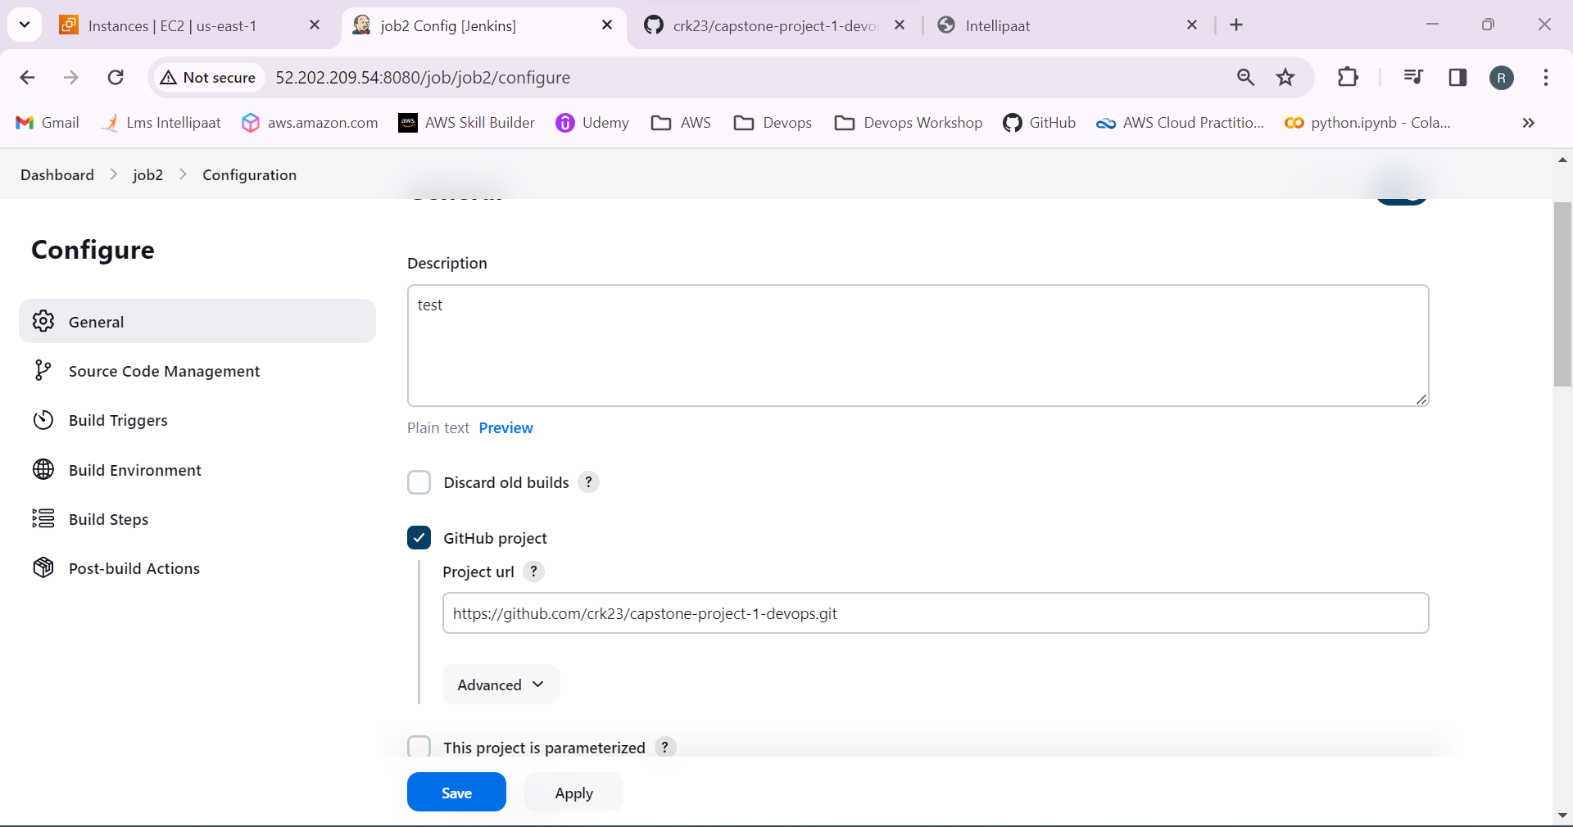

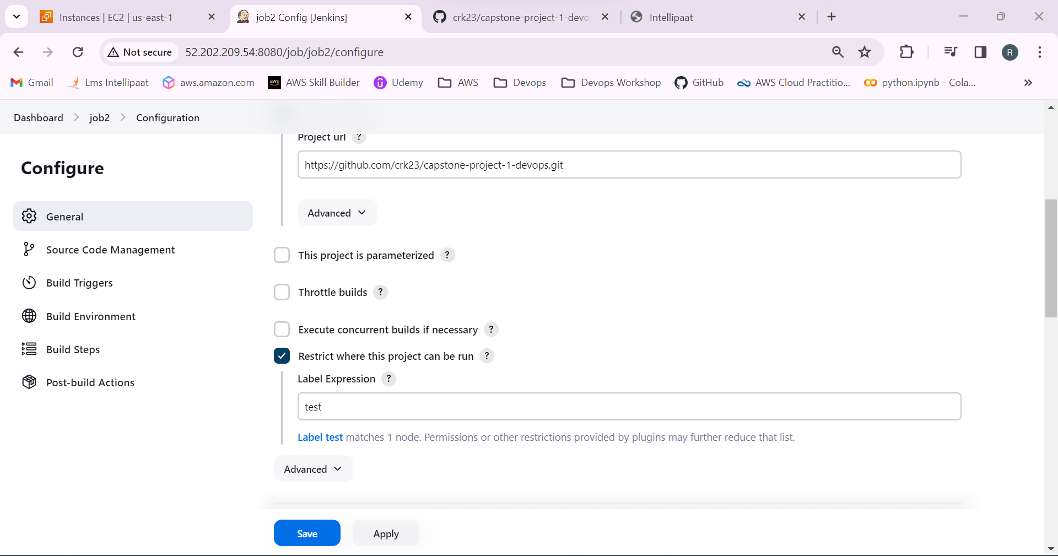

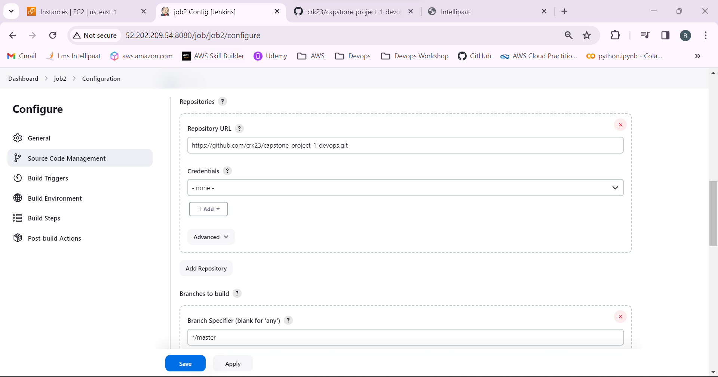

41.Select the github hook and build steps as execute shell to build a test docker image and to run container in port 82:80

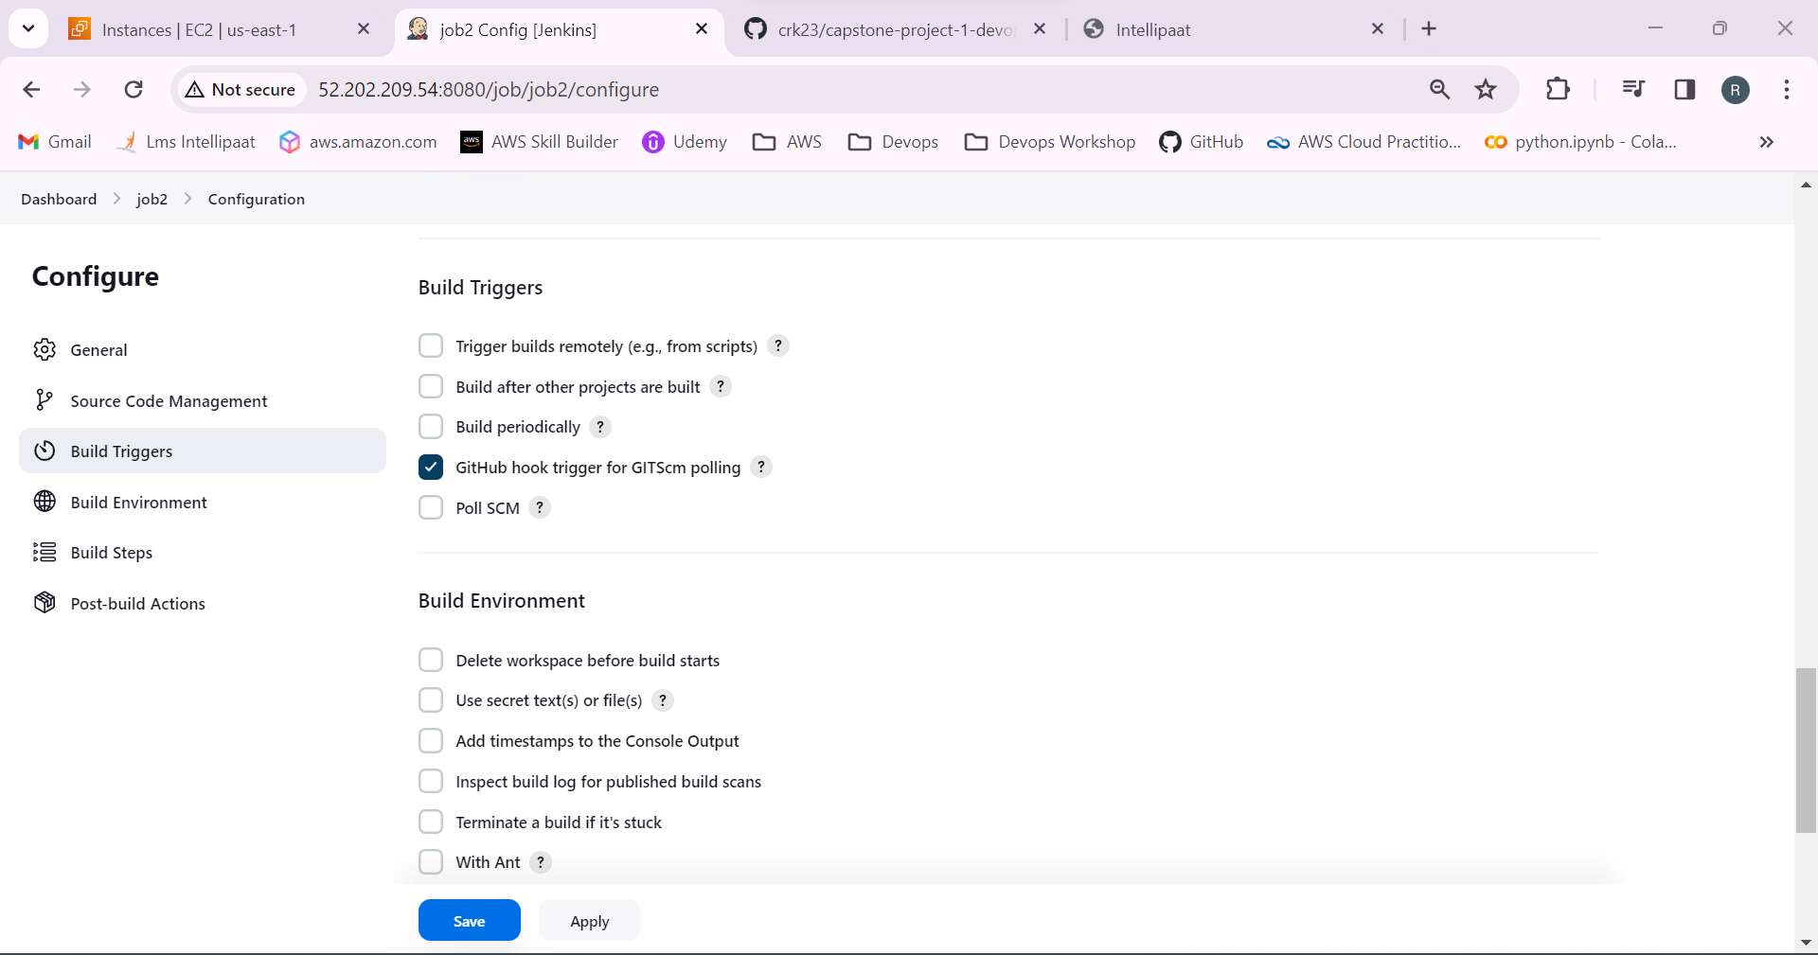

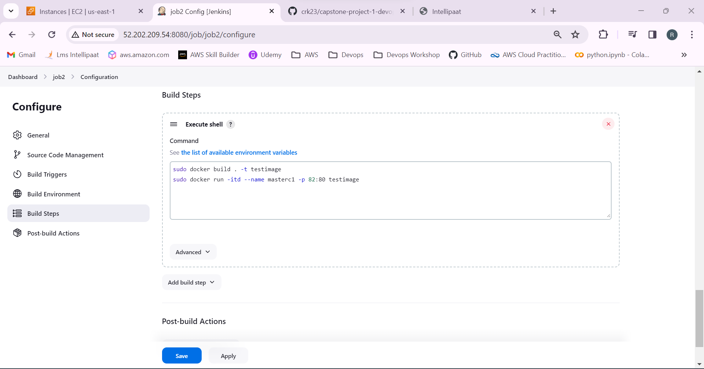

42.job 2 created successfully.

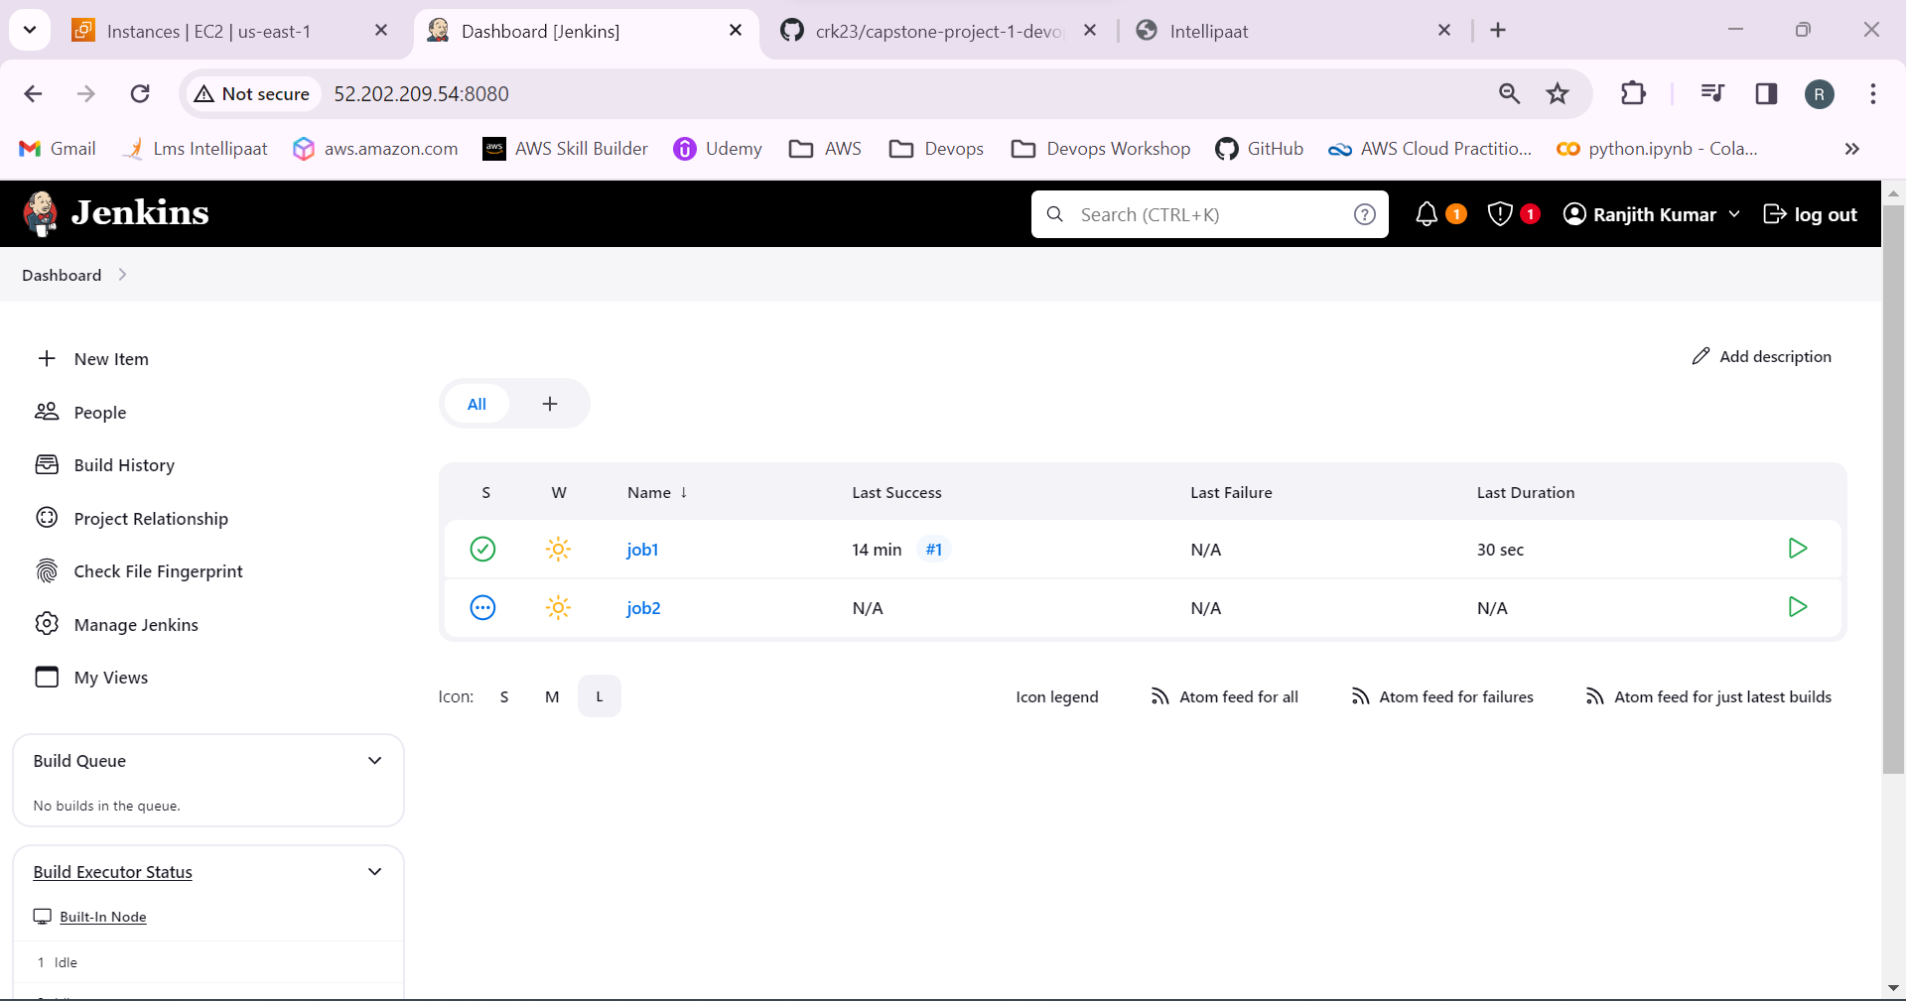

43.push the master branch to the github.

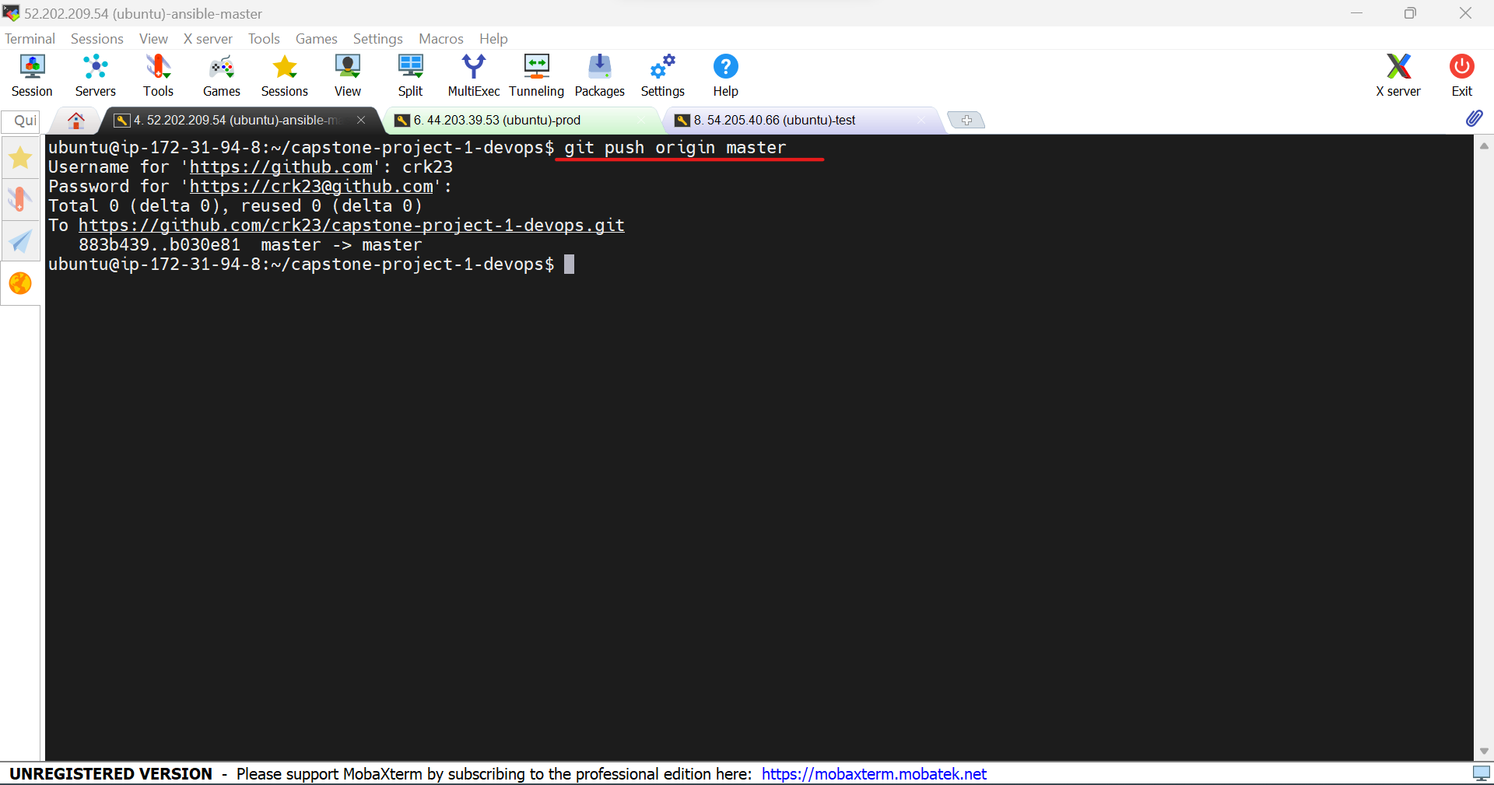

We can see the docker file after pushing the master branch.

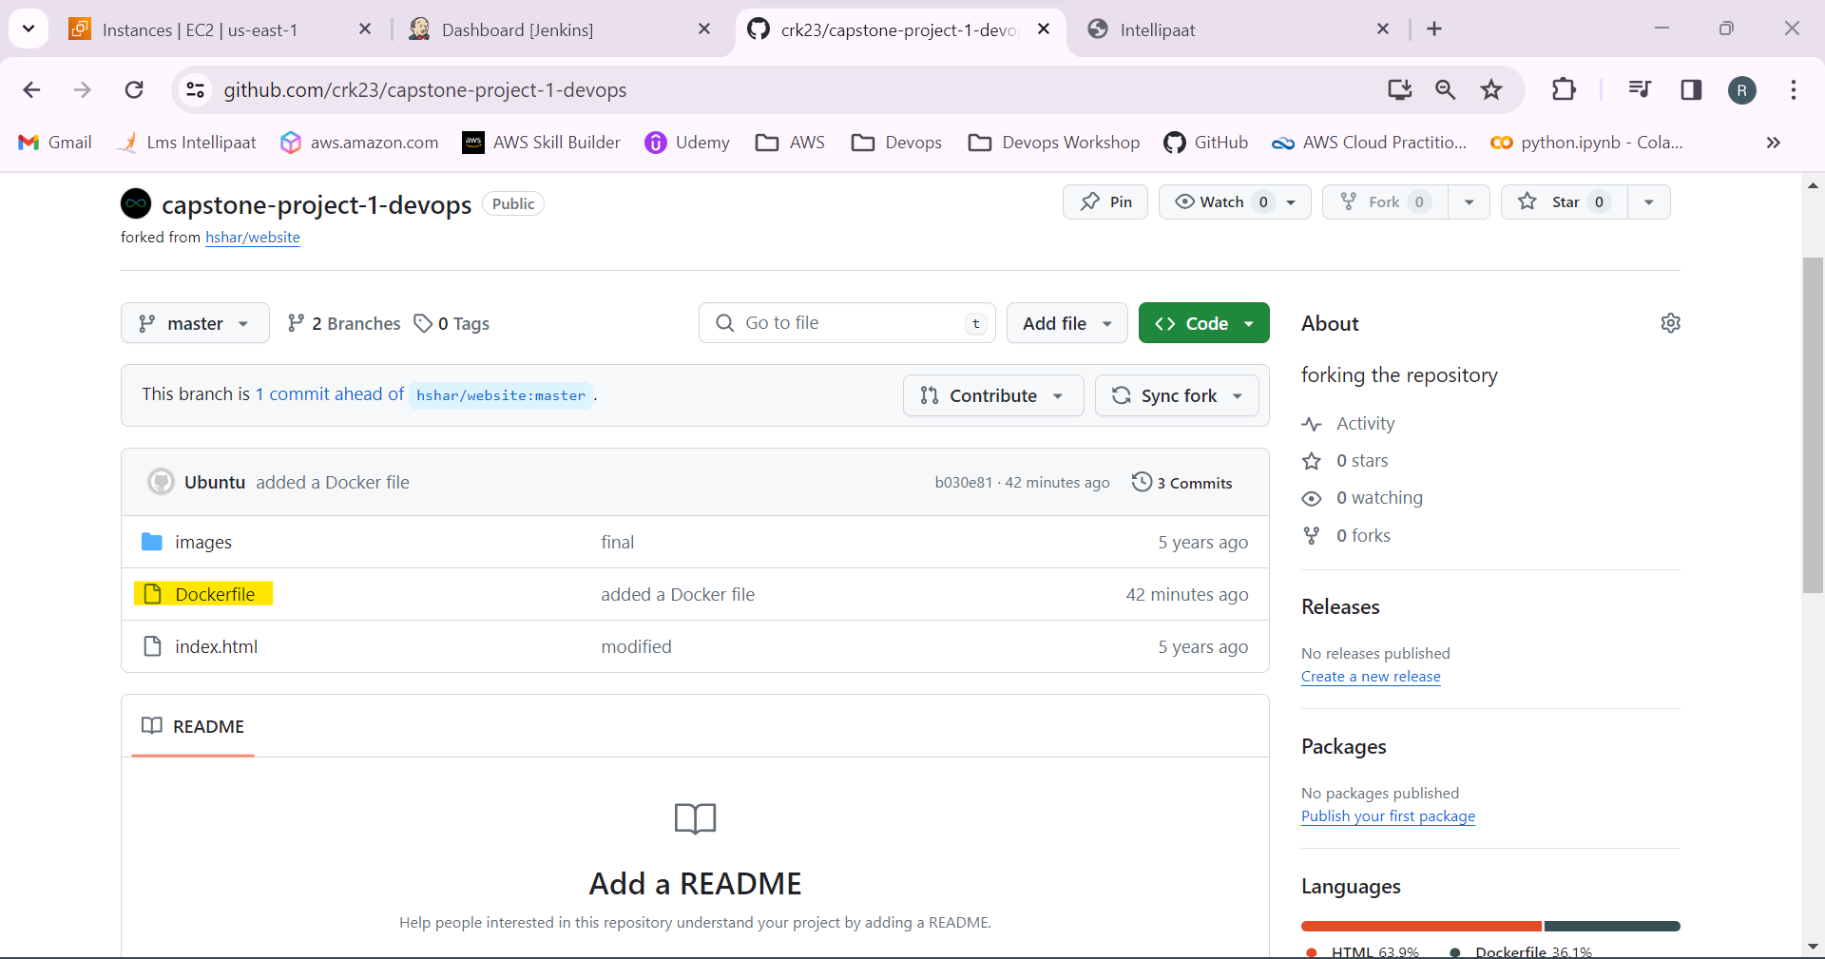

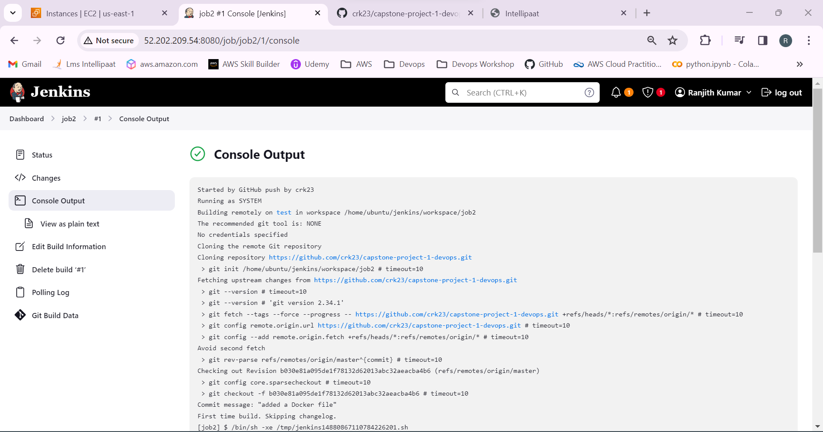

44.Copy the public ip of the test and paste it in the browser with port 82 opened.

It’s working!

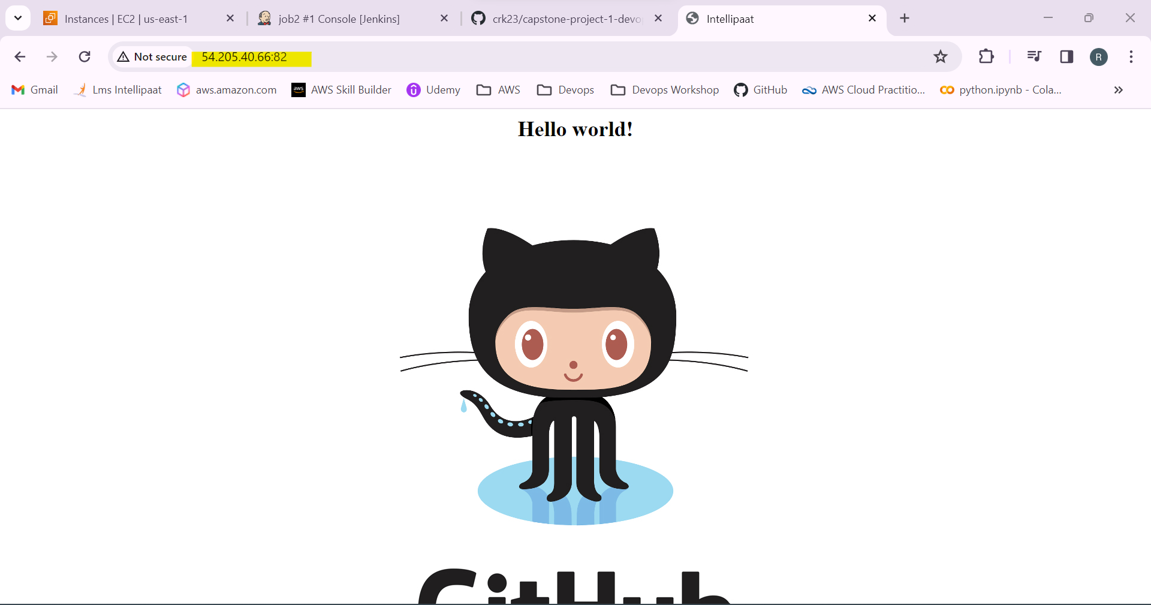

45.Create a Job 3 in Jenkins.

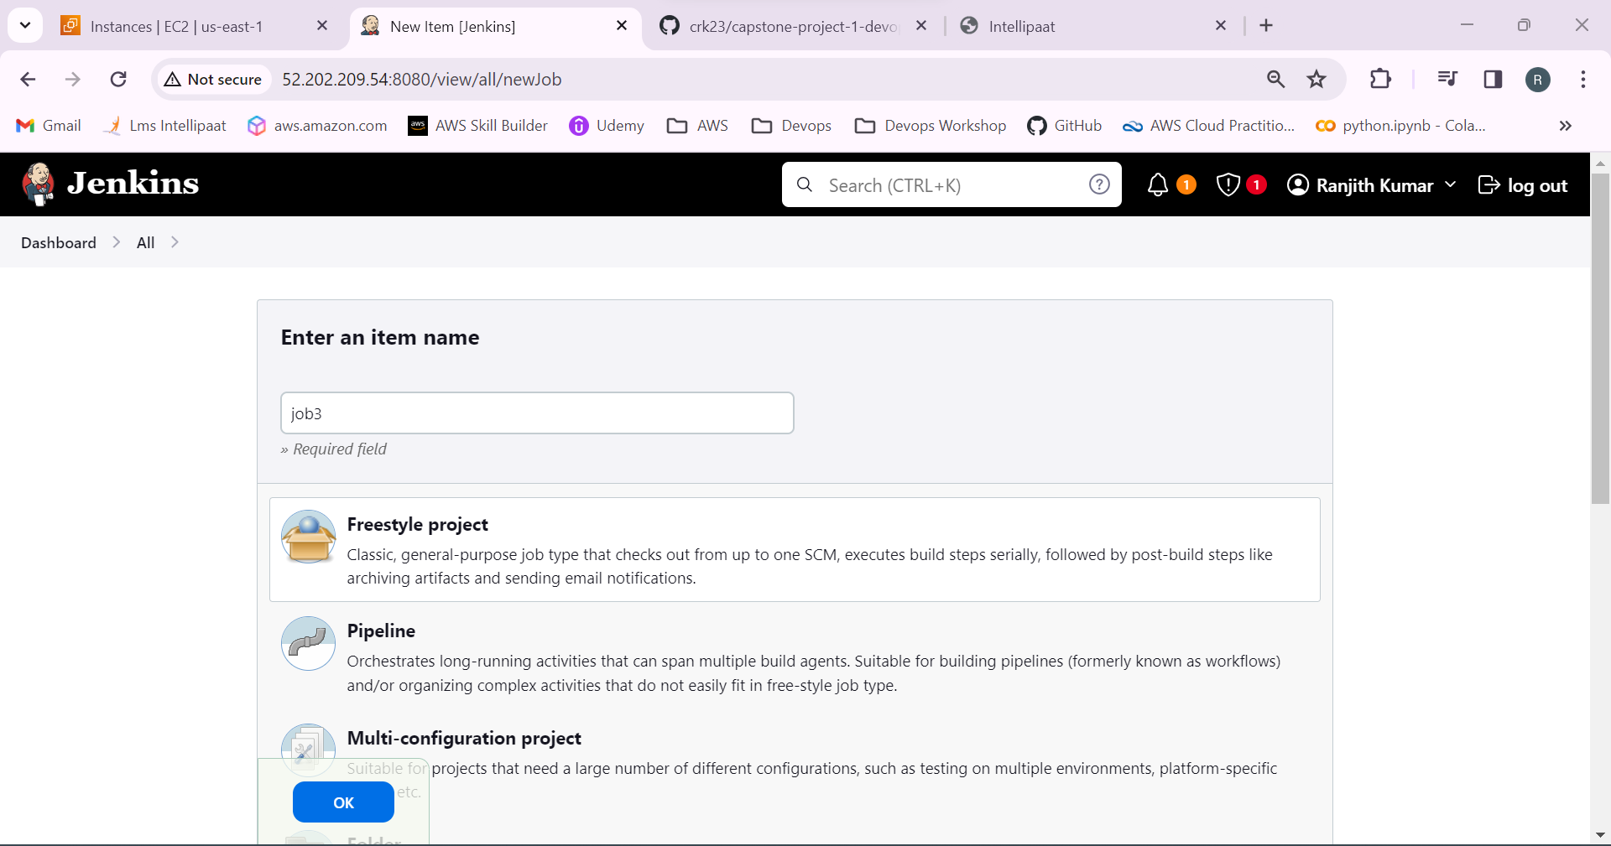

46. Add the github repo link in github project and source code management.

Restrict the project to run in prod node.

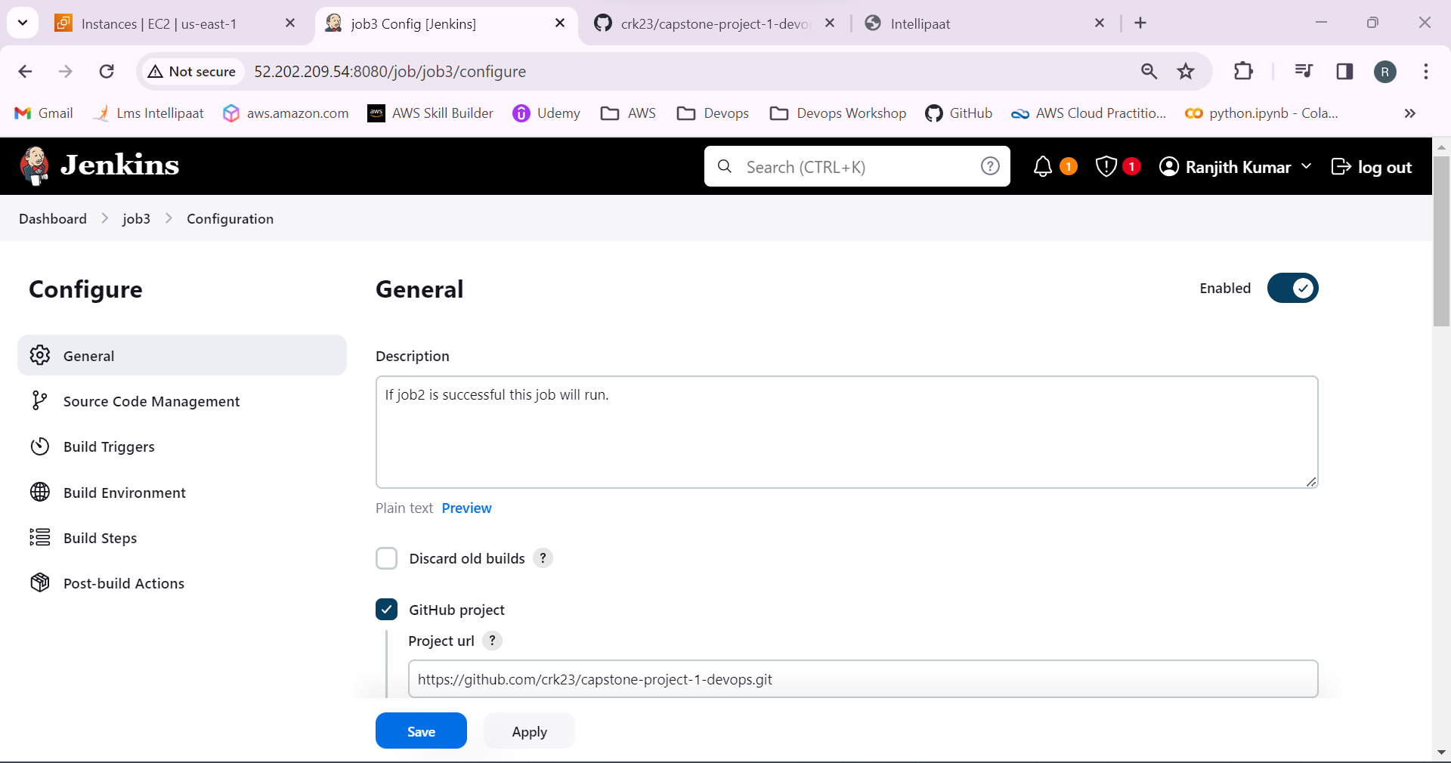

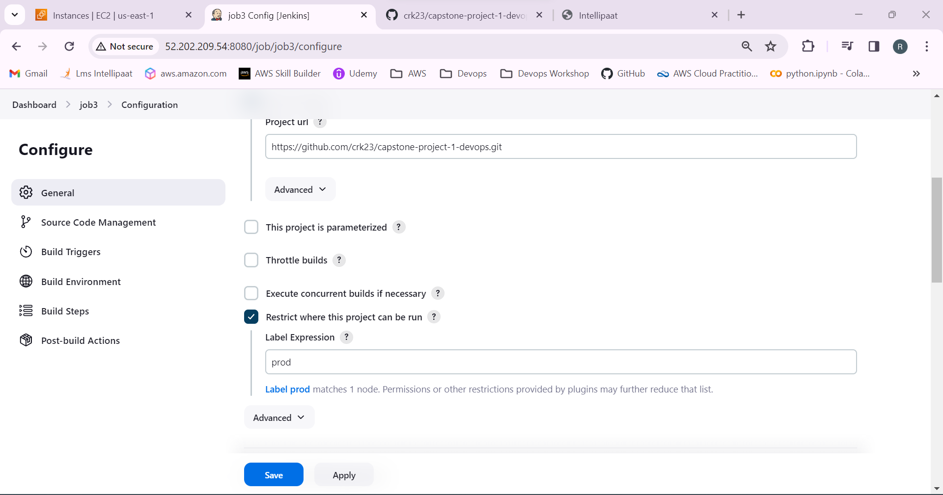

Don’t select webhook

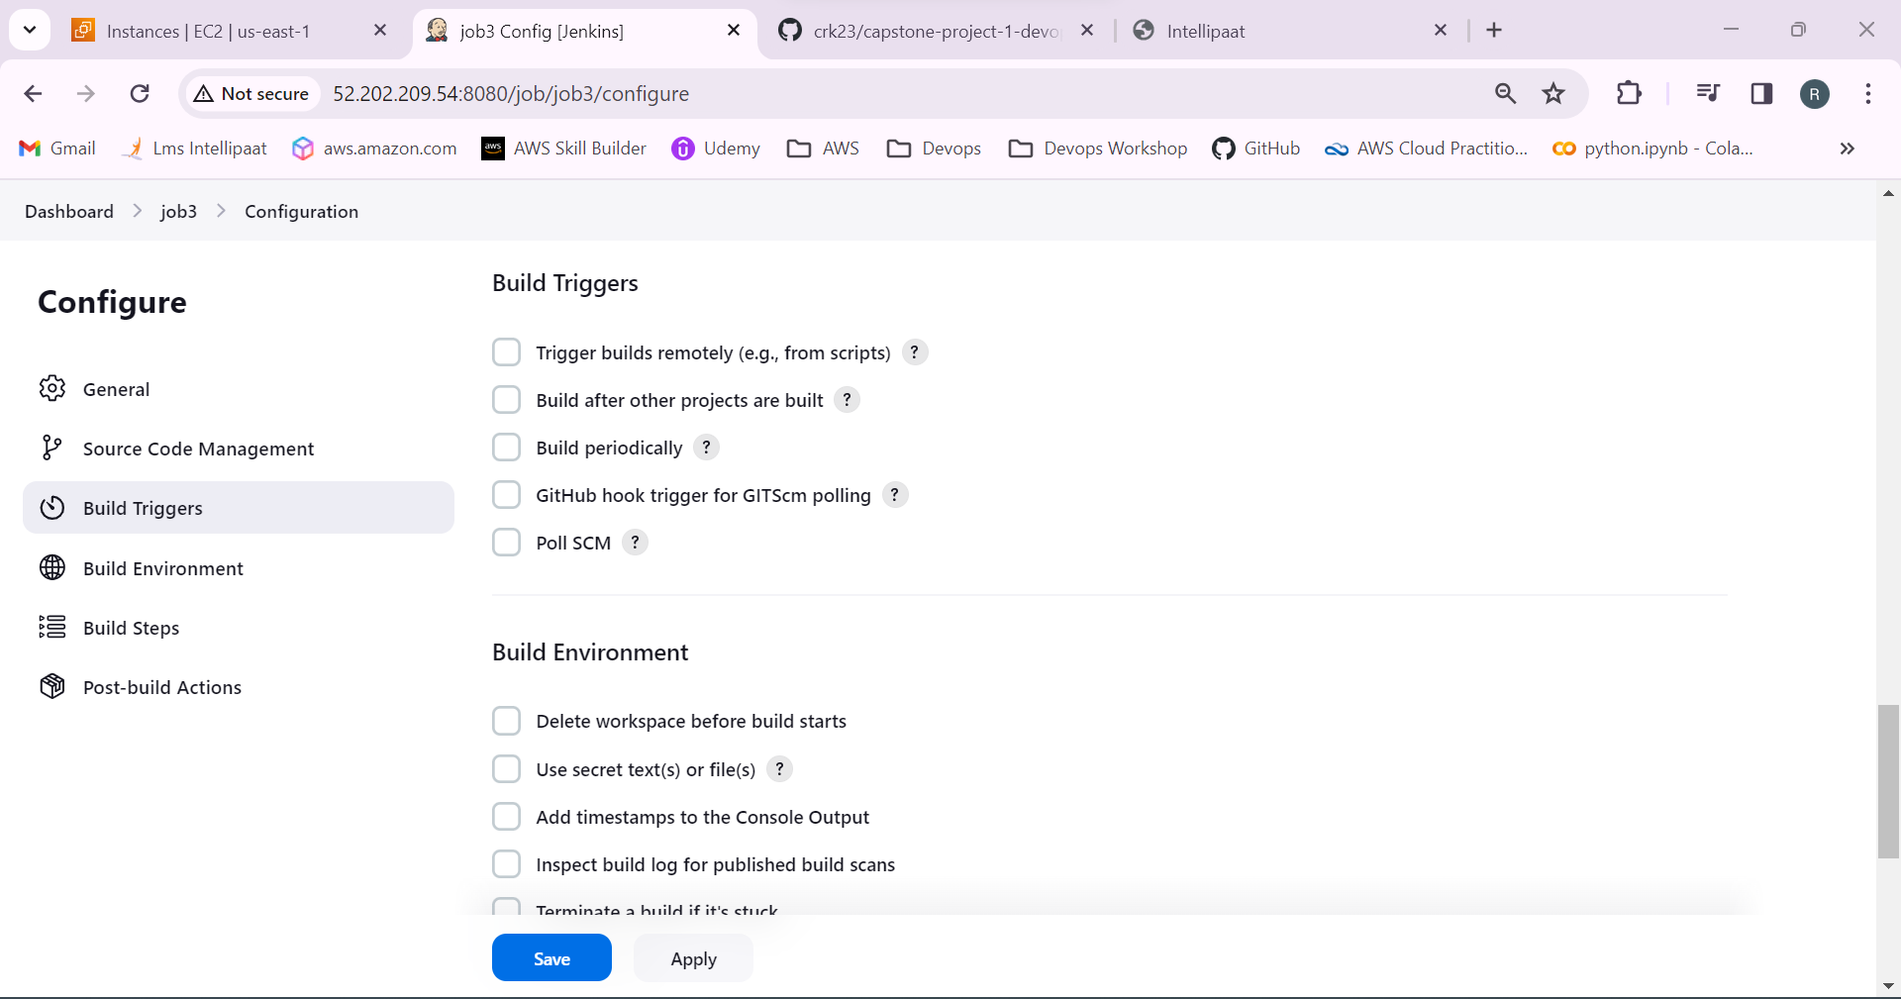

47.Select the build steps as execute shell to build a docker image and to run container in port 80:80

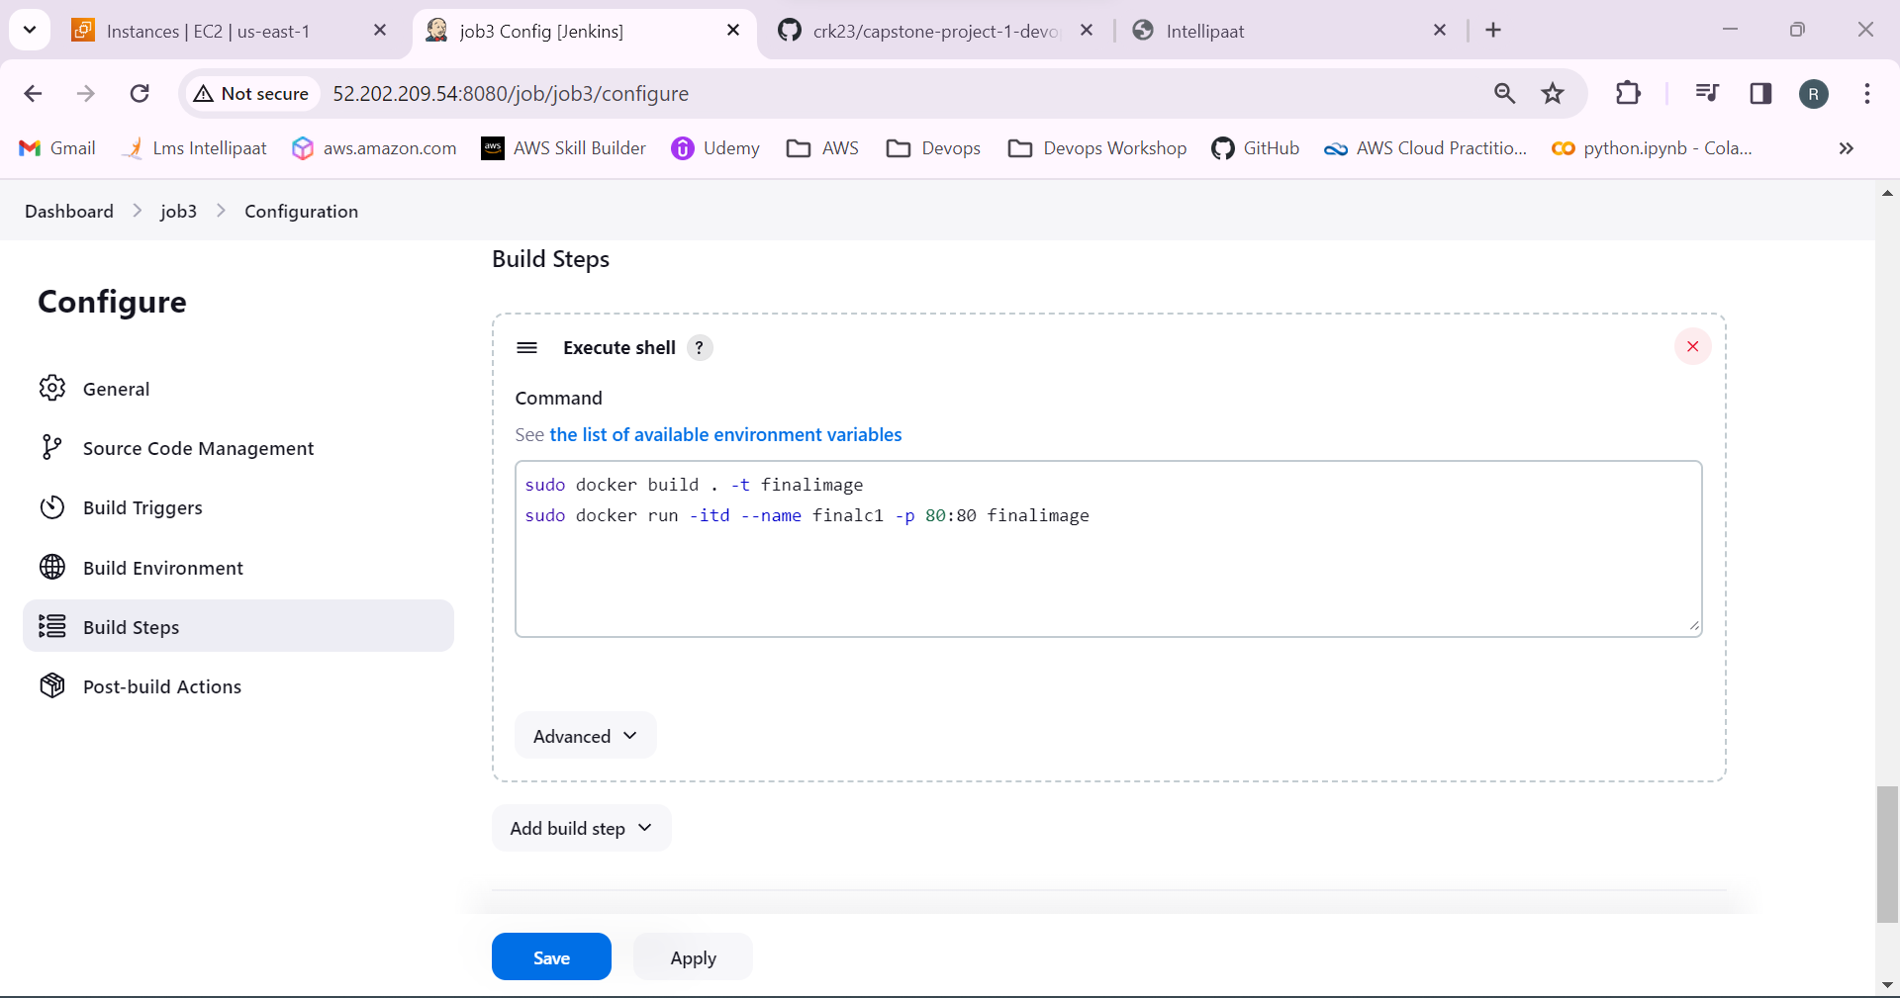

48.job 3 has created.

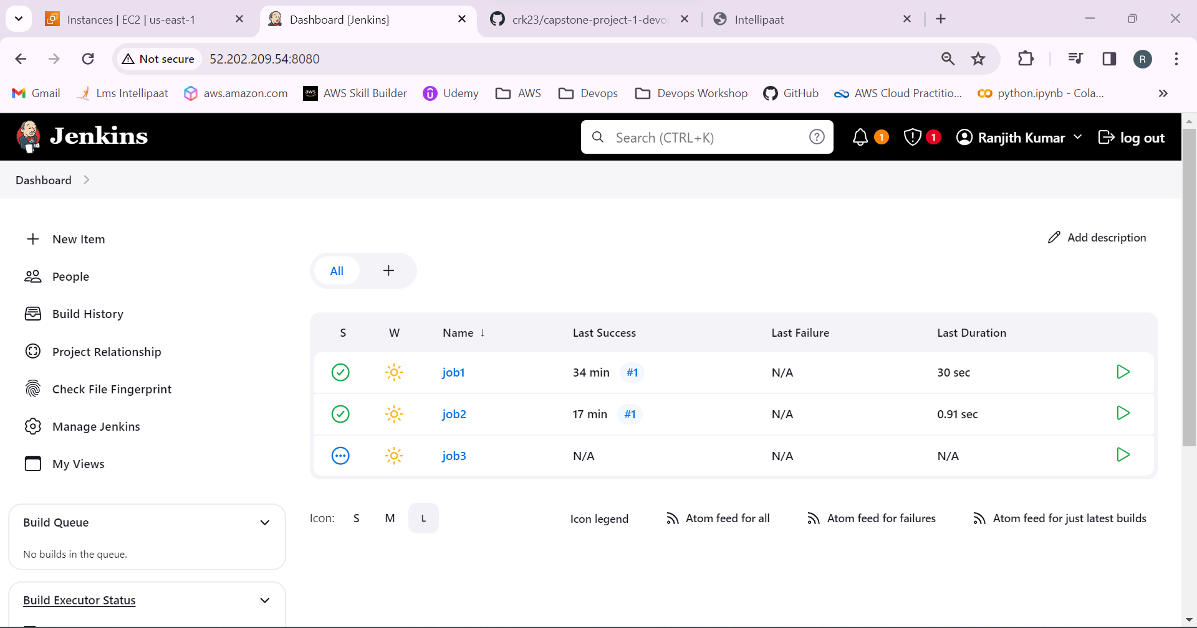

49.Go to the job2 > configure.

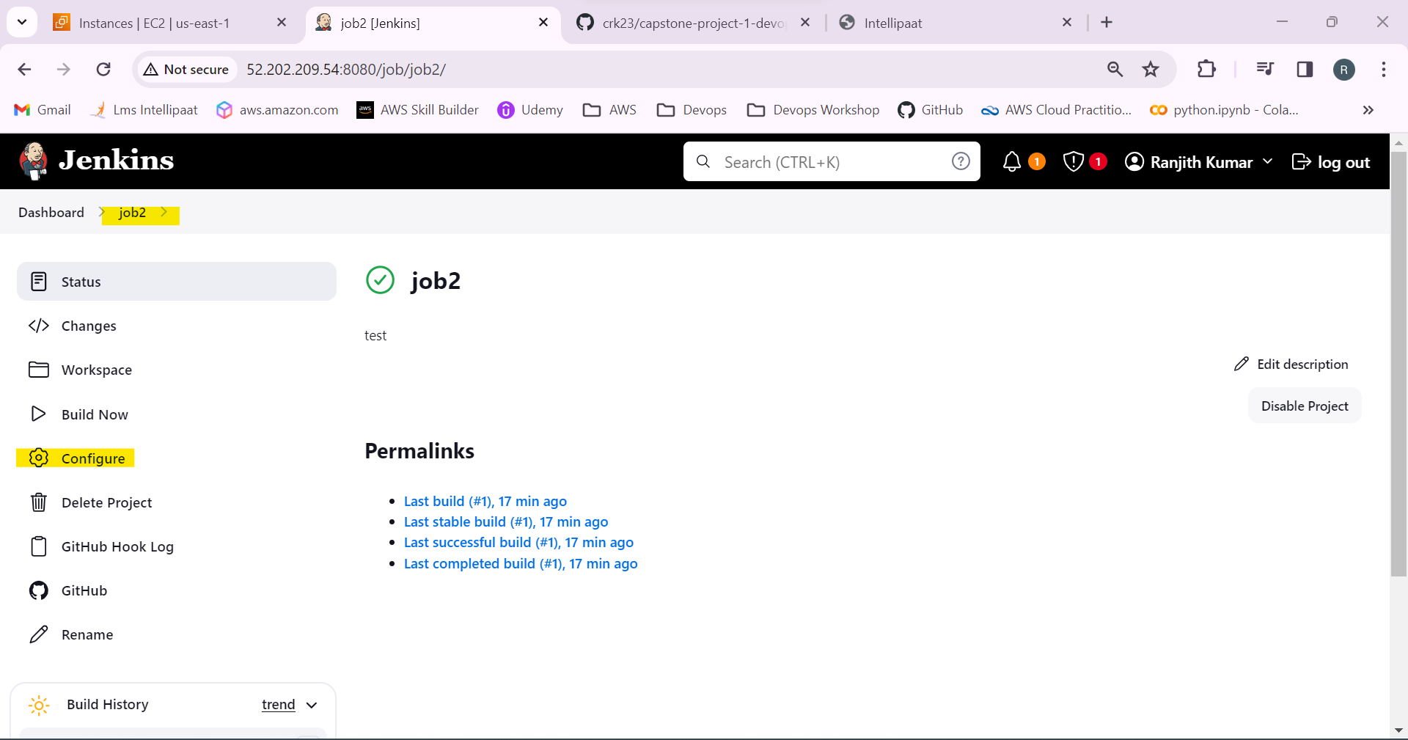

50.Select post build actions to build job3 after the job2 build is stable.

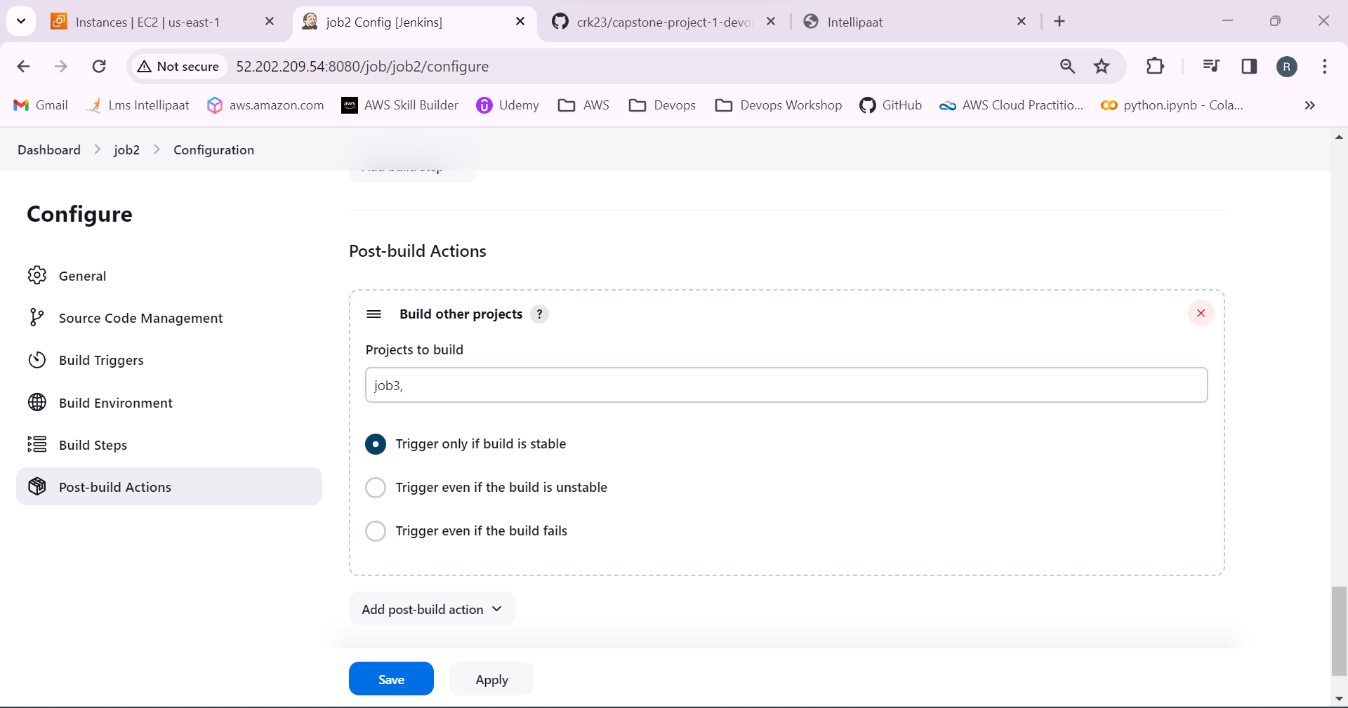

Add a line in the job3 build actions to remove the containers.

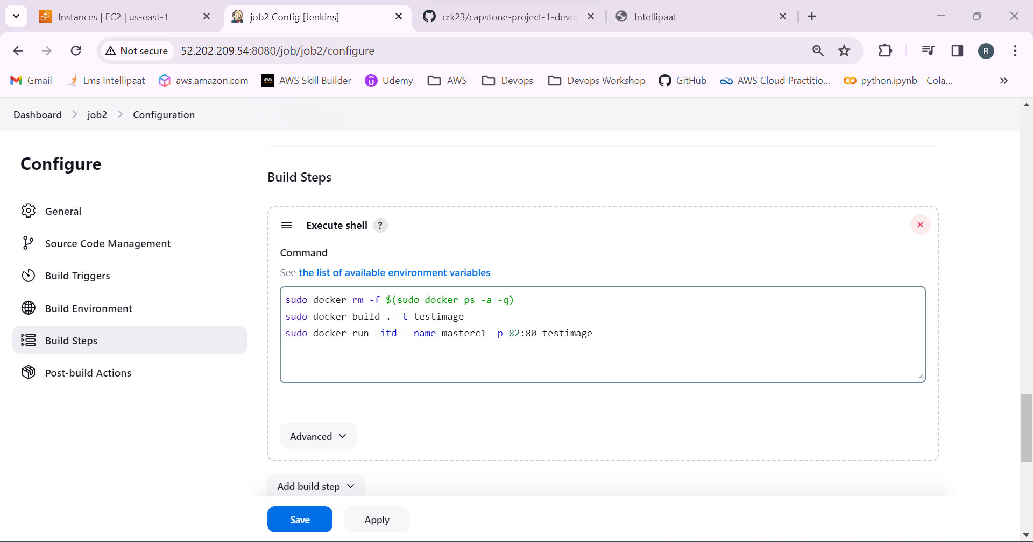

51.Job 2 is building after its completion job 3 will start to build.

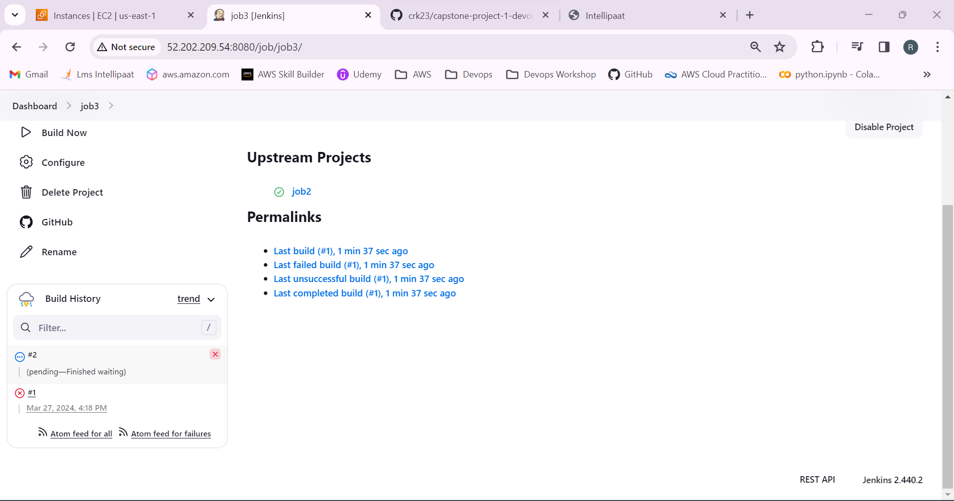

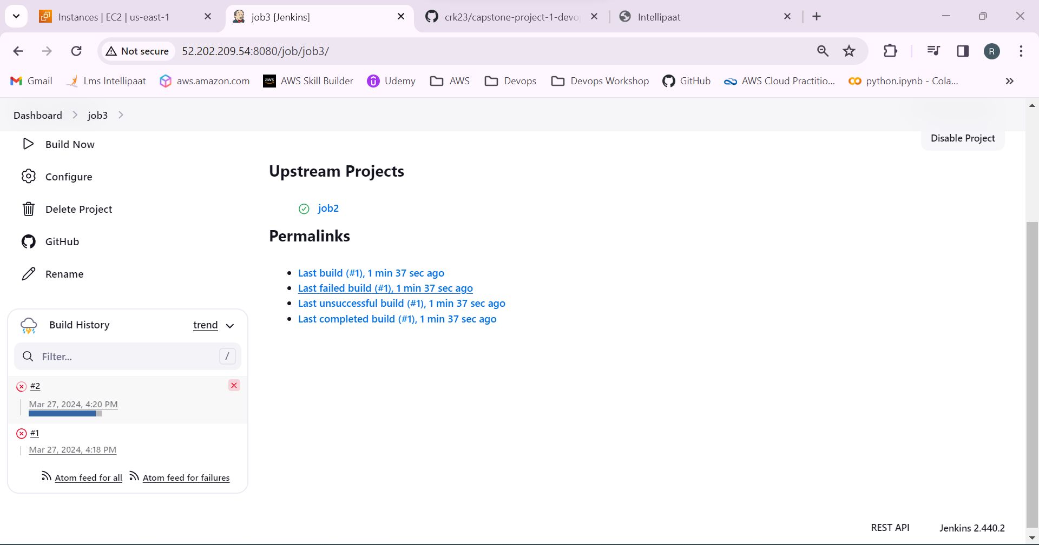

Job 2 is successfully build!

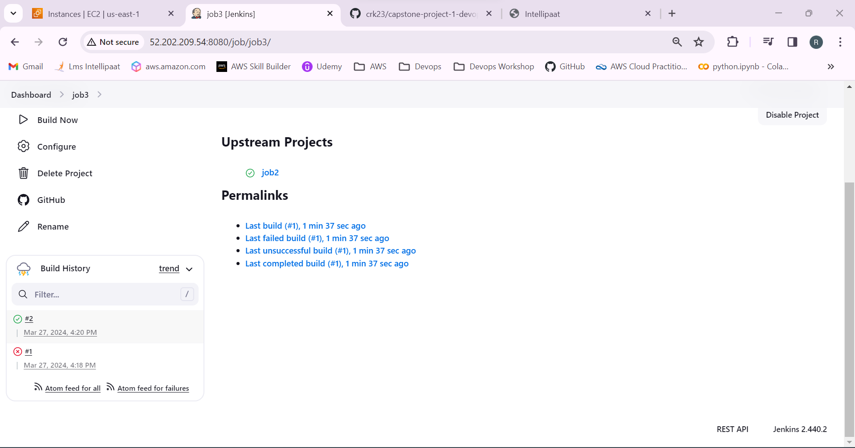

Job 3 starts to build and successfully built.

52.Copy the public ip of the production machine and paste it in the browser.

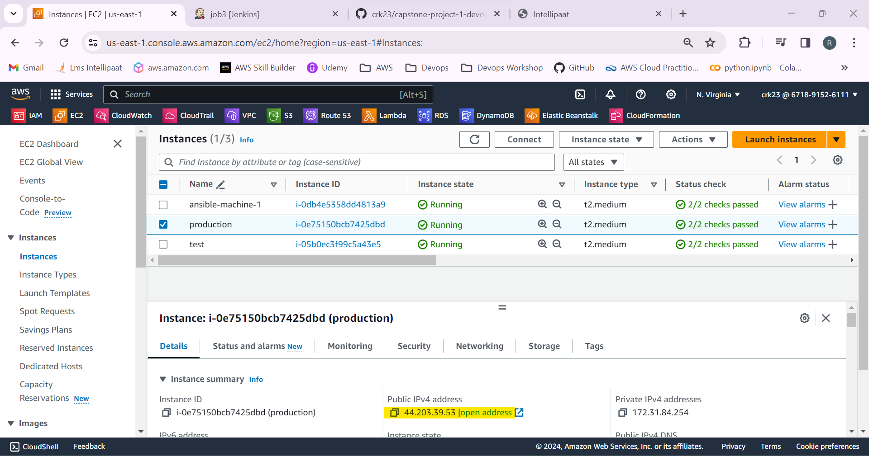

It’s working!

